 **FLOATING LOTUS** 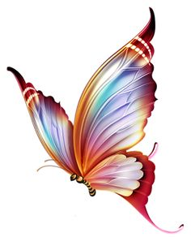

***Buddhist Deities of The Lotus Family***

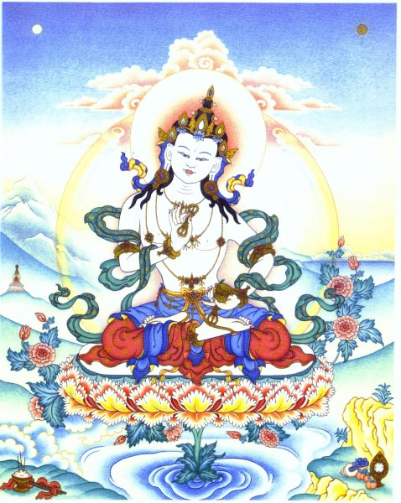

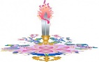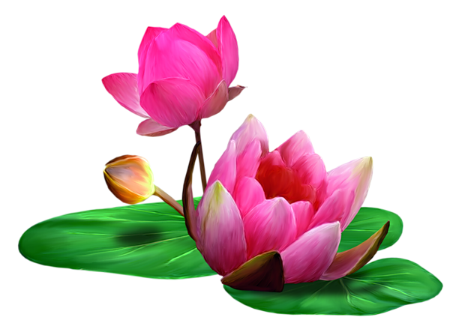****

**Stefan Schindler**

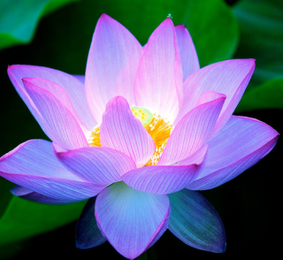 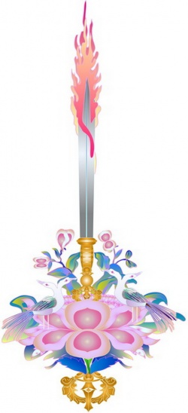 

***OM MANI PADME HUM***

**May the jewel of wisdom blossom**

**from the lotus of the heart,**

**so that each understands**

**we are all each other.**



Copyright 2015 **/** Don Stefan

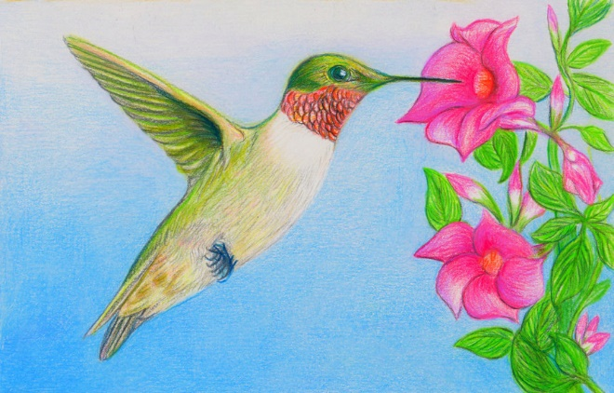

**CONTENTS**

**I Mudra Meanings 11**

**II Shamanism 51**

**III Lotus Power 60**

**IV Tough Love 91**

**V Kundalini 104**

**VI Compassion 111**

**VII The Magus 127**





A reporter asked Arnold Toynbee, perhaps the greatest 20th century British historian:

“Mr. Toynbee, what will future historians say was the single most important event of the 20th century?”

Toynbee: “The introduction of Buddhism to the West.”

……………………………………………………………………………………….

A reporter once asked Mahatma Gandhi:

“Mr. Gandhi, what do you think of Western civilization?”

Gandhi: “I think it would be a good idea.”

……………………………………………………………………………………….

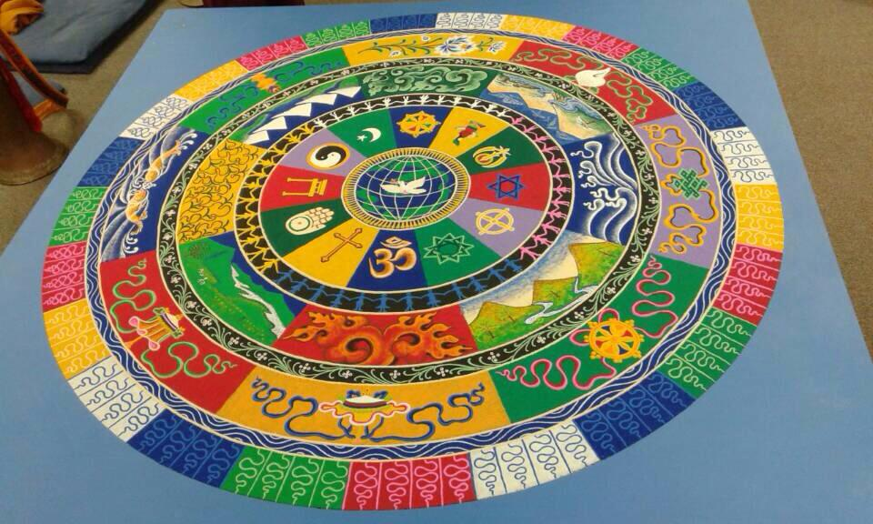

**CAST OF CHARACTERS – *Buddhas, Bodhisattvas, Adepts, and Dakinis* \*\***

Amitabha – Buddha of Infinite Light, Infinite Life, and The Lotus Family

Atisha – 11th century Indian adept; organized Tibet’s Dharma canon

Bhaishajyaraja – the blue Medicine Buddha

Kurukula – Red Tara fierce dakini; protector of the Dharma

Lokeshvara (Chenrezig) – Avalokiteshvara, Bodhisattva of Compassion

Mahakala – fierce protector of the Dharma; male counterpart to Kurukula

Maitreya – The Future Buddha

Mandarava – Indian consort of Padmasambhava

Manjushri – Bodhisattva of Wisdom

Mara – The Tempter

Milarepa – 11th century Tibetan mahasiddha and songster

Padmasambhava – The Lotus Born (Guru Rinpoche; Padmakara)

Sarasvati – Hindu-Buddhist Goddess of Music

Siddhartha Gautama – the historical Buddha (Shakyamuni); 6th century BCE

Tara (Kwan Yin and Kannon) – divine female emanation from Lokeshvara

Tsongkhapa – Tibetan adept; founder of Gelugpa school of Tibetan Buddhism

Vajradhara – Holder and Keeper of the Vajra; a divine Bodhisattva

Vajrapani – Bodhisattva of Vajra Power (often fierce in aspect)

Vajrasattva – The Vajra Being; Bodhisattva of Enlightened Equipoise

Vajrayogini – Kurukula variation; also called Vajravarahi; usually fierce

Yeshe Tsogyal – Tibetan consort of Padmasambhava

*\*\** ***Dakinis*** are rainbowed “sky-dancing” female deities; males are *dakas*. Colorful, often musical, *allies* of Buddhas, Bodhisattvas, and Adepts. Can be fierce when necessary, but are mostly delightful. May be thought of as angels, sprites or fairies. Often assist in rituals.

**Prefatory Notes:**

1 – To aid the reader unfamiliar with Buddhist names, I have occasionally inserted hyphens to assist in pronunciation.

2 – Shiva and Shakti are Hindu deities which are briefly mentioned in the text. Shiva is the dancer whose drumbeat is the rhythmic heartbeat of the cosmos. His consort, Shakti, is a mother goddess archetype, representing the female energy of the universe. Shiva and Shakti are pictured once, as Shiva-Shakti: male and female being two faces of the same; i.e., two aspects of the one underlying cosmic energy stream out which all things are made. Here’s a classic icon of Shiva:

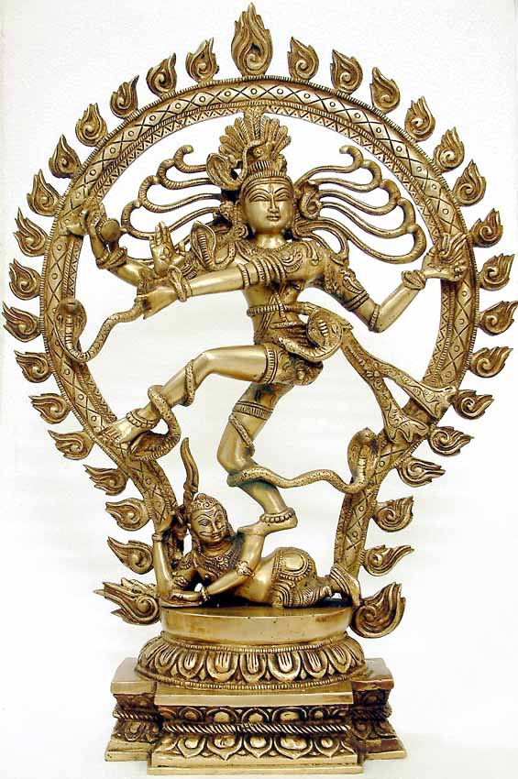

3 – As mentioned in the text, Amitabha Buddha is also called Amitayus. Technically, Amitabha is the Buddha of Infinite Light. Amitayus is the Buddha of Infinite Life, from whose bowl of immortality occasionally appears a stylized tree of life.

4 – A Buddha-family is called a *Buddhakula*. There are five Buddha-clans. In Vajrayana Buddhism, each Buddhakula is presided over by a Transcendent Buddha. Ratnasambhava, the Jewel Buddha, receives an honorable mention in the text, as well as, toward the end, a full page picture. The reader’s curiosity might reasonably be aroused: What are the five Buddhakulas? Which Buddha presides over which Buddha-clan? Here’s the answer:

**Akshobhya** – Buddha of The Vajra Family

**Ratnasambhava** – Buddha of The Jewel Family

**Vairochana** – Buddha of The Wheel (Chakra) Family

**Amitabha** – Buddha of The Lotus Family

**Amoghasiddhi** – Buddha of The (Practical) Action Family

Collectively, they are called ***Dhyani Buddhas***, because sitting in the meditation (*dhyana*) posture. Vairochana is typically in the middle, showing the dharma-chakra mudra, with both hands at the heart.

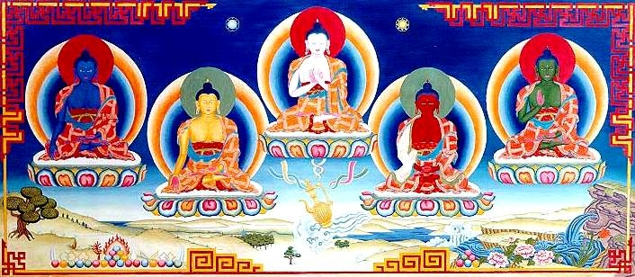

**Akshobhya – Ratnasambhava – Vairochana – Amitabha - Amoghasiddhi**

Use the color scheme above to interpret the Dhyani Buddha Mandala below:

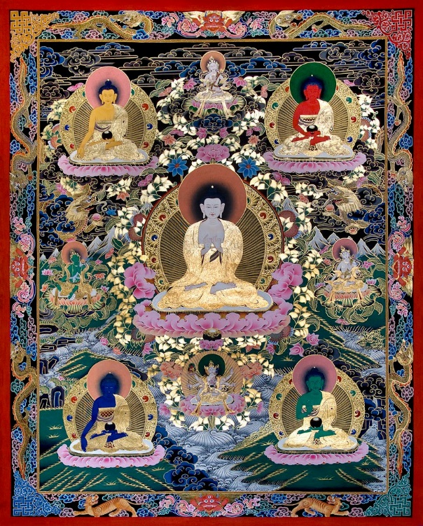

Dakini allies of Dhyani Buddhas

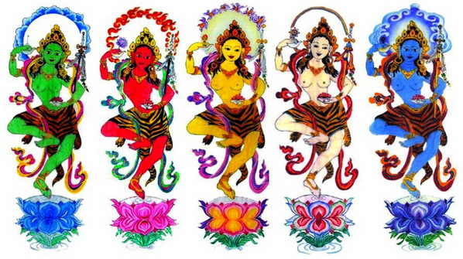

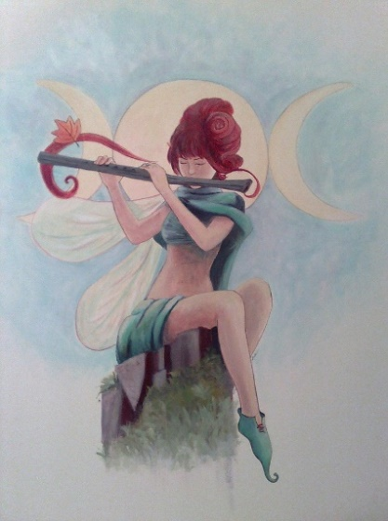 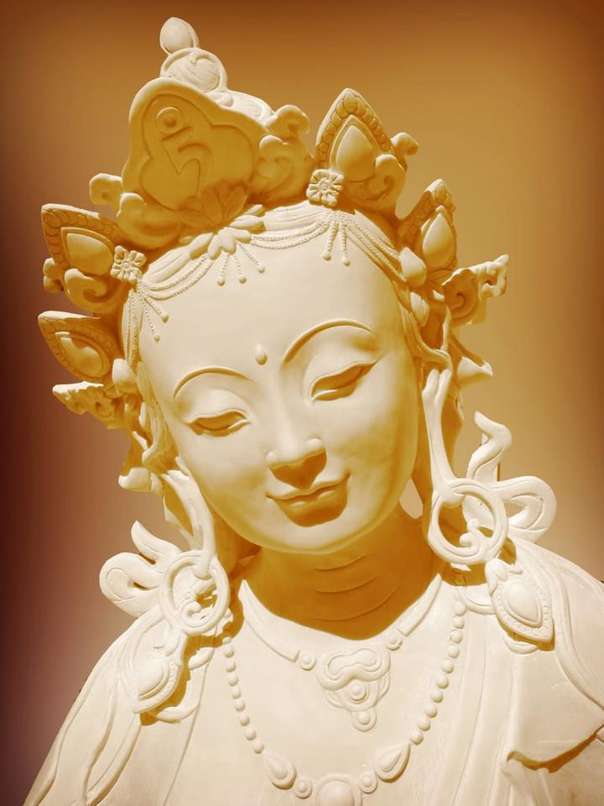 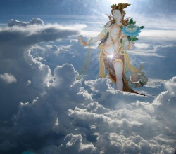

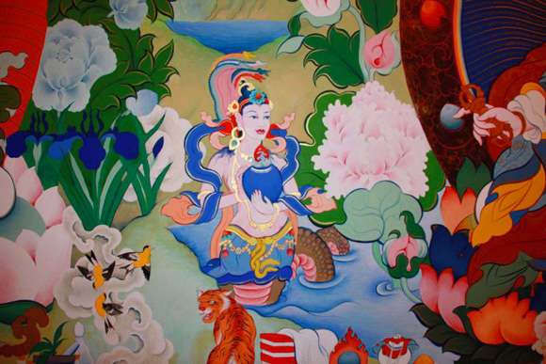

Amitabha / Amitayus: Buddha of Infinite Light and Infinite Life, with Elixir of Immortality bowl. Amitabha is Buddha of The Lotus Family. He emanates Lokeshvara, Bodhisattva of Compassion, and Padmasambhava, The Lotus Born.

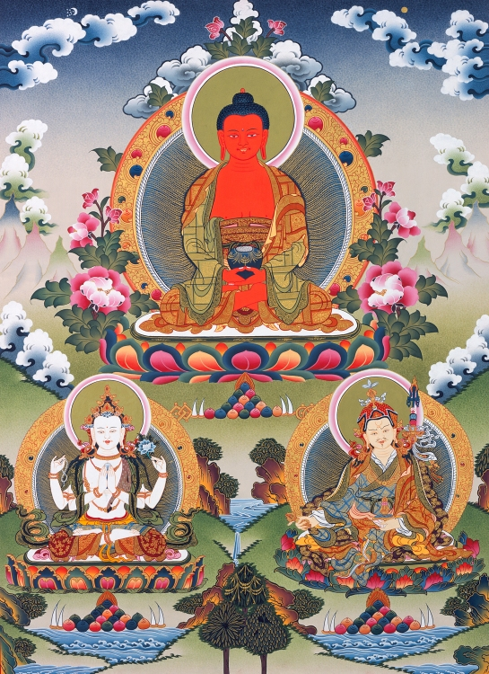

**I MUDRA MEANINGS**

Lotus means: *“Wisdom blooming from compassion.”*

Amitabha is the Buddha of The Lotus Family. He emanates Lokeshvara, the archangelic Bodhisattva of Compassion. Lokeshvara emanates a rainbow of female deities called Tara in Tibet, Kwan Yin in China, and Kannon in Japan.

***Amitabha, Lokeshvara, Tara*** – this is the primordial trinity of The Lotus Family. A Buddha-family is called a *Buddhakula*. There are five Buddhakulas. For example, just as ***Amitabha*** *– Buddha of Infinite Light and Life* – is Buddha of The Lotus Family, Ratna-sambhava, the Jewel-Born, is Buddha of The Jewel Family.

Lokeshvara holds a blue jewel to his heart chakra, between two palms in the prayer gesture. Lokeshvara’s mantra is *Om Mani Padme Hum* – May the jewel of wisdom blossom from the lotus of the heart. Wisdom and compassion: two names for the same.

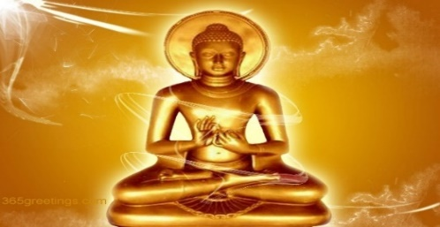

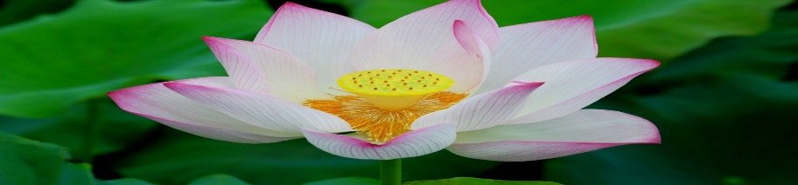

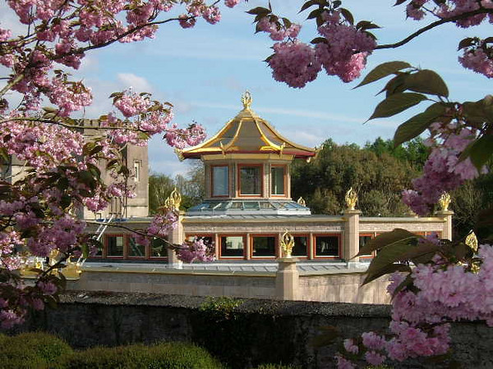

Now, most of the art works in this discourse exhibit hand gestures, called *mudras*. It will be helpful to begin by exploring seven of these common gestures.

**VARADA MUDRA**

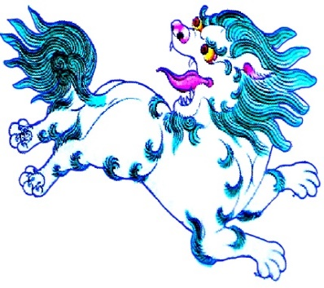 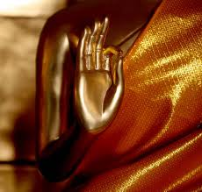 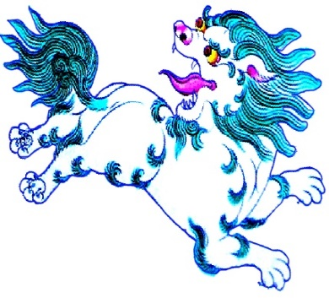

**Lokeshvara Siddhartha Gautama Tara**

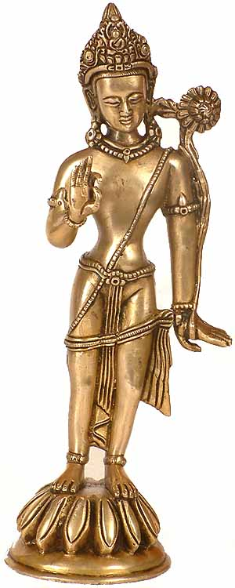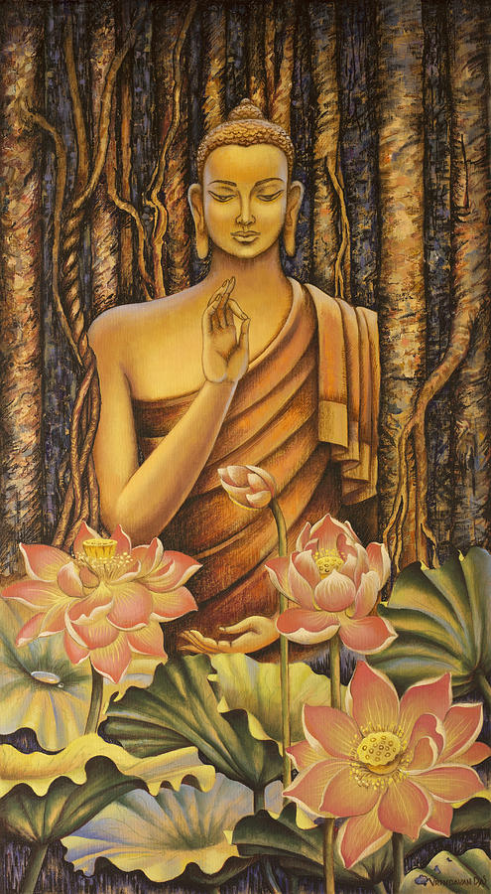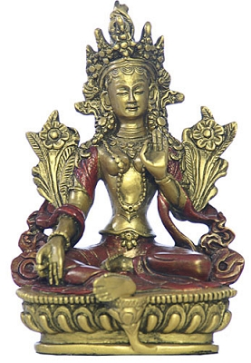

*Mudra* is a Sanskrit word meaning formation of the hands, and location of the hands with regard to body and posture.

The *varada-mudra* – shortened to *varada* – is the “boon granting” or “wish fulfilling” gesture, shown above. Thumb and forefinger form a circle. The other three fingers are extended. The palm faces outward.

*Varada* signifies boon granting, compassion, generosity, and teaching. Both Tara’s hands form *varada*.

In all three iconic postures above, we see the presence of the lotus.

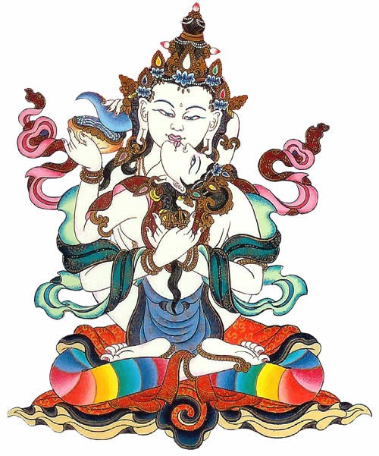

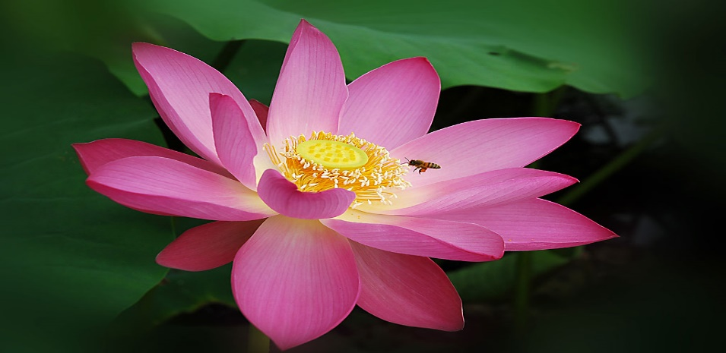

Below: ***Lokeshvara Bodhisattva***, with ***Amida*** (*Amitabha Buddha*) atop his crown. Lokeshvara’s far right-hand *varada* mudra holds a bodhi seed, while his far left holds the stem of a budding lotus. *Bodhi* is Sanskrit for “wisdom.” Bodhi *seed* and lotus *bud* show potential for awakening. Lotus *blossom* is enlightenment.

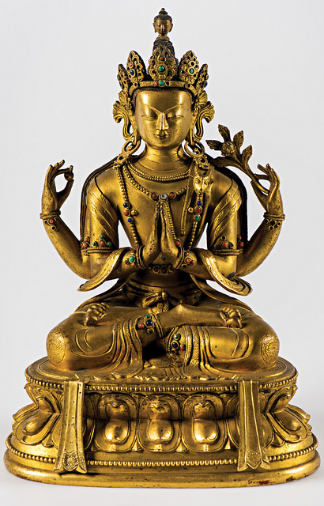

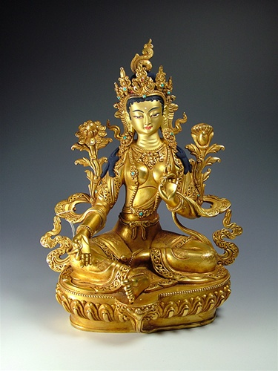

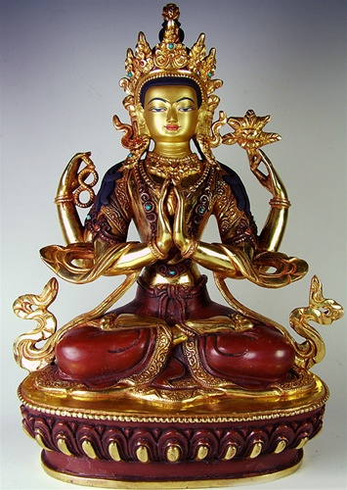

 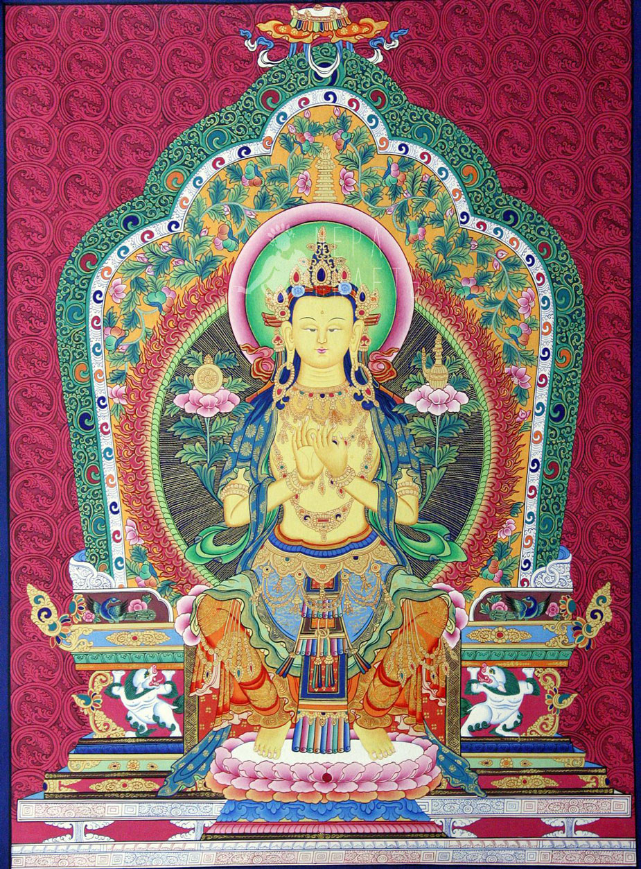



Above is *Maitreya, The Future Buddha*. Maitreya is Lord of the Dharma Palace in Tushita Heaven.

Siddhartha Gautama – also called Shakyamuni Buddha – spent a long time as Lord of the Dharma Palace in Tushita Heaven. Just prior to Gautama Buddha’s compassionate descent to Kapilavastu in northeast India – incarnating as Siddhartha (“goal achiever”) in the Gautama family of the Shakya clan – he passed the mantle, *Lord of the Dharma Palace*, to Maitreya.

Siddhartha instructed Maitreya to incarnate on earth about 2600 years after Siddhartha’s “death,” to revivify the Dharma to a lost humanity crying in the wilderness of their own greed, hatred and delusion. Siddhartha Gautama was born about 2500 years ago.

*Varada-mudra* is iconic among the lotus family, emanating from Amitabha.

**Amitabha Buddha emanates Lokeshvara**

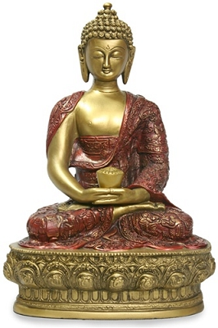 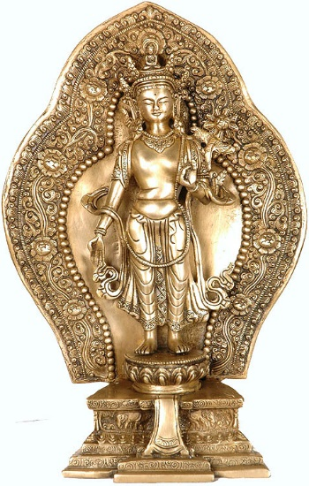

**Amitabha**, Buddha of Infinite Light, emanates **Lokeshvar**a, Bodhisattva of Compassion. “Lokeshvara” is short for Avalokiteshvara. Lokeshvara is also called ***Padmapani*** – Lord of Lotus Power. His Tibetan name is ***Chenrezig***. Lokeshvara’s own female emanations are called **Tara** in Tibet, **Kwan Yin** in China, and **Kannon** in Japan.

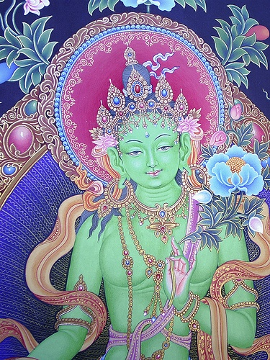 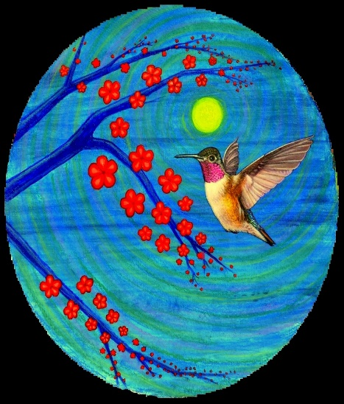 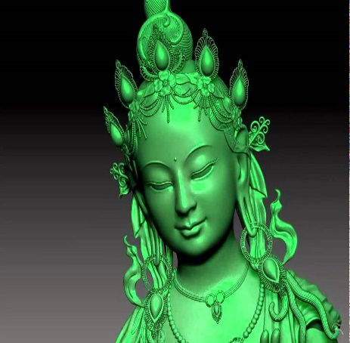

**LOTUS**

**Wisdom (*prajna*) blooming from compassion (*karuna*).**



“Wisdom” translates *prajna* and *bodhi*. “Compassion” is the translation for *karuna*. Wisdom and compassion – *prajna* and *karuna* – are the two wings of Buddhism. Wisdom and compassion go together.

In the images on the second page of our discourse, standing-Lokeshvara, on the left, holds the stem of a lotus. The stem stretches upward and blooms above his shoulder. In the middle picture, Gautama Buddha has lotus flowers before him, in various stages of growth, the center lotus still a bud. The sitting icon of Tara, on the right, shows two flowers in full bloom, one lotus at her right shoulder, the other at her left. Often, when two lotuses are shown, one is in bloom, while the other is a swelling bud.

**A lotus *bud* signifies our potential for awakening.**

**A lotus *blossom* signifies enlightenment.**

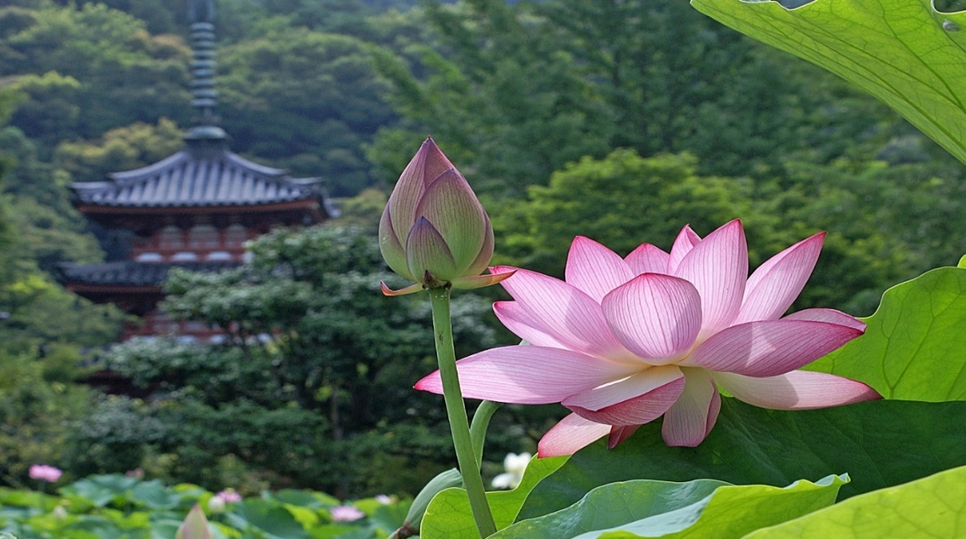

When Lokeshvara is imaged with four arms – or a thousand – he holds a bodhi-seed rosary (here: in his back-right-hand). This is the rosary for chanting ***Om Mani Padme Hum***.

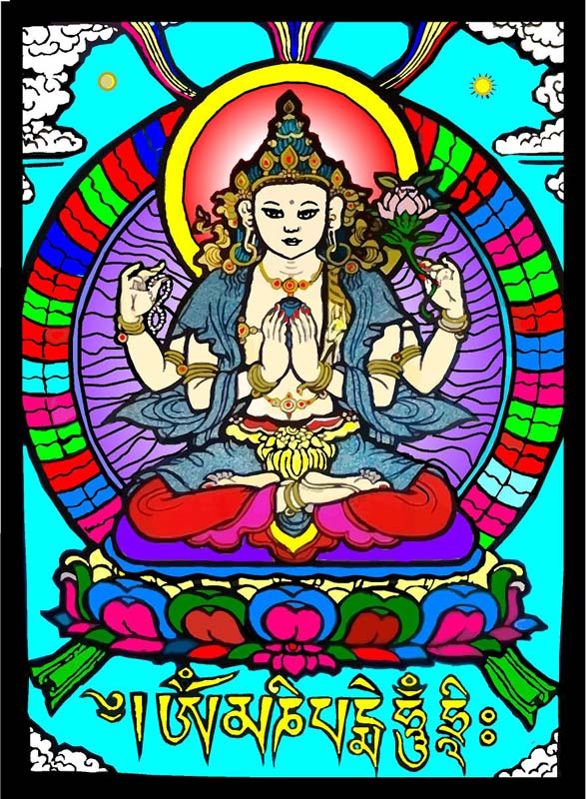

***Mani*** is mind and jewel. ***Padme*** is lotus and heart. ***Mani Padme***: the jewel of wisdom blooming from the lotus-heart of compassion. He holds a blue jewel to his heart chakra.

***Om*** is one. ***Hum*** is all. ***Om Mani Padme Hum***: “May the wisdom-jewel bloom from the lotus of the heart, so that each understands we are all each other.”

***Vitarka* *mudra***. With one hand held up, the other down by the knee, both palms out-facing, both hands in varada – the *vitarka mudra* combines compassion, generosity and teaching with “discernment.” **TARA in *VITARKA* mode …**

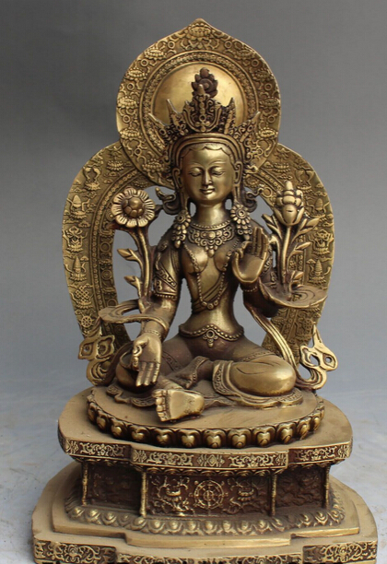

One lotus is in full bloom. The other is about to bloom. Framed in the center of the base is a dharma-chakra – a teaching wheel. *Chakra* means circle or spinning energy-center. *Dharma* has multiple meanings, including truth, reality, and teaching. Buddha-dharma is the truth that Buddha taught. Tara here conveys that same truth. Generosity (*dana*) is the first of the six *paramitas*: the “perfect virtues” of a bodhisattva.

*Vitarka* is called *The Discerning Gesture*.

***Vitarka mudra*** means:

I discern the nature of reality; I discern the exact nature of your distress; I discern the exact *upaya* (“skillful means”) for relieving your distress. I am an *upaya* maestro, blessing you with healings and teachings from the lotus of compassion.



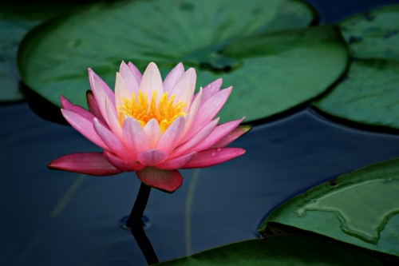 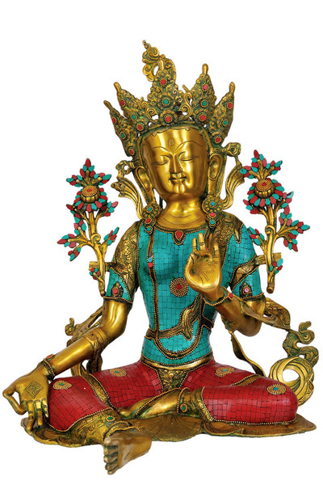

Above, Lokeshvara in vitarka mudra. His left-hand thumb touches the *third* finger. *Thumb-touching-third-finger* is an iconic gesture emphasizing ***teaching***. Teaching Mudra presupposes *discernment* of the skills needed and the knowledge taught.

***Vitarka*** shows four meanings: 1) compassion; 2) generosity; 3) discernment; 4) teaching. Here are more examples of this iconic combination …

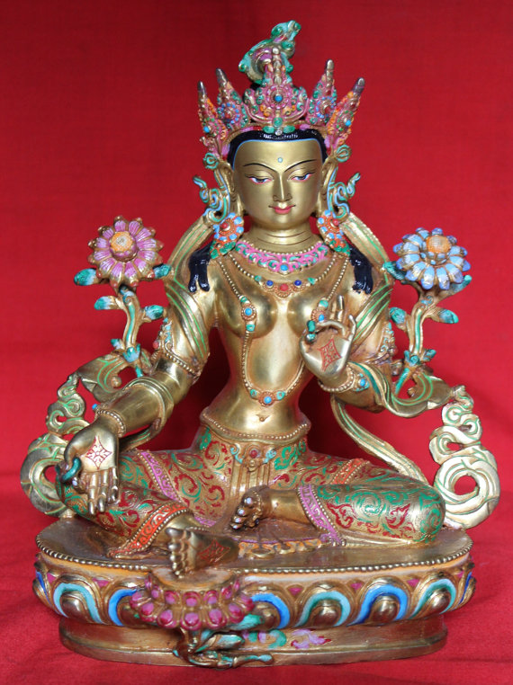

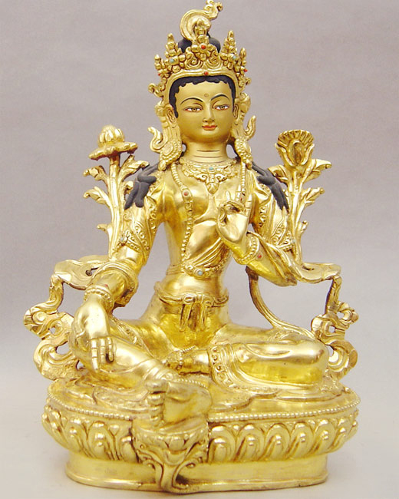

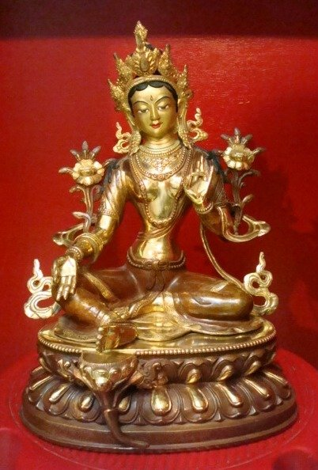

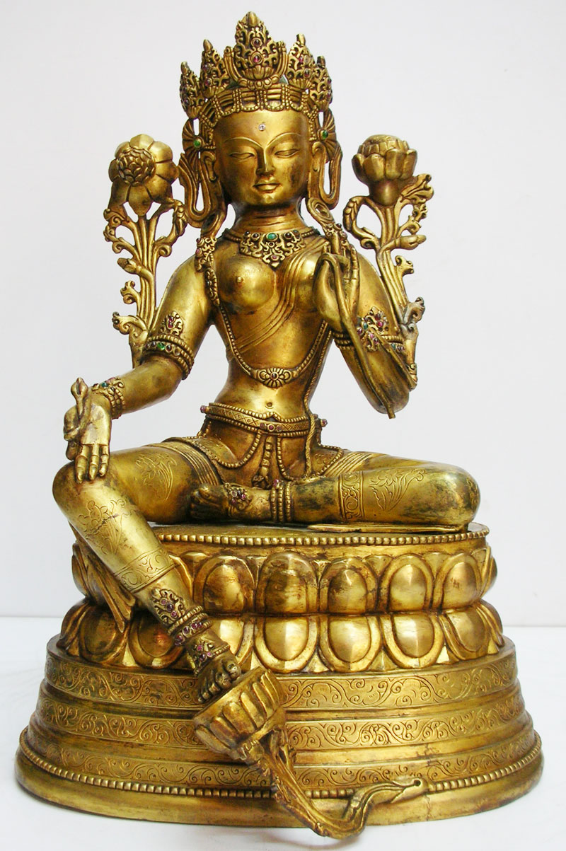

In the picture above, note the kundalini cobra. Its tail begins at Tara’s left ankle. The subtle serpent body stretches around her left knee, then disappears behind her back. The serpent reappears at her right hand. The cobra’s head ascends through the varada crevice, its neck snuggled against the stem of the lotus.

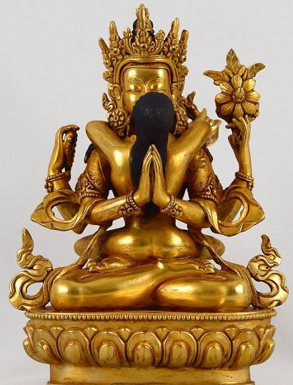

The cobra, wrapped around Tara, signifies metamorphosis of erotic libido into spiritual ecstasy. Optimal fire-serpent whirling in chakra symphony.

In Hindu terms, Tara is Shakti; Shiva is the serpent. The Shiva-Shakti cosmic erotic dance is both multi-galactic and individually available, since, as Hermes Trismegistus writes on The Emerald Stone: “As above, so below. Microcosm mirrors macrocosm.”

***Abhaya Mudra*** **– Protective / Fear-Not Gesture**

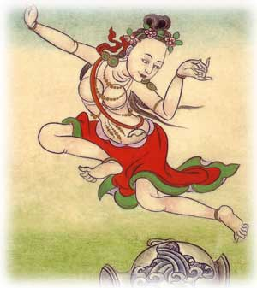 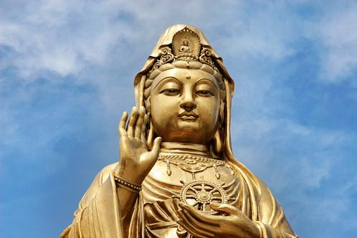 

Kwan Yin’s upturned right hand is in the *abhaya* – fear not – mudra. Kwan Yin’s left hand supports a *dharma-chakra* – “teaching wheel” – at the level of the heart. The eight spokes of the dharma-chakra signify Buddha’s Fourth Noble Truth: The Eightfold Path to freedom and enlightenment.

In Kwan Yin’s crown is a small icon of Amitabha Buddha. Amitabha emanates Lokeshvara, who in turn emanates Kwan Yin. Kwan Yin’s countenance mirrors the Madonna theme so familiar in the West. One of Tara’s names is Mother of All Buddhas.

The *abhaya* mudra radiates a force-field protecting the Dharma. Kwan Yin encourages the devotee to be fearless. If you find yourself in harm’s way, chant the mantra: “*Only love, and only peace; only love, and only peace*.” It is potent and successful.

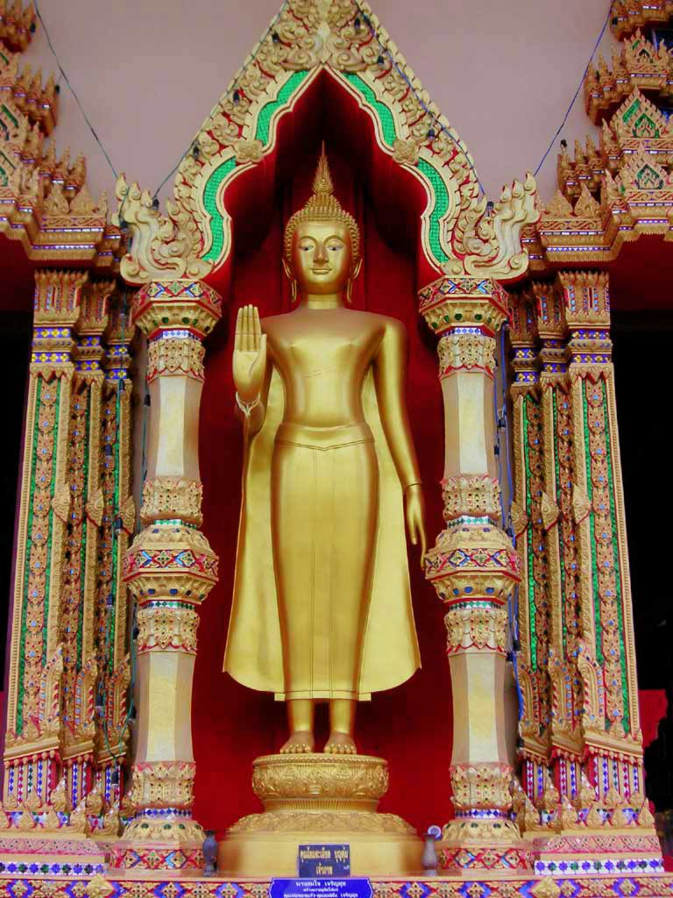

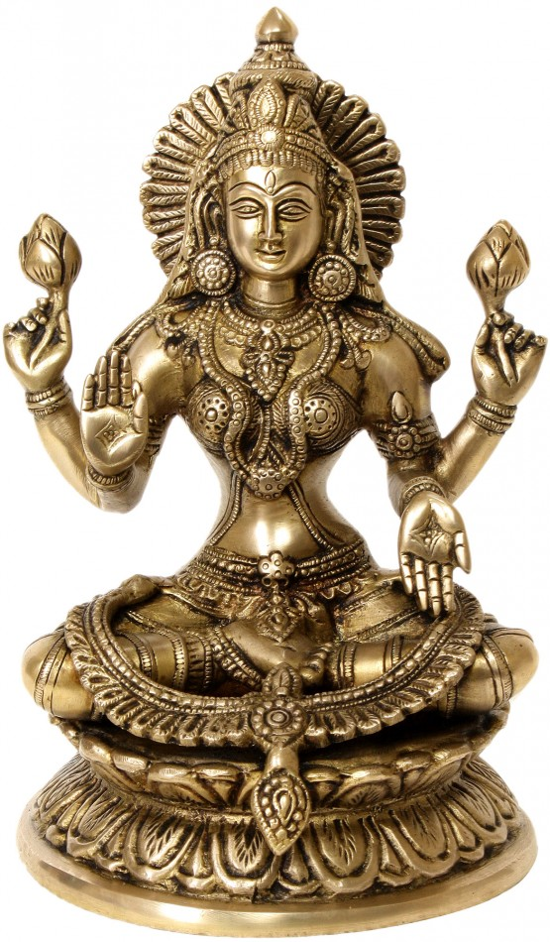

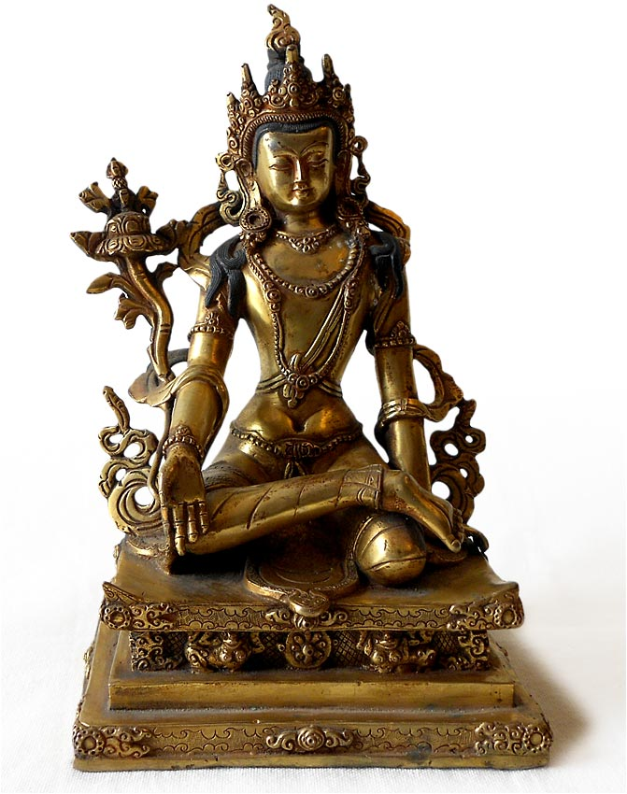

***Bhumi-sparsha*: Earth Witness Mudra**

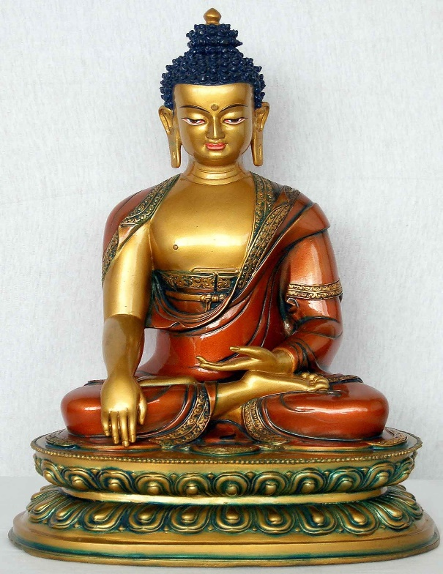

The Earth Witness Mudra recalls a moment during the night of Siddhartha’s enlightenment, sitting beneath the Bodhi Tree.

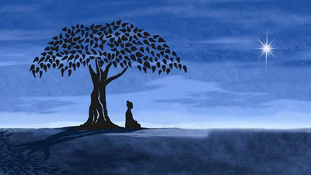

Mara, The Tempter, sought to break Siddhartha’s equipoise with three temptations – fear, lust, and pride. Mara sent monsters; then his daughters. Siddhartha showed that he was immune to fear and lust. Then Mara asked: “Who are you to deserve enlightenment? Aren’t you really just an egomaniac, sitting here full of pride, elevating yourself above others?”

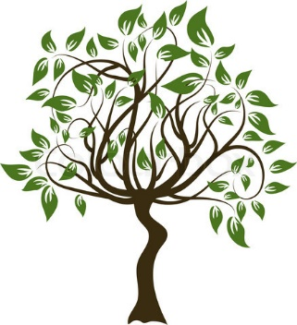

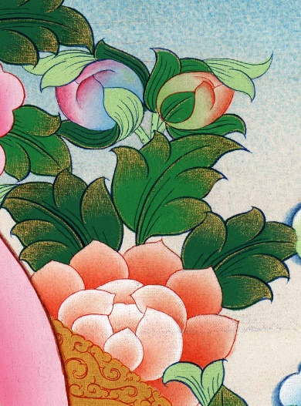 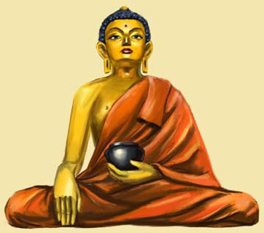 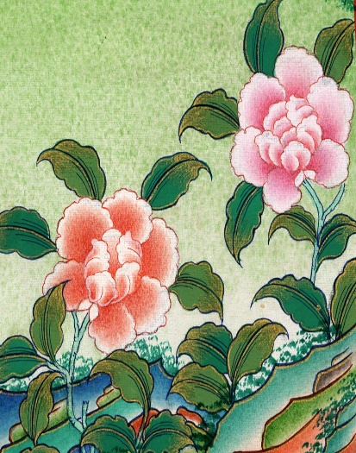

Siddhartha, remaining silent, gestured down. Mother Earth responded to Mara’s question:

“This is my beloved son, who for countless incarnations has been a true bodhisattva. Even as animal, he sacrificed his life so others may live. His equanimity and merit earn him freedom, bliss, and enlightenment.”

Mara was defeated. He left, taking his monsters, maidens and insults with him. Below is a *thangkha* (scroll painting) showing Siddhartha Gautama in meditation, impervious to Mara’s temptations:

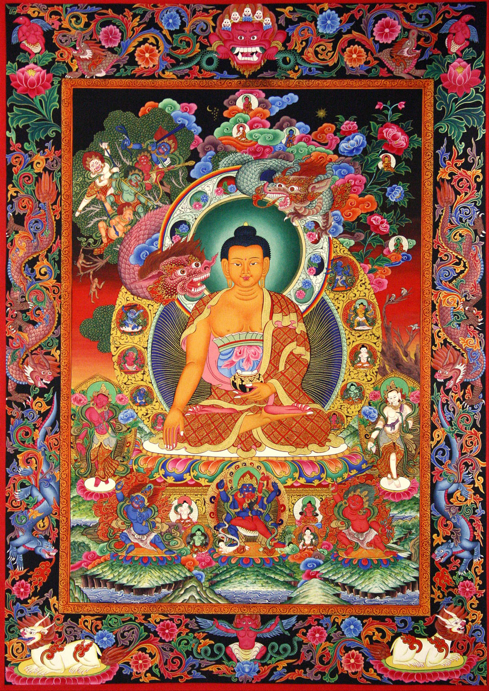

*Padma-sana* is the “lotus posture,” also called “diamond posture.” The posture, and hands in the lap, signify *Meditative Inwardness*.

***Dhyana-mudra* –** Sinking into meditative emptiness (s*hunyata*).

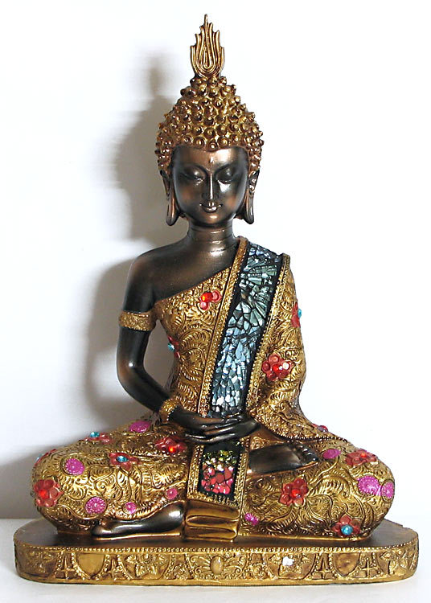

*Dhyana* is a Sanskrit word meaning “meditation.” The Pali term is *jhana*. Dhyana is the eighth step in The Eightfold Path, though rightly understood in Zen – as befits Buddha beneath the Bodhi Tree – as the real “first step.” “Right thinking” – the normal first step – suggests meditation as the royal road (*raja yoga*) to awakening. *Dhyana-mudra* is also called *dhyani-mudra*. Meditative descent into and through *samadhi*. *Samadhi* is the equipoise of perfect peace.

**Atisha in *Dharma-chakra* Mudra**

**“Dharma Wheel”**

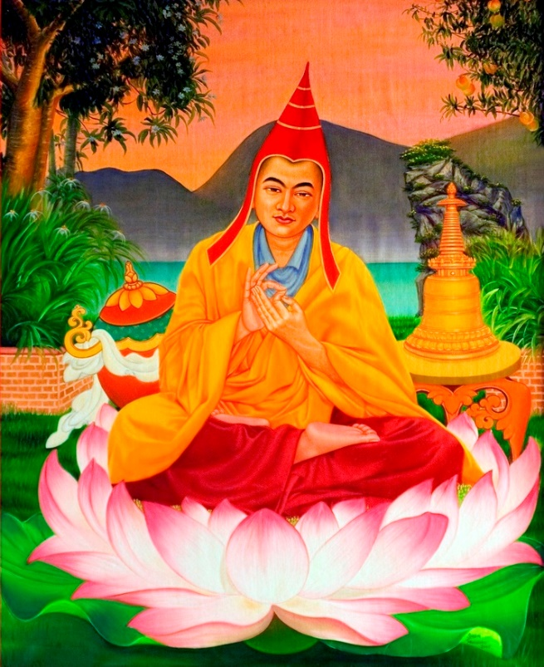

Around 1040 CE, Atisha, the great Indian sage and Vajrayana master, took Tara’s advice. He journeyed to Tibet, to organize Buddhist teachings into a coherent curriculum. Texts and teachers had been pouring into Tibet from surrounding countries for four centuries. Not all were authentic. Although Tibet now had monastic universities with growing libraries, the sutras and commentaries were in disarray, and often seemed to contradict each other. Atisha declared: “There is no contradiction in Buddha’s dharma.” Atisha made it clear that Gautama spoke skillfully. Gautama’s word-arrows aimed at the heart, for therapeutic shock. Atisha proclaimed that beneath all the seeming differences, Buddha’s teachings were coherent, cogent, luminous, and free of taint. Then Atisha explained that Buddhism in India had progressed over a period of 1500 years, moving from Theravada through Mahayana to Vajrayana.

Atisha organized a library system and curriculum for Tibet’s temples and monastic universities. He traveled widely across the vast Tibetan plateau; learning, teaching and writing. His impact on Tibetan Buddhism – and, therefore, Tibetan culture – was enormous. Tibetan’s consider him one of Tibet’s “three most kind.” The other two are Padma-sambhava (The Lotus Born) and Tsongkhapa:

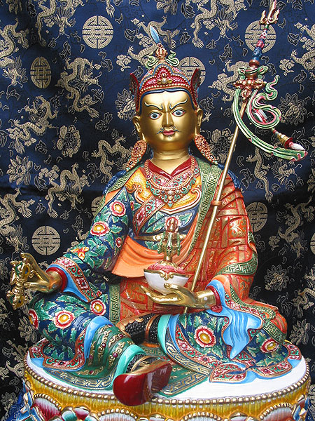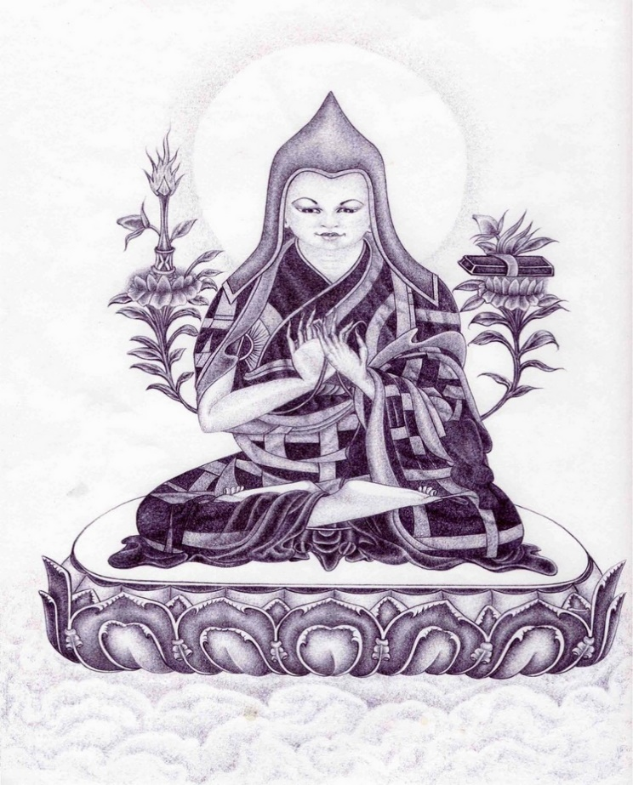

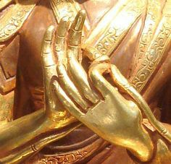

The **Dharma-chakra** mudra is iconically associated Vairochana Buddha, and with *Maitreya,* the *Future Buddha*. Maitreya presides over, and continues teaching in, The Dharma Palace of Tushita Heaven, until the time is ripe for his descent to earth and re-vivifying Buddha’s lost dharma-lessons …

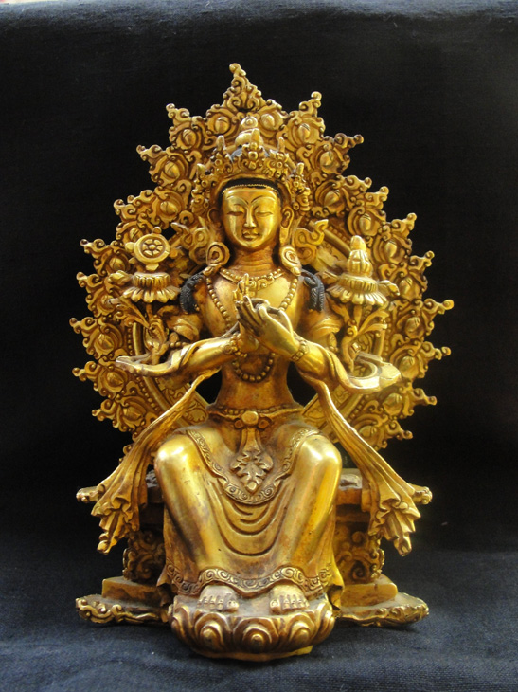

**Maitreya Buddha**

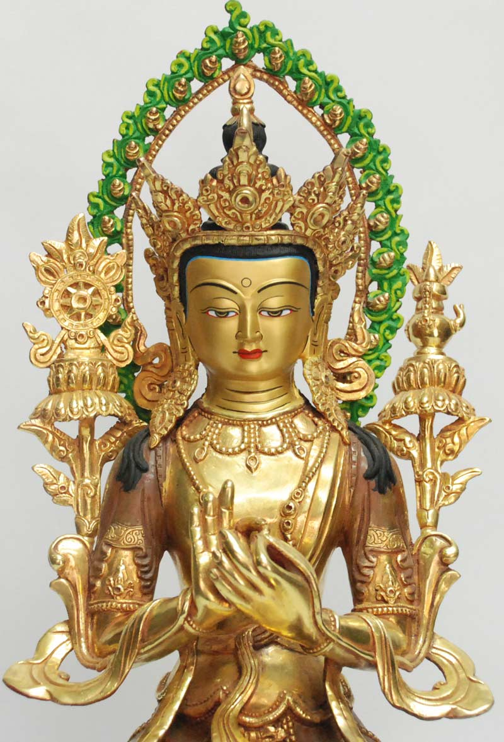

*Maitri* is the Sanskrit word for “loving kindness.” It is familiar to Buddhist practioners in the West in its Pali form: *metta*.

*Maitri* is the root of Maitreya’s name. Thus Maitreya is The Buddha of Unconditional Love.

Note the “teaching wheel” atop the lotus on the left.

Siddhartha Gautama anticipated the major phases of Buddhism’s evolution. During his 45-year teaching career, he is said to have turned *The Teaching Wheel* – the *Dharma-chakra* – three times.

**Dharmachakra**

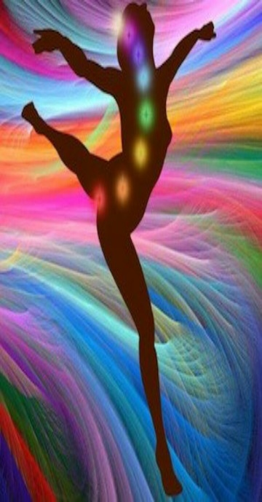 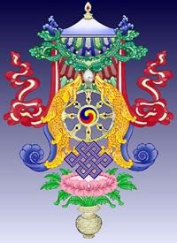 

The *First Turning* corresponds to Buddha’s pronouncing The Four Noble Truths, then establishing that revolutionary innovation called monasticism, where individuals could “drop out” of a class and caste based society, and devote themselves instead, in a context of group support, to the enlightenment project. The First Turning inaugurates Theravada – “Original Buddhism,” or “School of the Elders.”

Buddha’s *Second Turning* of the teaching wheel emphasizes compassion as the royal road to enlightenment. Compassion becomes the touchstone of Mahayana. An adept in Theravada Buddhism is an arhat. An adept in Mahayana Buddhism is a bodhisattva. A bodhisattva commits to awakening *and* service.

Buddha’s *Third Turning* was the “esoteric” teaching of Vajrayana – the “diamond thunderbolt path” to enlightenment. Vajrayana is also called Tantrayana and Mantrayana.

An accomplished adept in Vajrayana is a *siddha*, endowed with paranormal powers. A *maha-siddha* is pretty much the same as a Buddha: endowed with “transcendental” prowess – like Padma-sambhava and Milarepa.

Here’s *Padma-sambhava, The Lotus Born –* 8th century “Indian” incarnation of Amitabha. He tames Tibetan storm-gods, allowing Buddhism’s safe importation from India. Called *Guru Rinpoche*, and considered “a second Buddha.” We then see *Milarepa*: 11th century Tibetan Mahasiddha Songster.

**Padmasambhava Milarepa**

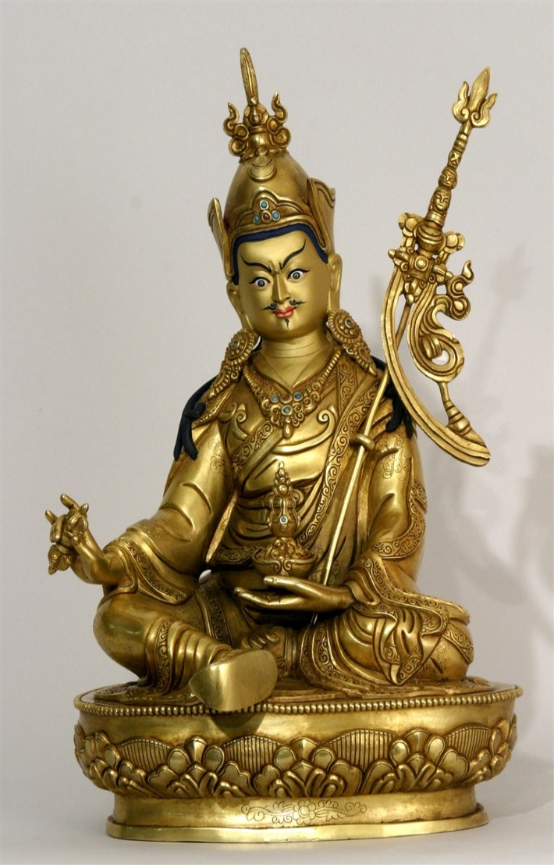 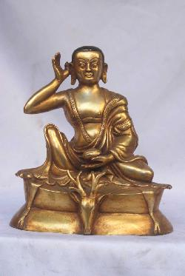

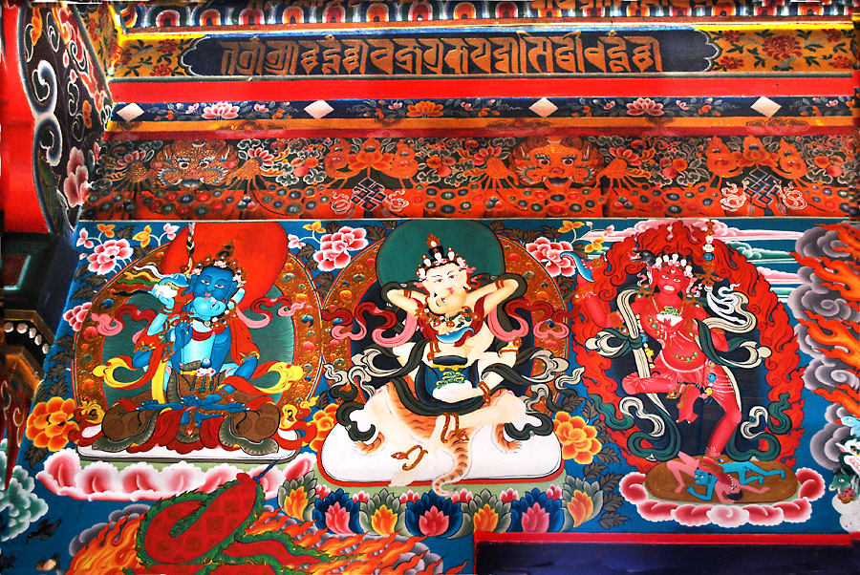

**Vajrasattva**



Two of the major deities in Vajrayana Buddhism are Vajrasattva and Vajradhara. They often overlap.

Vajrasattva – “the vajra being” – typically holds a vajra and a bell.

Vajradhara – “holder of the vajra” – holds two vajras:

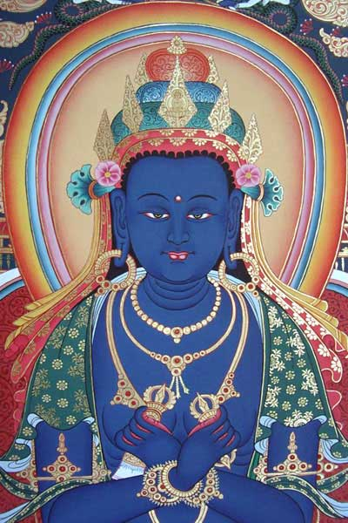

***Vajra*** in Tibetan is *dorje*. ***Dorje*** is a ritual symbol for lightning bolt, enlightenment, and Vajrayana yogic metamorphosis toward Buddhahood.

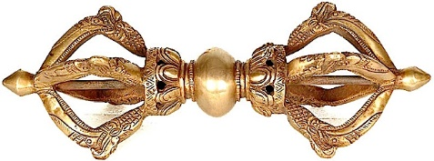

Vajradhara Kundalini





The Mahayana movement elaborates, invokes and reveres a kaleidoscopic pantheon of Buddhas and Bodhisattvas. Mahayana Buddhists agree with Meister Eckhart: *Heart work is also art work*.

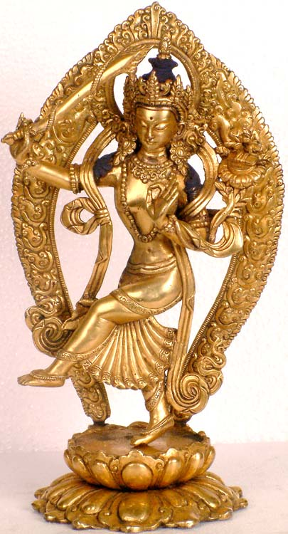

**Manjushri, Bodhisattva of Wisdom, in left-handed varada-mudra, dancing on lotus. He holds his flaming sword – Chanda Hasa, “Dreadful Laugh” – in his upturned right hand. A sutra (“wisdom book”) rests upon a blooming lotus by his left shoulder.**

*Yana* means path, vehicle, way. *Maha* means “large” or “great.” Mahayana Buddhism is the “Great Vehicle,” large enough to carry all beings from suffering to freedom. Vajrayana, like Zen, is an offshoot of Mahayana. Deities of The Lotus Family are distinctively part of the Mahayana pantheon. Below on the right: Lokeshvara in *samadh*i – the peace of perfect equipoise …

**Double Vajra Lokeshvara Samadhi**

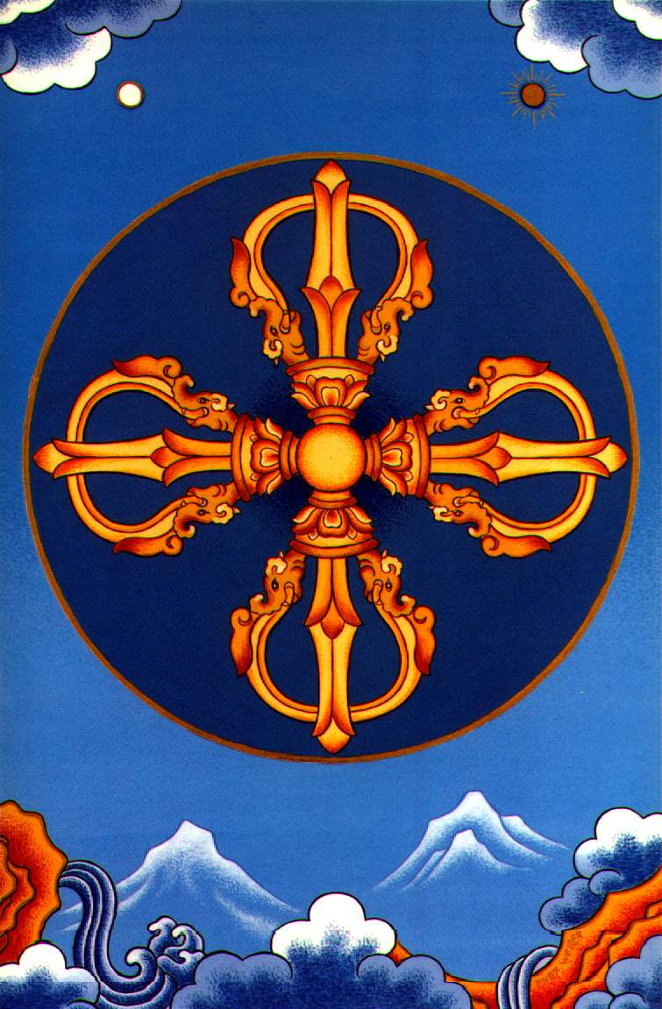 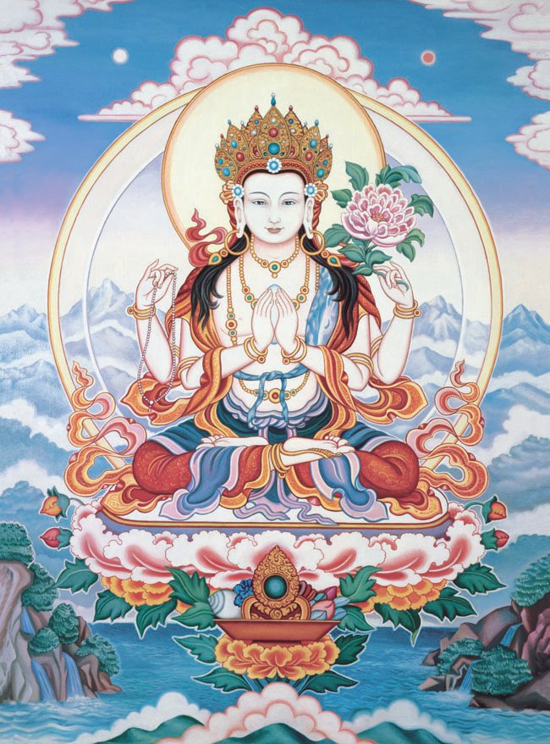

Above-left is a double-vajra, called *vishva-vajra*. The four points signify Buddha’s **Four Noble Truths**:

1) The unenlightened life is suffering.

2) The three causes of suffering are greed, hatred, and delusion.

3) Freedom from suffering is possible.

4) The Eightfold Path is the way to freedom: Right thinking, right speaking, right intention, right action, right vocation, right concentration, right meditation.

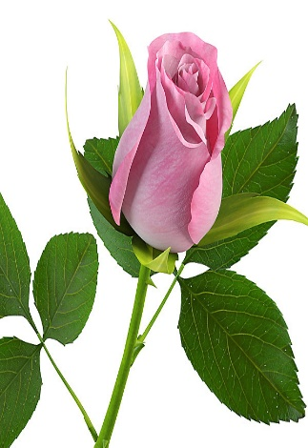 

In the dharma-chakra above, the tricolored Tao sign in the center signifies:

1) *The Three Turnings* of The Teaching Wheel: Theravada; Mahayana; Vajrayana;

2) *The Three Jewels*: Buddha, Dharma, Sangha (teacher, truth, community);

3) *Hermes Trismegistus*: Shaman, Healer, Sage.

The Tao sign serves Buddhism as a symbol for The Middle Way. It is here portrayed in its original Taoist form as a vortex. Zen is the center in the swirl.

The Tao sign above becomes a wheel. The wheel rests upon a *Tantric Knot*.

The knot is Indra’s necklace, symbol for *The Living Web of Interbeing*. All is process; we are all brothers and sisters; karma is a fact.

The Tantric Knot rests upon a lotus – wisdom blooming from compassion. The lotus sprouts from a vase. The vase is a) the bowl containing Amitabha’s Elixir of Immortality; b) Siddhartha’s alms bowl; c) Kwan Yin’s libation pitcher.

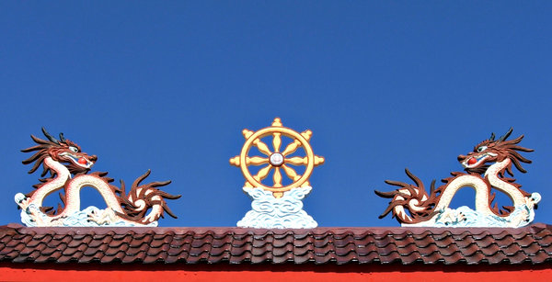

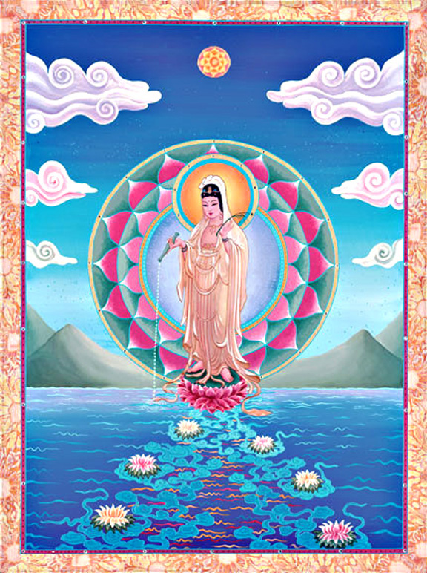

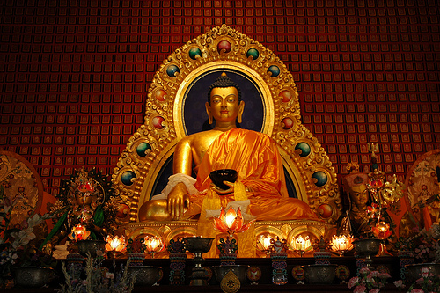

There are hundreds of mudras. They appear in a bewildering variety of combinations. This introductory mudra-discourse shows only a few.

Every mudra is a blessing, healing, teaching. An inspiration to fearlessness and faith.

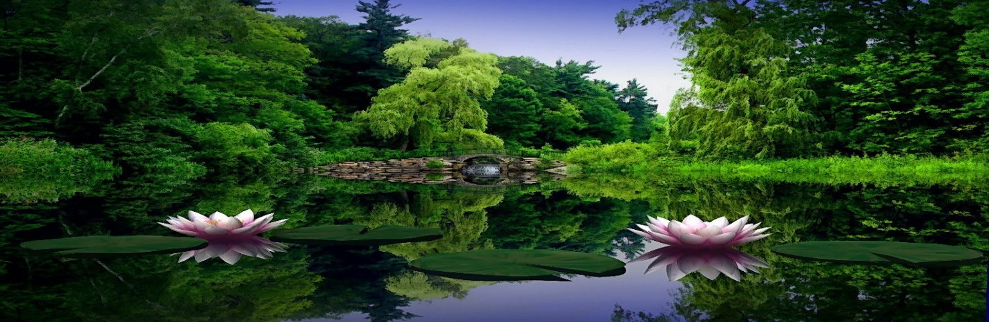

Let’s review. We have explored seven mudras …

7 **Mudra Meanings (with supplemental notes)**

1. *varada* – boon granting and teaching
2. *vitarka* – discernment and teaching
3. *varada-vitarka* – generosity, insight, teaching
4. *dharma-chakra* – teaching wheel
5. *bhumi-sparsha* – earth witness
6. *abhaya* – fear not
7. *dhyana* – meditation

a) Varada is also commonly called the Jnana Mudra. Jnana Yoga is philosophy, emphasizing knowledge, learning, teaching and discourse. These meanings apply to the Varada Mudra, as well as Vitarka and Dharmachakra. b) The Dhyana Mudra is also called the Samadhi Mudra, *samadhi* being a word for peace and equipoise. c) Thumb touching middle finger can be called the Akash or Shuni Mudra. It indicates patience, perseverance, and assuming (karmic) responsibility for events and experiences. Associated with Saturn, the planet of karmic lessons. d) Below: Vairochana Buddha showing the Dharmachakra Mudra (or, more commonly, with hands in lap and a Teaching Wheel):

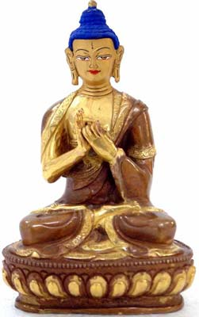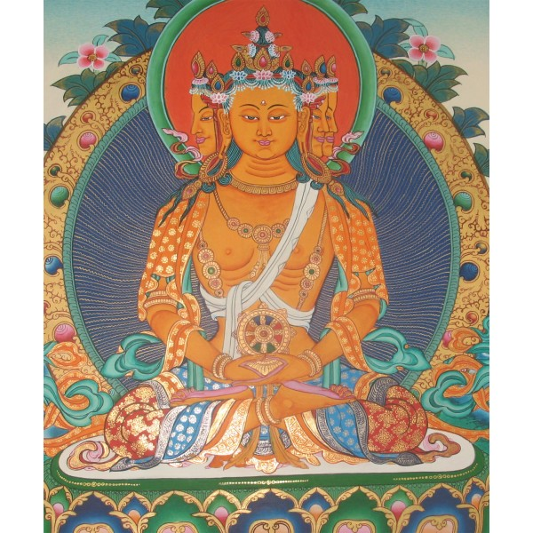

**II SHAMANISM**

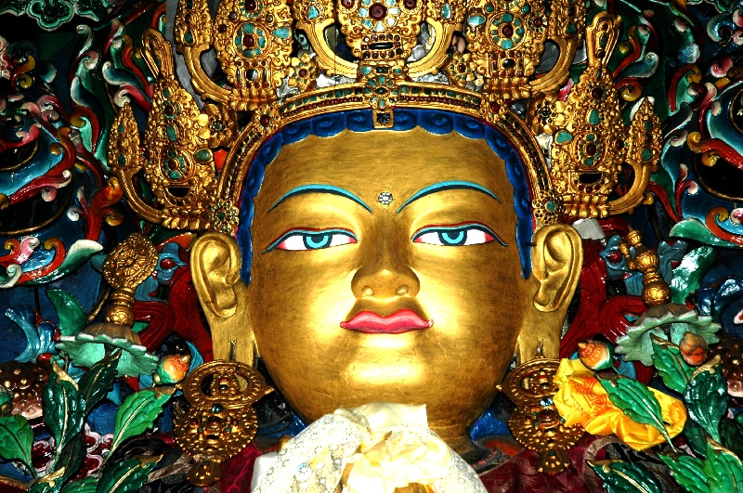

Above, Amitabha Buddha exhibits two of the “transcendental” powers (*siddhis*) which occur on the path to enlightenment: 1) The diamond in the forehead is the third-eye (*ajna chakra*), endowed with clairvoyance. 2) The elongated ears signify clairaudience. Aspirants on the path who awaken and master such powers are called *siddhas*. A *maha-siddha* is a “rainbow” adept; a yogi of transcendental prowess, like Gautama, Padmasambhava, Atisha, Milarepa, Tsongkhapa. Each an archetype of Hermes Trismegistus: shaman, healer, sage.

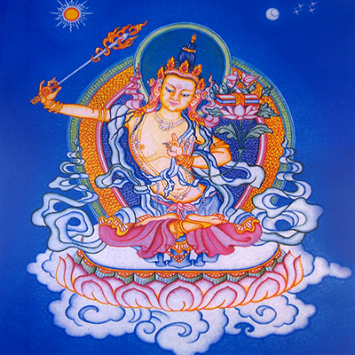 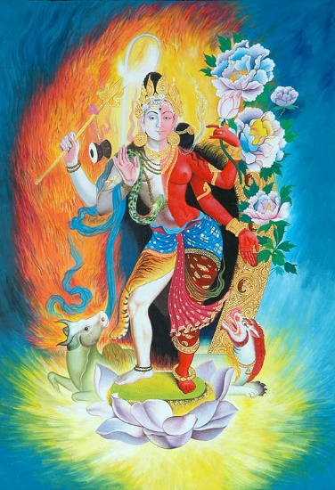 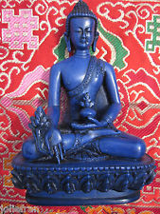

Taoist “Immortal”

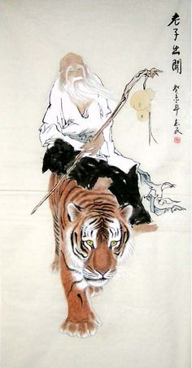

***Guru Rinpoche*** – The Lotus Born

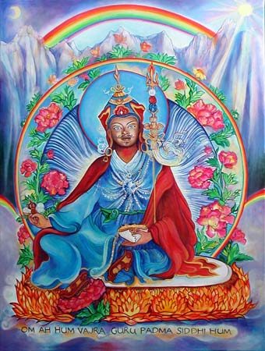 

***Guru Rinpoche*** – *Vajra* in his right hand; *katvanga* **Trident Scepter** other side.

**The** **Trident** has multiple meanings:

1) The 3 Jewels: Buddha, Dharma, Sangha.

2) The 3 Phases: Theravada, Mahayana, Vajrayana.

3) The 3 Bodies (*Trikaya*): Truth body, Bliss body, Form body (respectively: *Dharmakaya, Sambhogakaya, Nirmanakaya*).

4) The 3 Channels: The three major subtle-body channels employed in tantra yoga.

5) The 3 Poisons: Greed, Hatred, Delusion – the three major causes of suffering. Technically, the trident in this respect means the *Overcoming* of the 3 poisons.

6) *Hermes Trismegistus*: Shaman, Healer, Sage.

7) The 3 Seals or marks of samsara: impermanence, selflessness, and suffering (*anitya, anatta, dukkha*).

8) The 3 Stages of Perfection Yoga (*dzogchen*): outer, inner, and secret. If we focus on the 3 major subtle-body channels and the healing aspect of Trismegistus, we see the trident as a version of the medicinal caduceus.

Buddha taught – and his disciples throughout the centuries have explored, practiced and perfected – the healing arts.

**Siddhartha Gautama**

**Shakyamuni Buddha, in bhumisparsha mudra.**

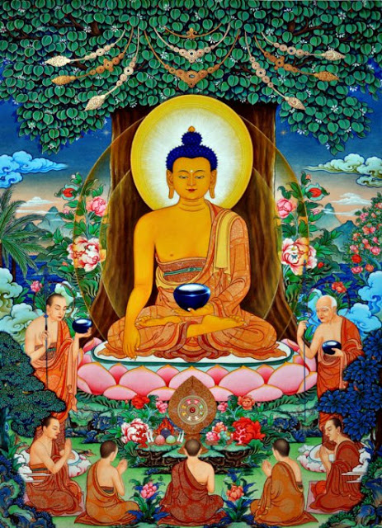

The Mahayana Pantheon celebrates a **Medicine Buddha**. He goes by two names. ***Bhaishajya-raja***: Medicine King; and ***Bhaishajya-guru***: Master of The Healing Arts. “The Blue Buddha” typically holds the stem of a myrobalan plant, packed with vitamin C, as in the picture below. His other hand, resting in the lap, supports a medicine bowl …

**Bhaishajyaraja, The Medicine Buddha**

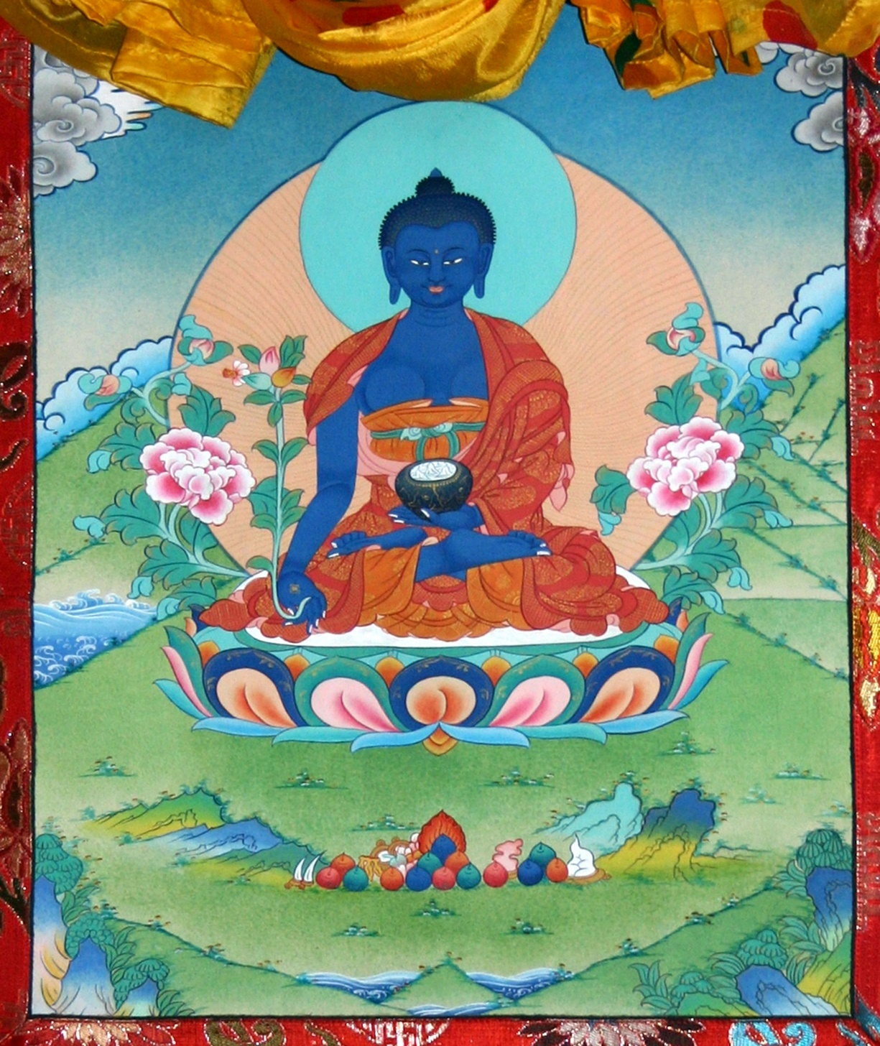

In some representations of **Bhaishajya-raja**,

another myrobalan plant is sprouting from the bowl …

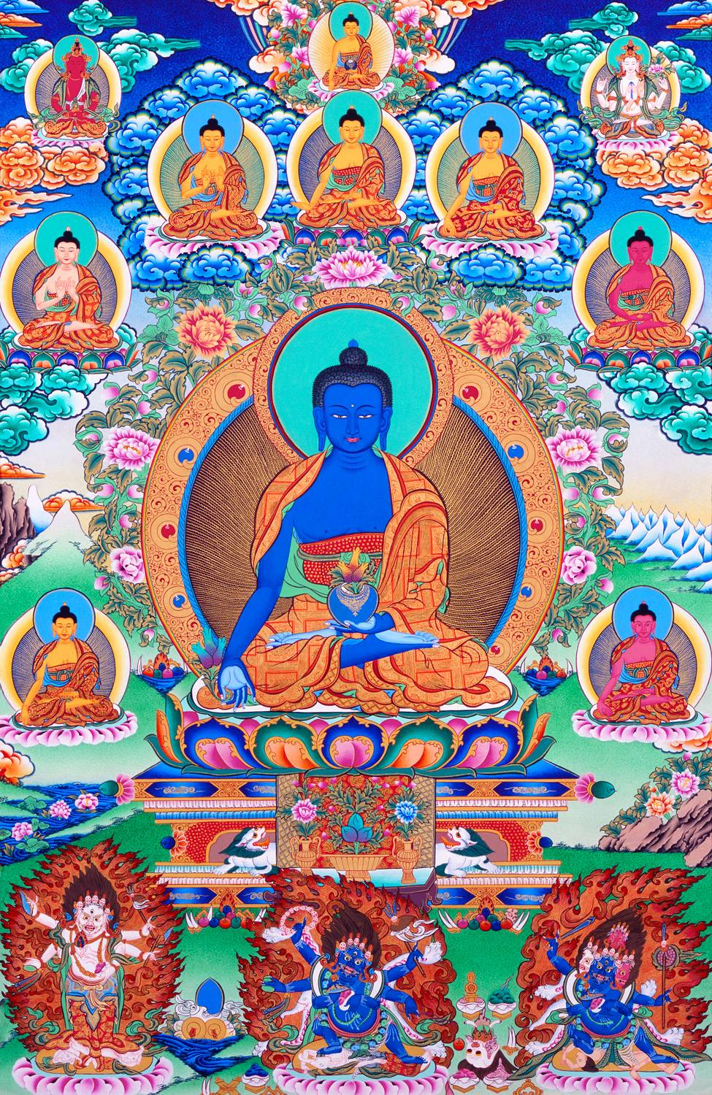

Buddha advised many kings in his 45-year teaching career. He advised universal health care, anticipating Jesus: “Feed the poor; heal the sick.”

The medicinal arts have been the heart of Buddhist practice for two and half millennia. As Buddhism spread across Asia – and, as Siddhartha predicted, into the West – this commitment to holistic healing has endured.

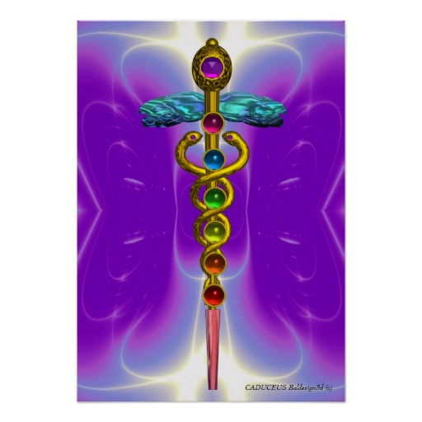 



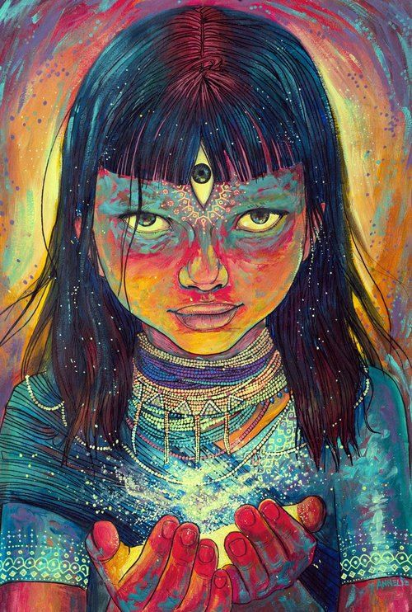

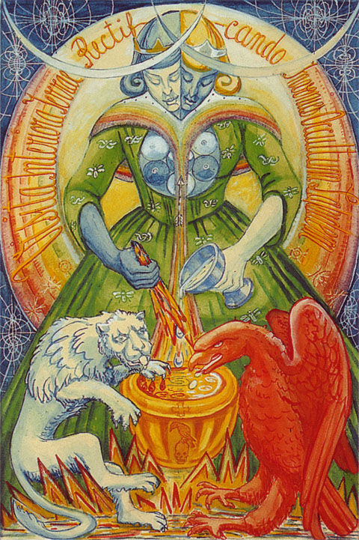

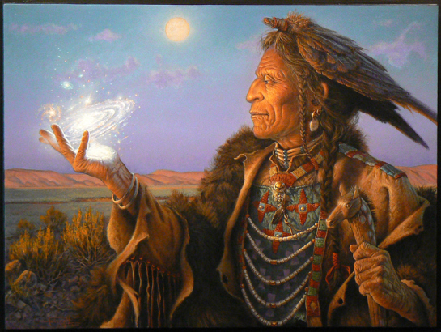

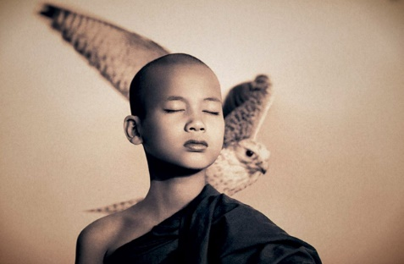

**III LOTUS POWER**

In Buddhist symbolism, the lotus is the flower of wisdom that blossoms from compassion. ***Amitabha*** is celestial **Buddha of The Lotus Family**:

 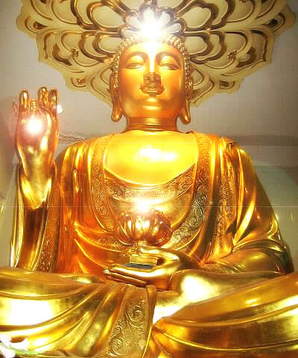 

***Amitabha*** is also called ***Amitayu***s. He is the **Buddha of Infinite Light**. He is most often shown sitting in meditation posture, holding in his lap a bowl which contains the Elixir of Immortality. Amitabha is thus also the **Buddha of Infinite Life**.

As Buddha of The Lotus Family, Amitabha presides over the “Western Paradise” called ***Sukhavati***, where the faithful are reborn in a floating lotus, often with a golden body. This is their final rebirth before attaining nirvana. Sukhavati is a Buddha-field of beauty, adorned with flowers, lakes, rivers, jewel trees, birds, deer, temples, and wondrous fragrances. ***Sarasvati*** is a Hindu-Buddhist goddess of music. Her music carries souls to lotus rebirth in Sukhavati. Her animal Familiars are the swan and the peacock. *Sukha* is a Pali-Sanskrit word meaning ease and bliss, usually translated “happiness” or “joy.” Sarasvati exhibits the musicality and color of Sukhavati. She often has a peacock-feather in her crown …

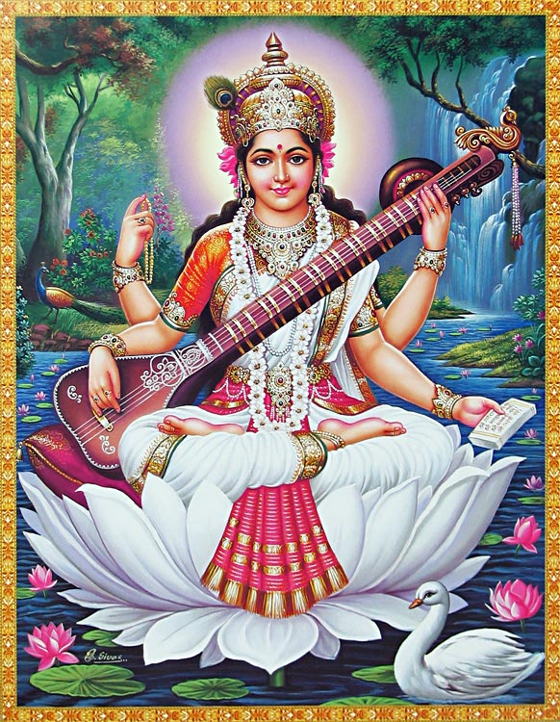

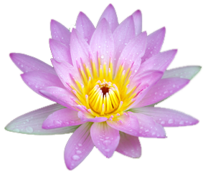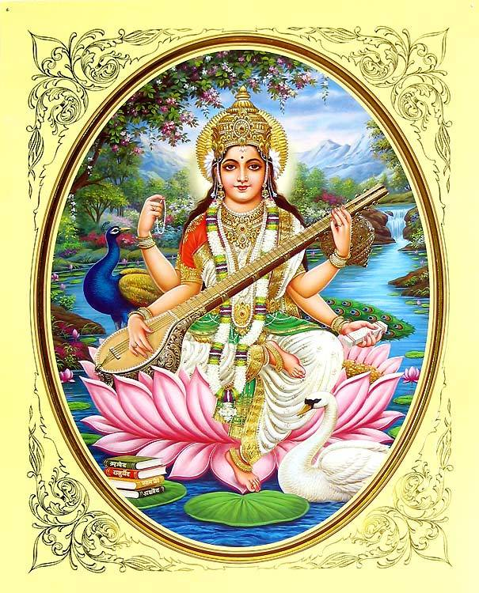

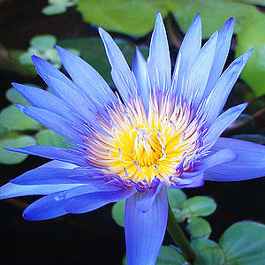 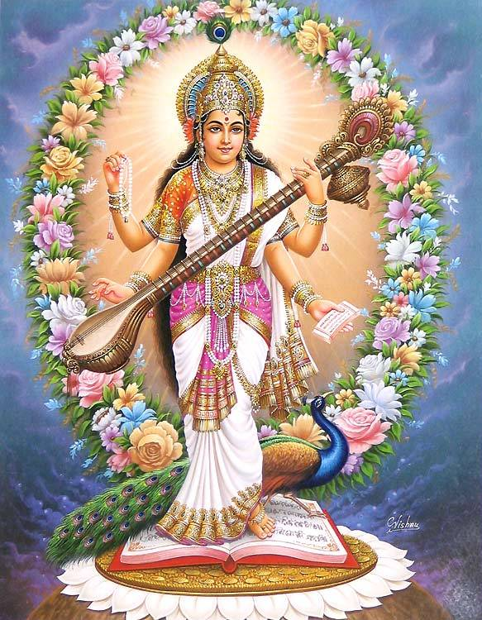

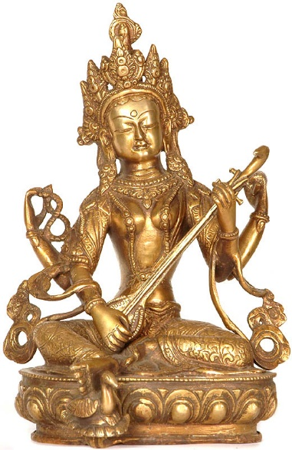

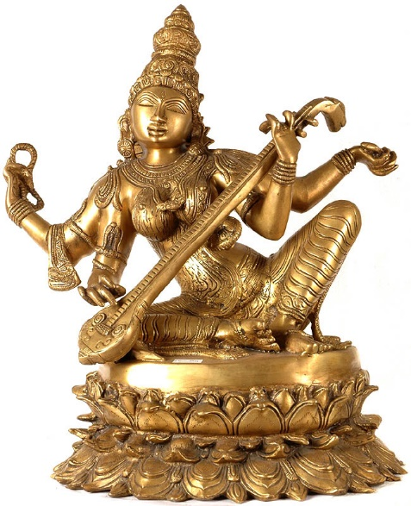

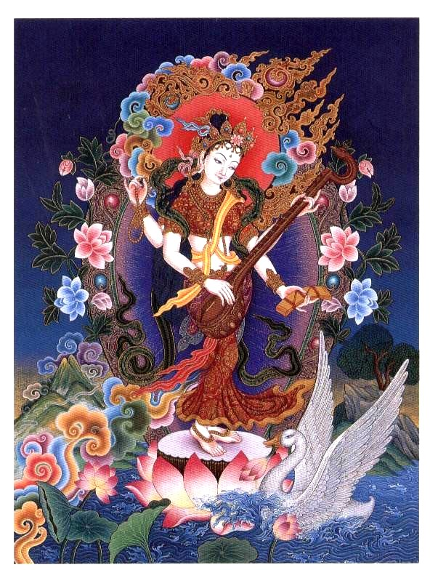

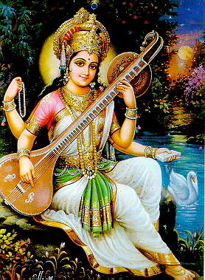 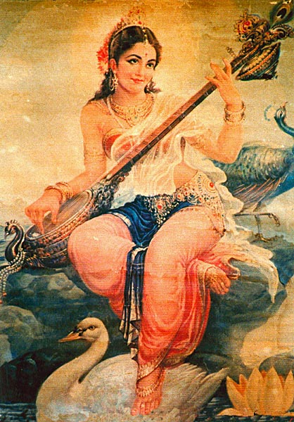

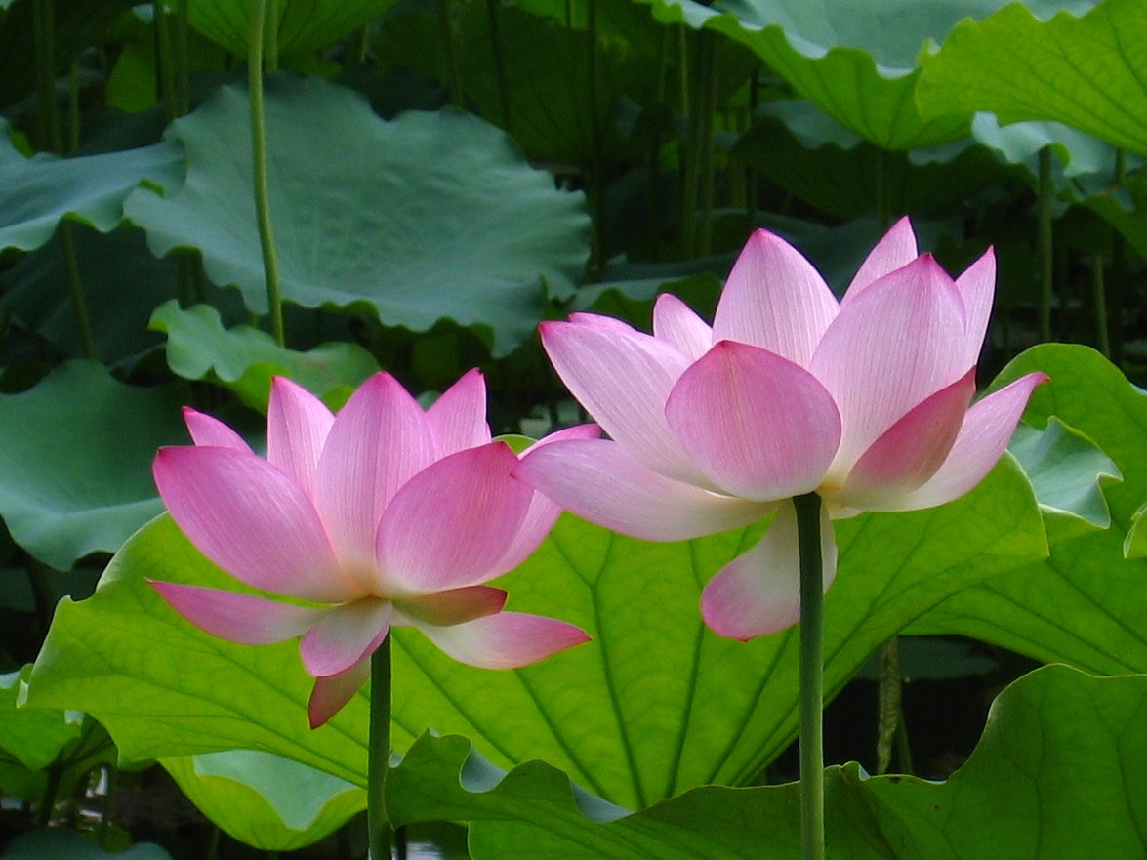

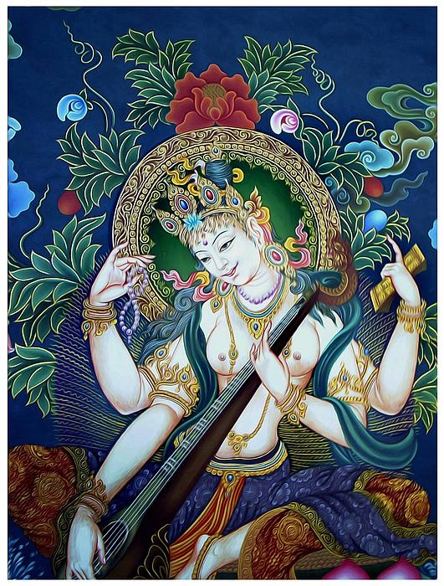

**Amitayus, with a tree of life sprouting from the bowl of immortality:**

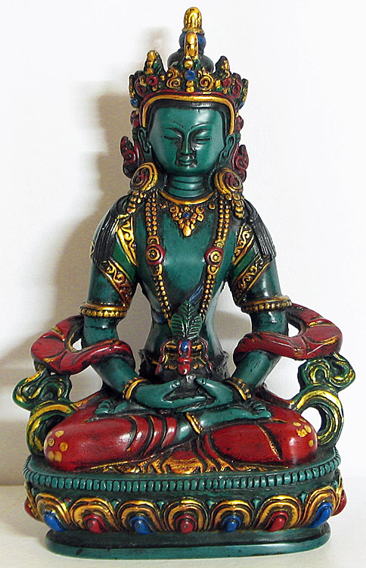

**AMITABHA**

Varada-mudra and Elixir of Immortality

 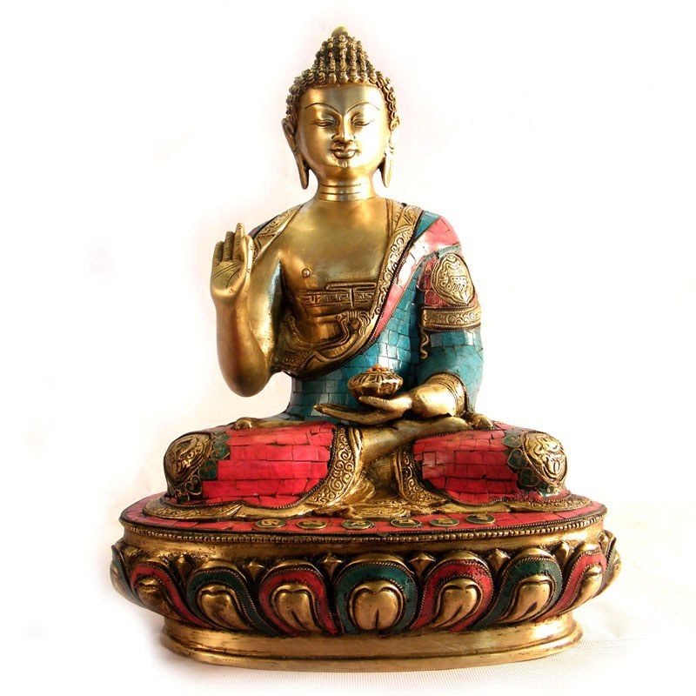 



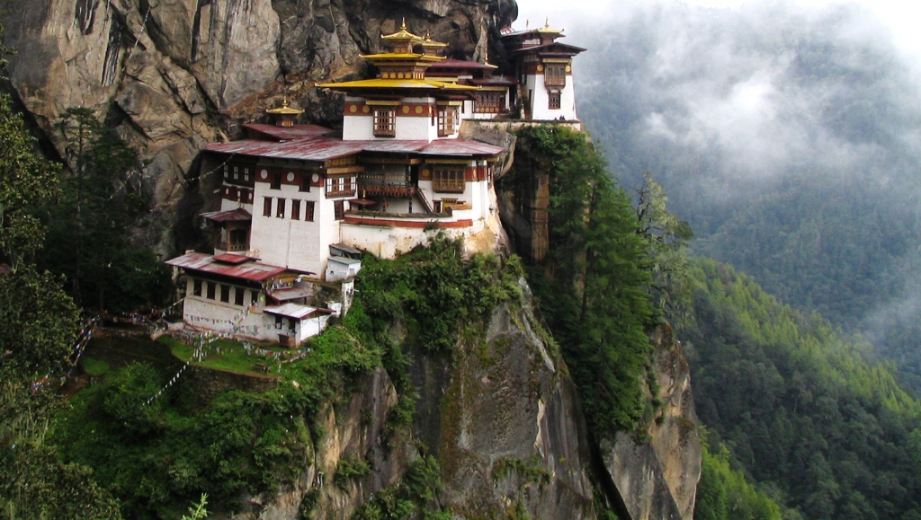

Now, there was a time when, from Amitabha’s right eye, a cosmic light-beam shot forth. From this light-beam stepped a fully evolved, completely enlightened ***Bodhisattva*** named ***Avalokiteshvara***. His Tibetan name is ***Chenrezig***.

 

Avalo-ki-*tesh*-vara is also called ***Lokeshvara*** and ***Padmapani***. Lokeshvara is the archangelic ***Bodhisattva of Compassion***. As emanation from Amitabha, he is essence of lotus. Above: Lokeshvara standing, with a lotus blooming over his left shoulder, and a small icon of Amitabha meditating in his crown.

*Padme* is Sanskrit for lotus and heart.

In Tibetan: *padma.* In Pali: *paduma*.

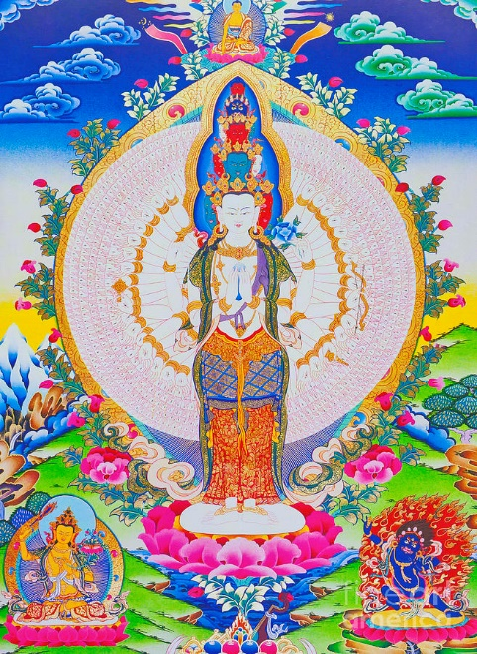

***Padmapani*** means Lotus Power and Lotus Holder.

***Lokeshvara*** is *Padma-pani*: Holder of the Lotus, and incarnation of the Power of Compassion.

The heart-chakra’s color is sparkling blue. Lokeshvara holds a *lapis lazuli* (blue emerald) in palm-hands at his heart. Heart is *padme*. *Padme* is lotus.

Here’s Lokeshvara as ***Vajrasattva*** in kundalini mode …

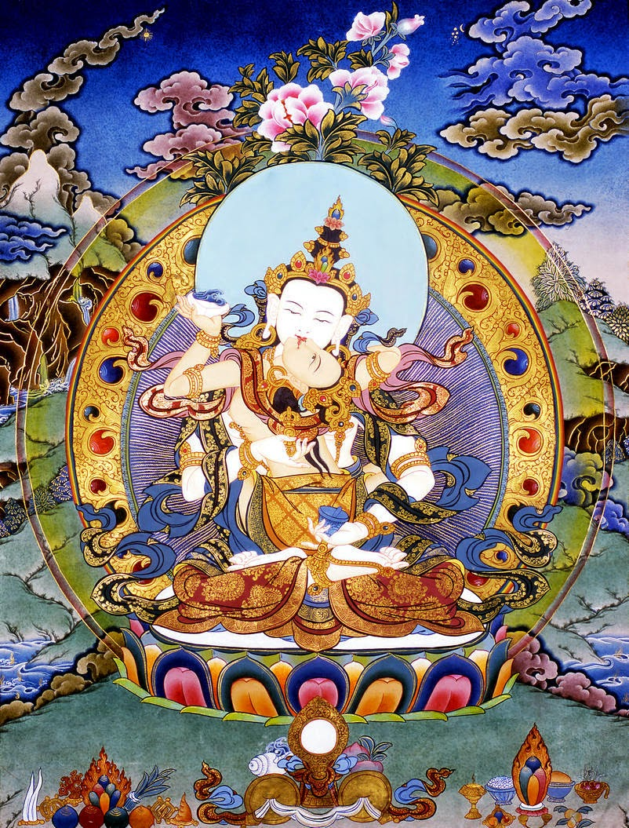

Lokeshvara, surveying the galaxies while standing on Amitabha’s light-beam, settled his gaze on earth. He saw misery pervasive on our blue floating orb. He heard countless cries of distress. The impact broke his heart. His eyes moistened with tears.

**Green Tara. Also called Jade Tara.**

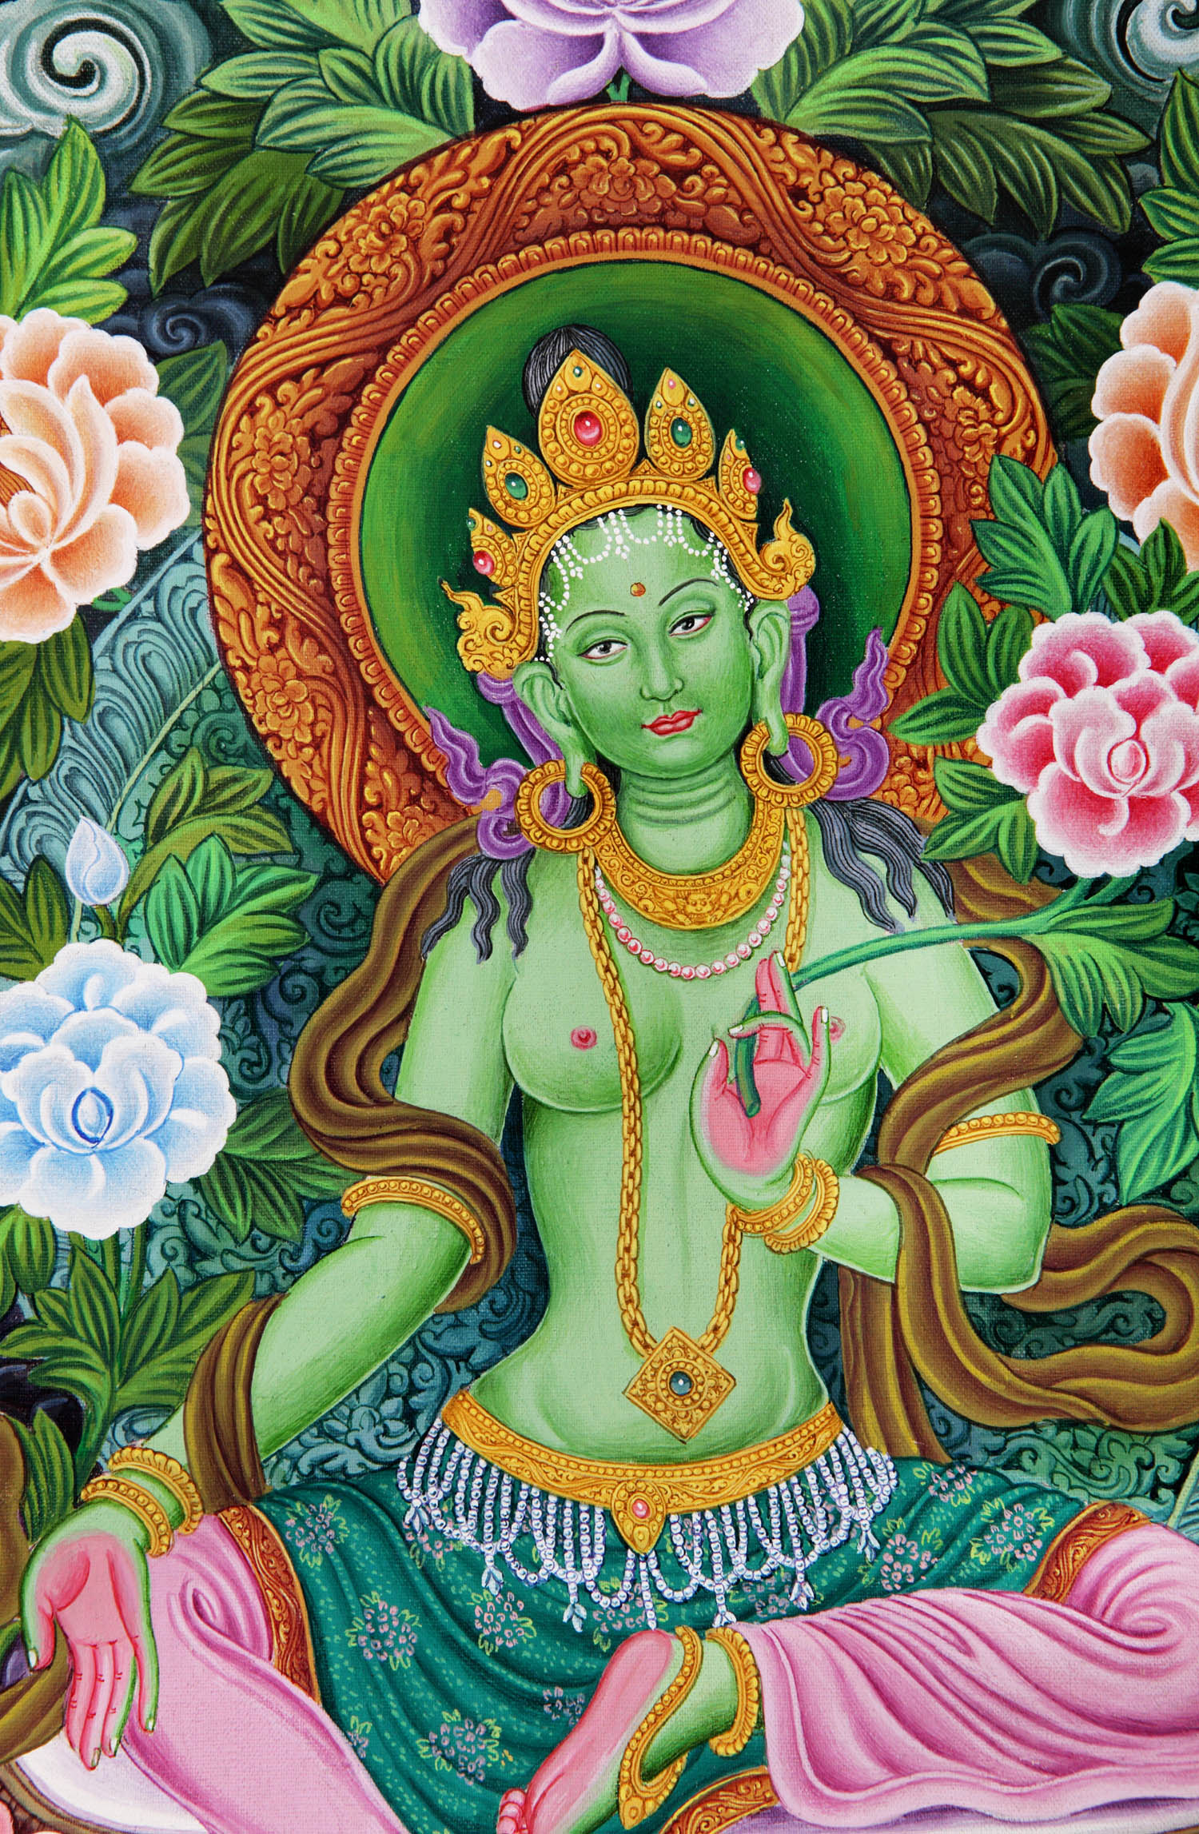

Two tears fell through space, landing in Tibet and becoming a lotus, upon which rode a female incarnation of compassion. One was Green Tara: young and playful. The other was White Tara: motherly and serene. Above: Tripartite necklace: same multiplicity of meanings as applied to the Trident scepter.

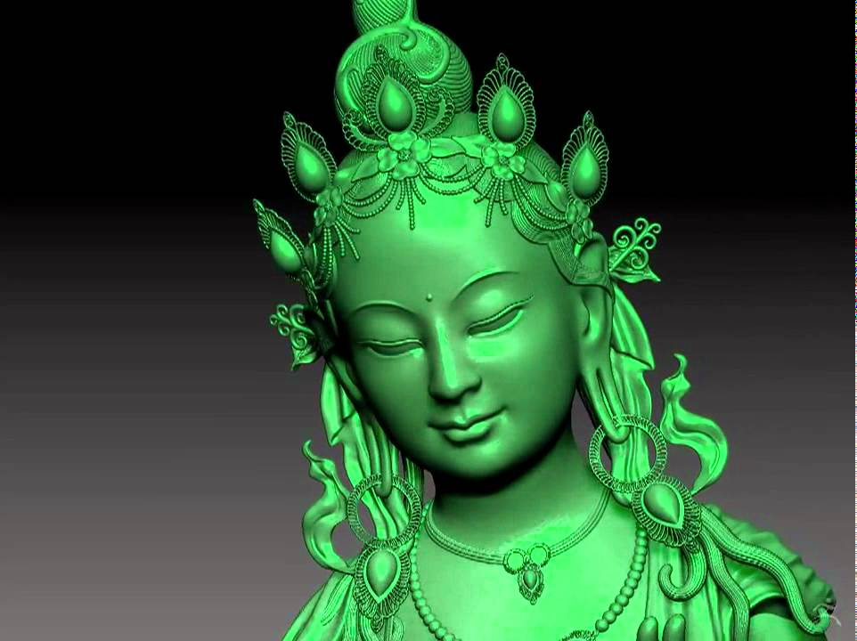

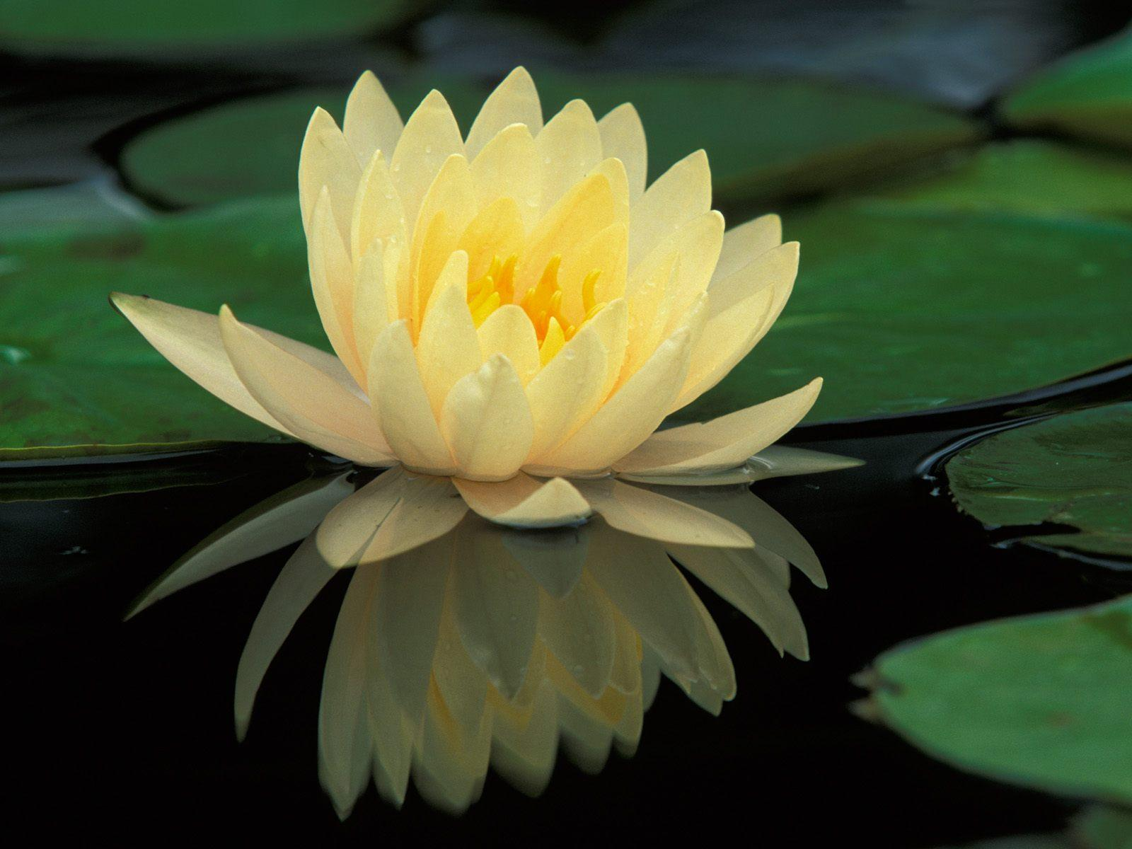

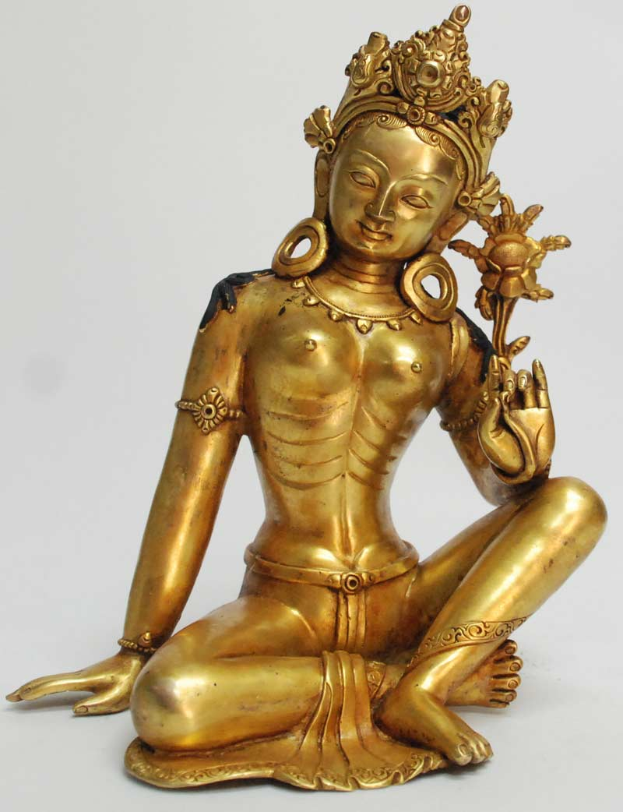



Tara’s ambience is water sparkling in moonlight. She is the patron goddess of voyagers. As female incarnation of Lokeshvara, she is healing and compassion; never bereft of musicality and cheerful countenance – except when fierce. She is supremely wise, and a virtuoso of “skillful means” (*upaya*). In response to prayers for safety, healing, and guidance, she often arrives in a moonbeam, seated on a lotus.

She is honored as “Mother of all the Buddhas.” Here’s White Tara fused with Gold, occasionally shown with blue lotus in bud or bloom:

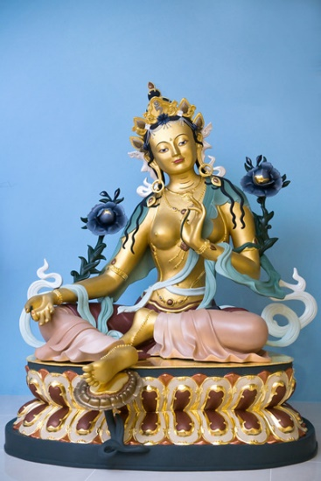 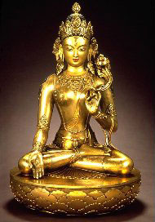

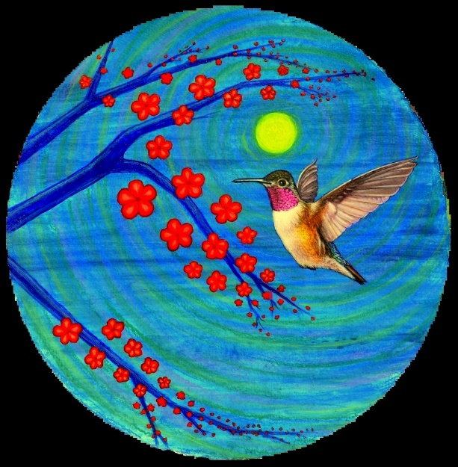

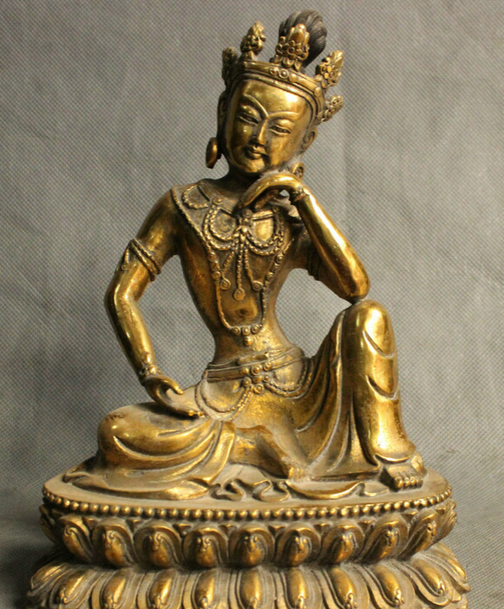

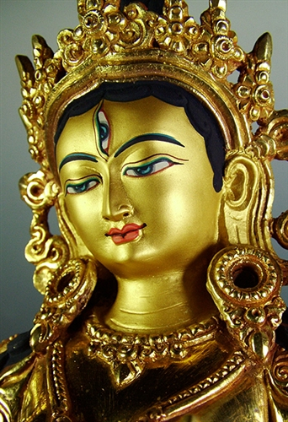

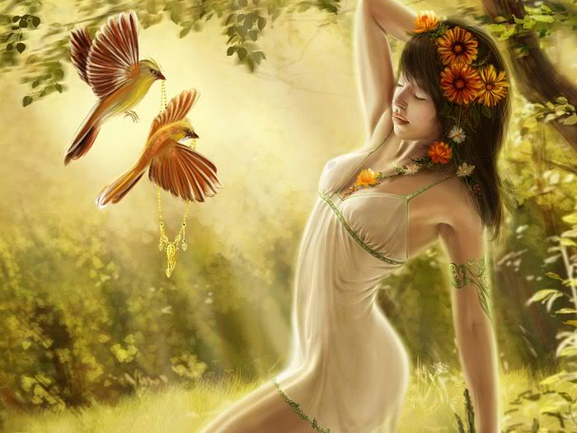

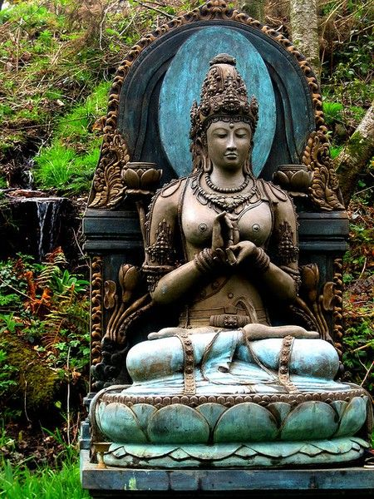

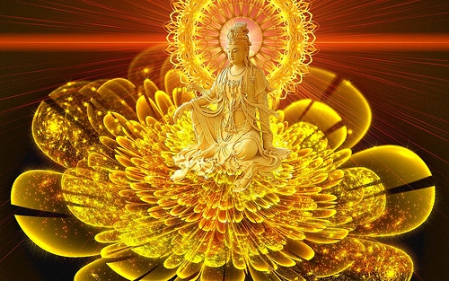

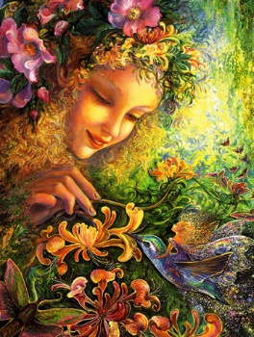

As Buddhism traveled east, Tara became known in China as Kwan Yin, and in Japan as Kannon. In Japanese, she is also *Kanjizai* and *Kanzeon*

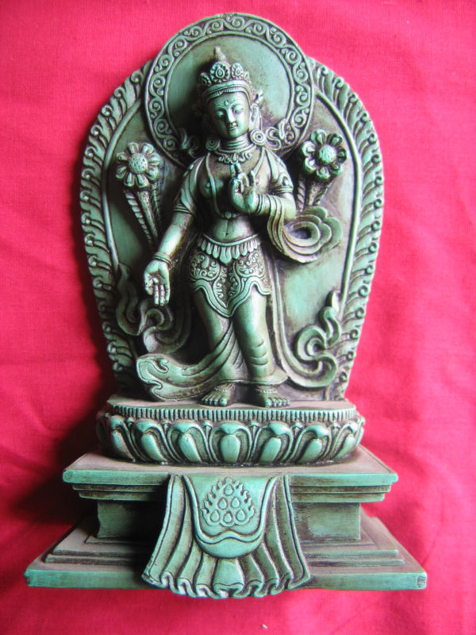

*Tara* means “One Who Saves.”

She rides a lotus, a dragon, a fish, a turtle, or a tiger.

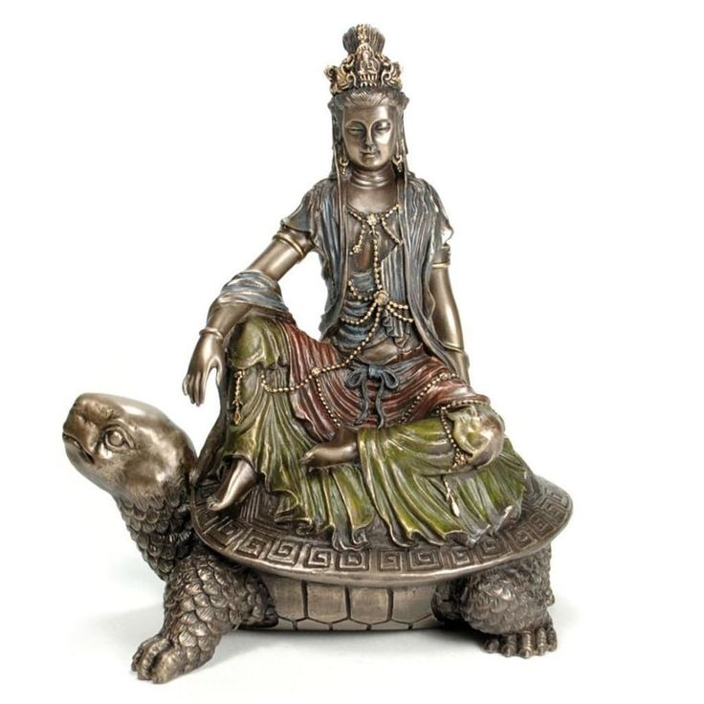

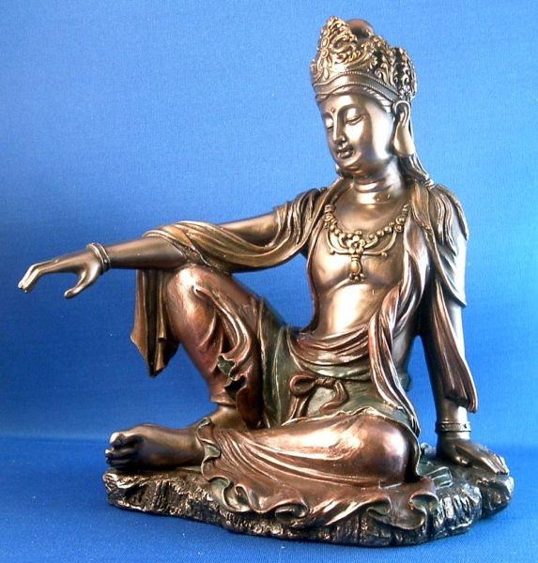

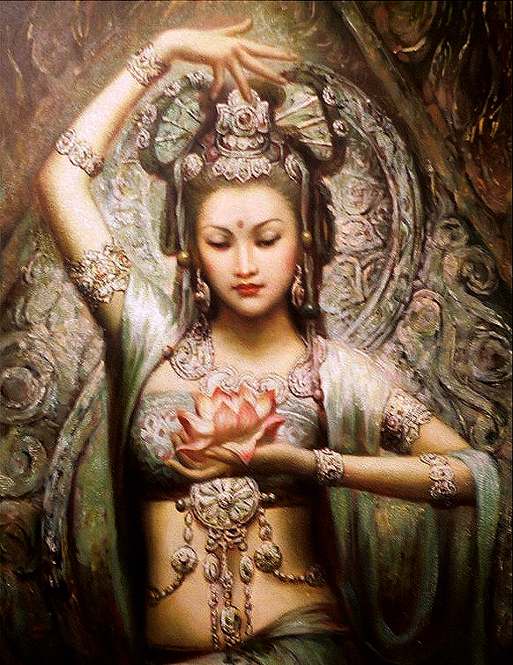

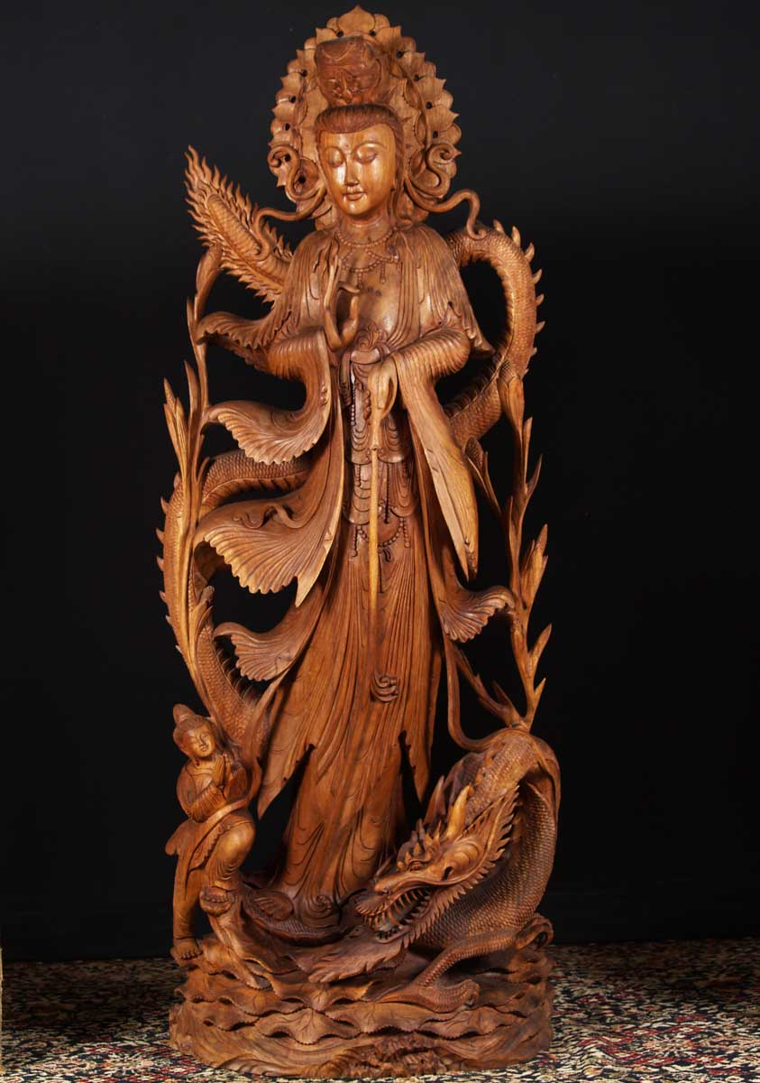

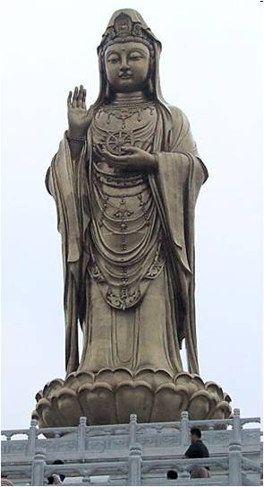

Alchemical Oven

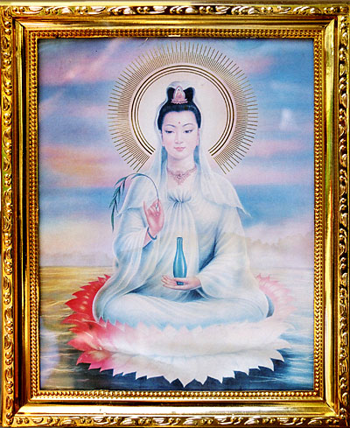

Kwan Yin as Eleusinian Earth Goddess, Demeter, mother of Persephone

**White Tara and Green Tara**

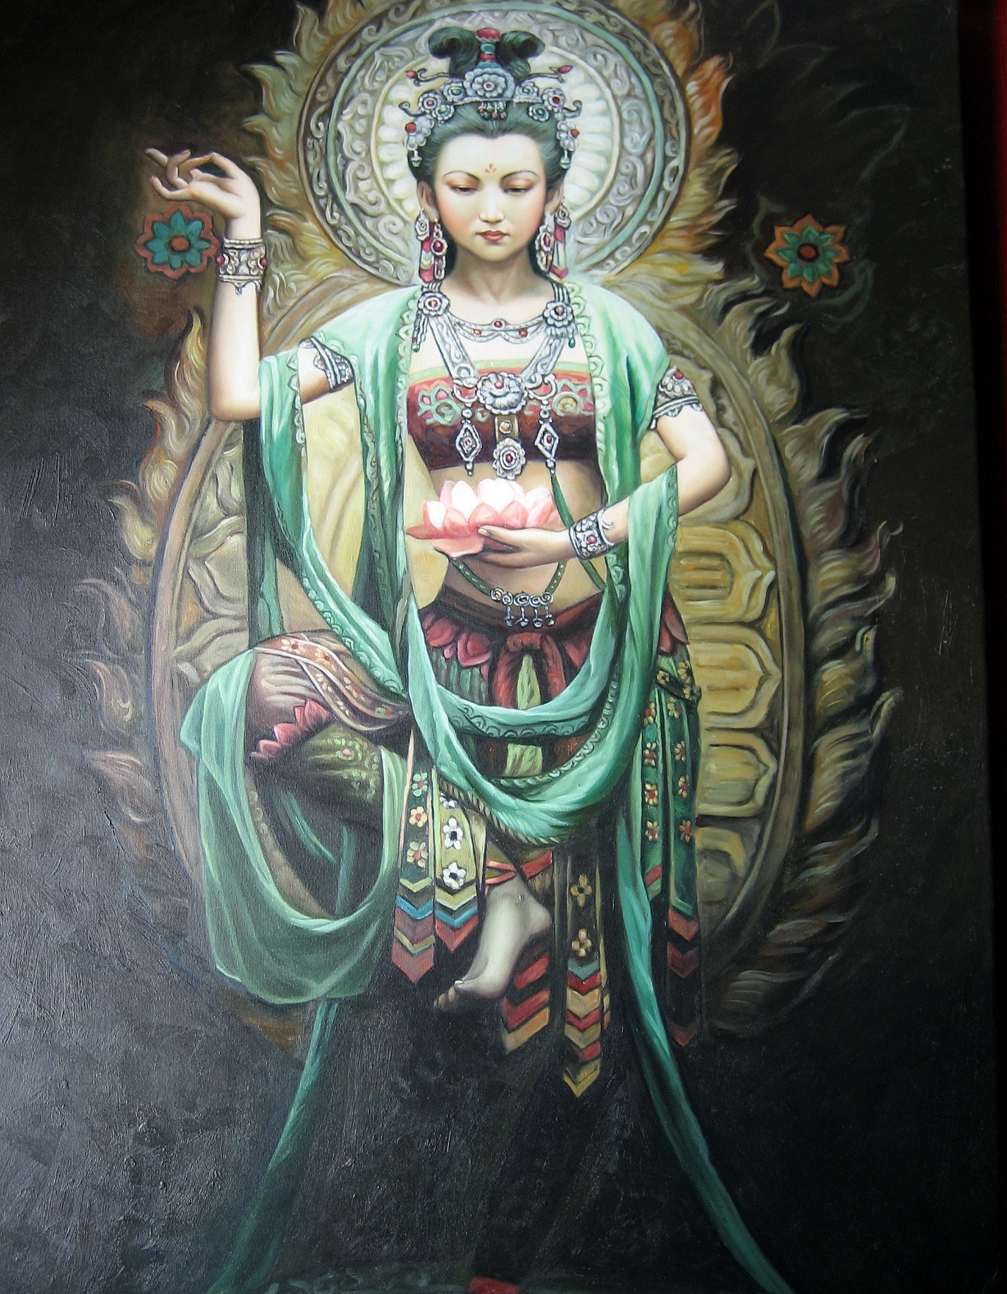

Kannon

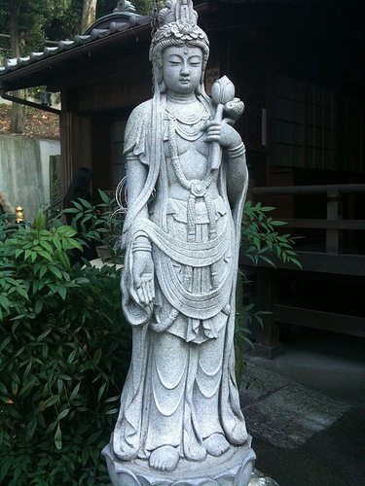

Gold Tara

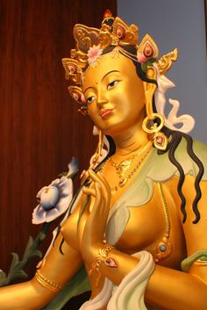

**IV TOUGH LOVE**

As befits a master of *upaya* – “skillful means” – Tara can be fierce when necessary.

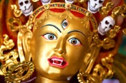

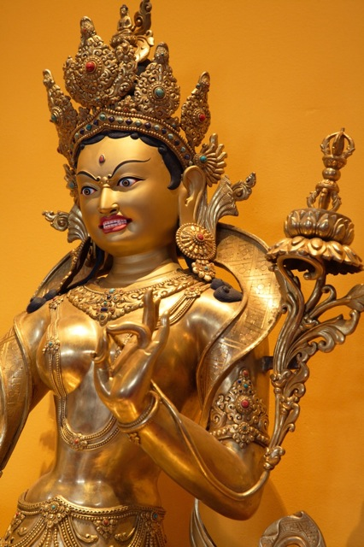

Only by being pushed to our limits do we go beyond our limits. Ferocious compassion can blow your mind. Red Tara Kurukula eats brains from a skull cup, then drinks the blood. Dismemberment is chrysalis-crucible of metamorphosis.

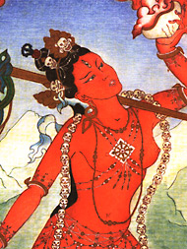 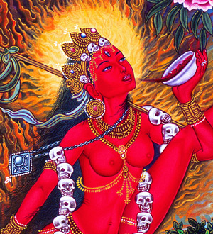

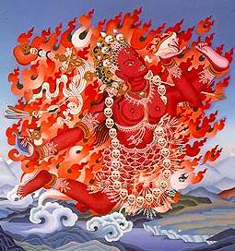

***Red Tara / Kurukula / Vajra-yogini*** – her names are many, but her title is the same: Protector of The Dharma. She serves not only to crush the egotism of the *chela* – the disciple upon whom she dances – but also to protect the chela from malignant forces. In her right hand she holds a flailing knife called vajra chopper.

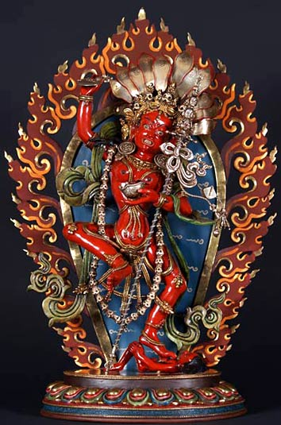

If she is frightening to the chela, she is even more frightening to those who obstruct the Dharma Path to freedom. *Kurukula* is sister-equivalent to *Vajra-yogini*. She is often shown, as above, with a vajra-tipped *katvanga* scepter; and, of course, she wears a necklace of skulls. Death is our wisest advisor. It cuts through all the crap. Below: *Vajra-yogini*, and *dakinis* …

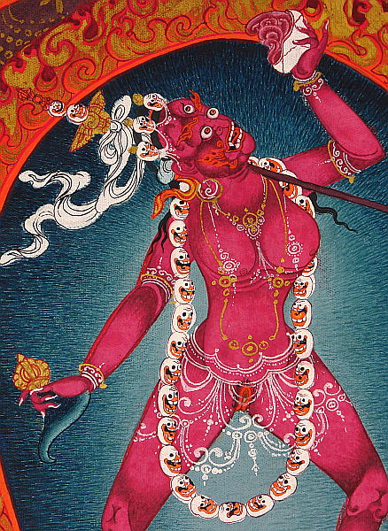

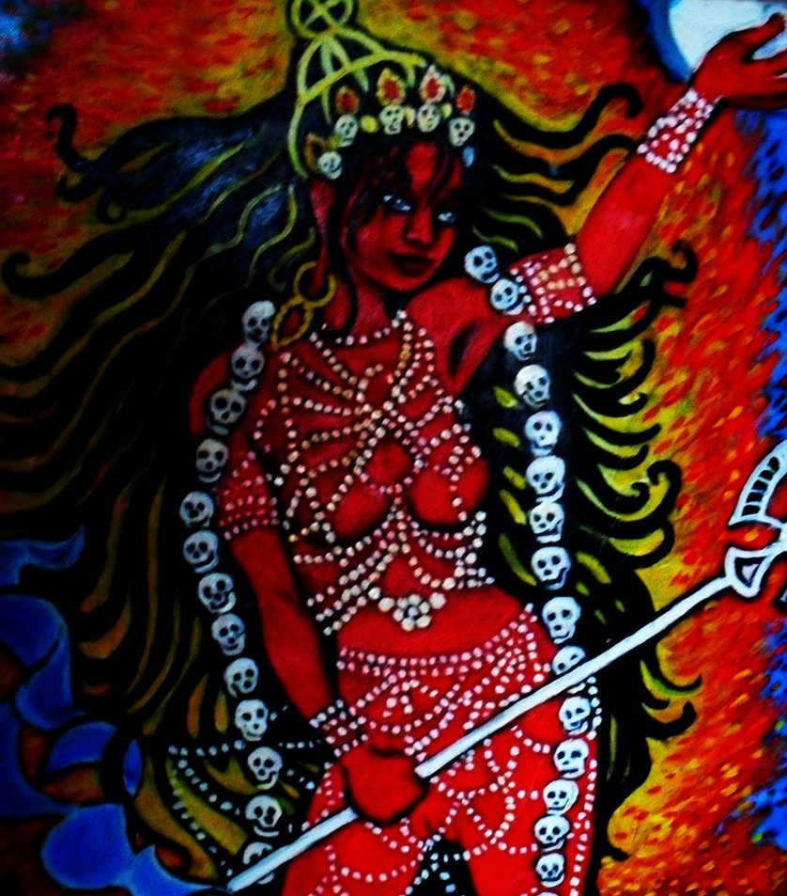

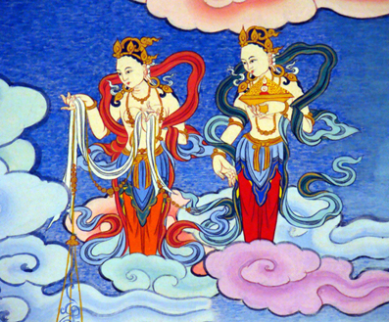

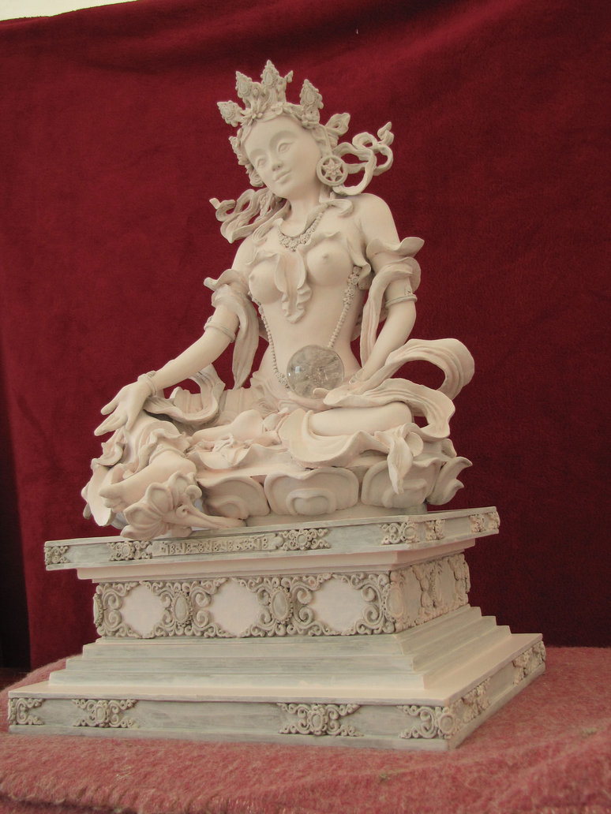

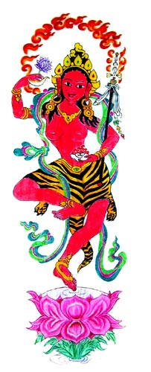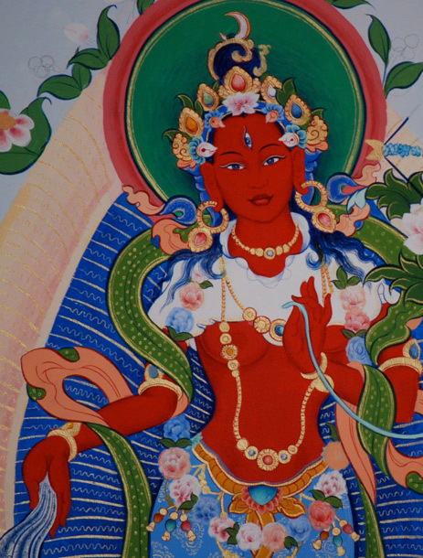 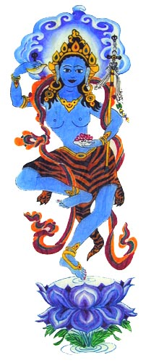

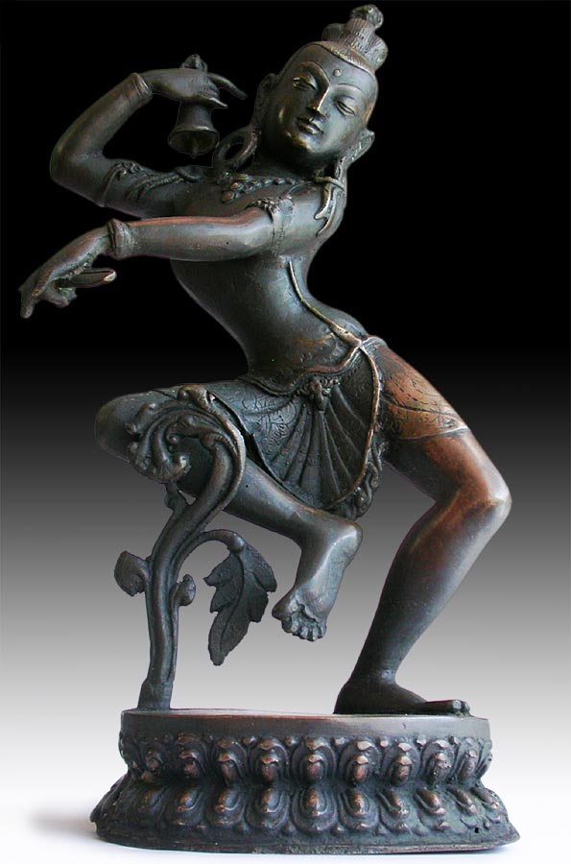 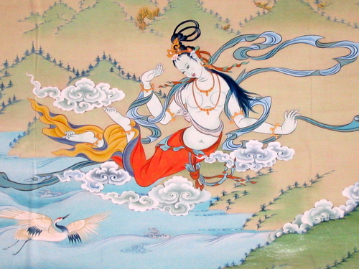 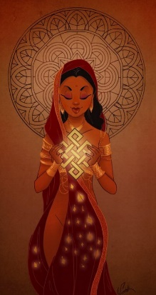

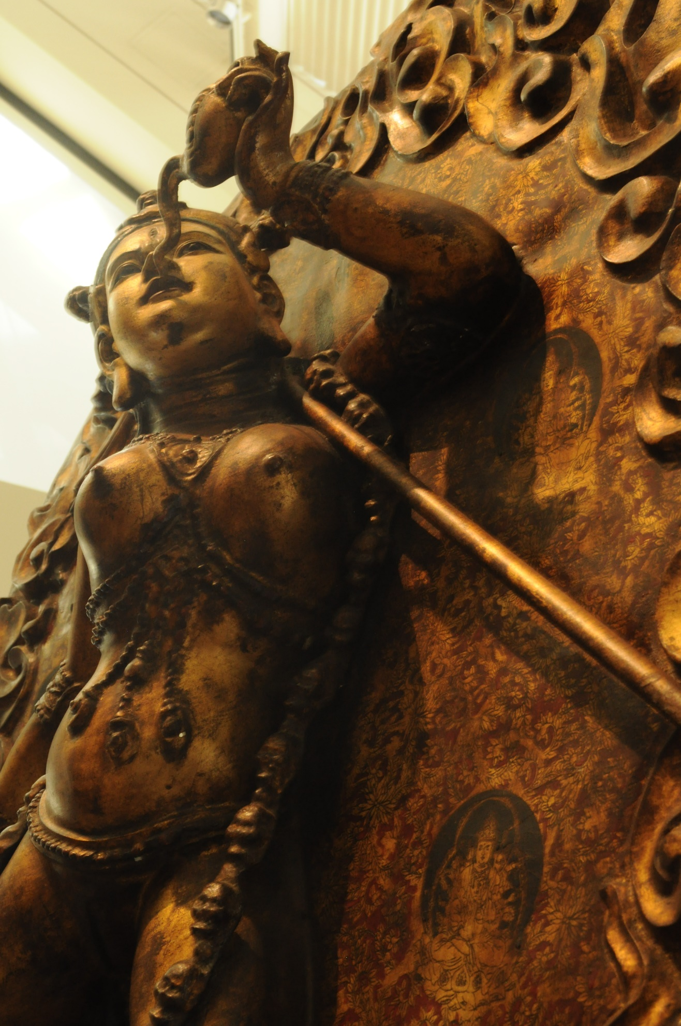

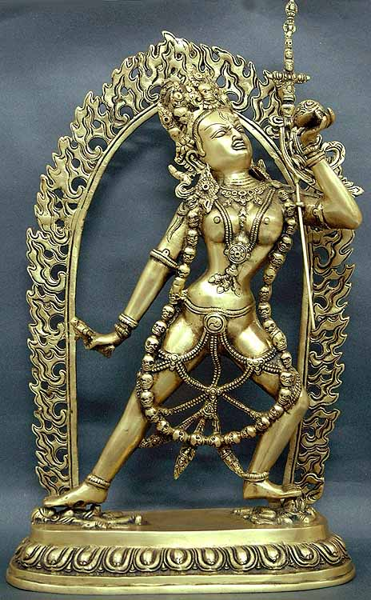

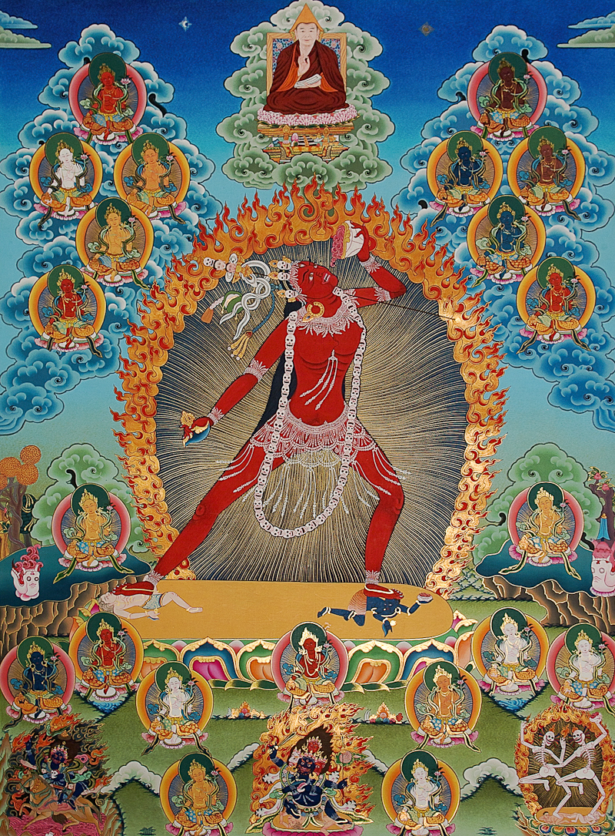

The male counterpart to Vajra-yogini and Kurukula is *Mahakala*, the fierce version of Vajrapani. Note the tiger skin. In India, tiger is Lord of the Jungle.

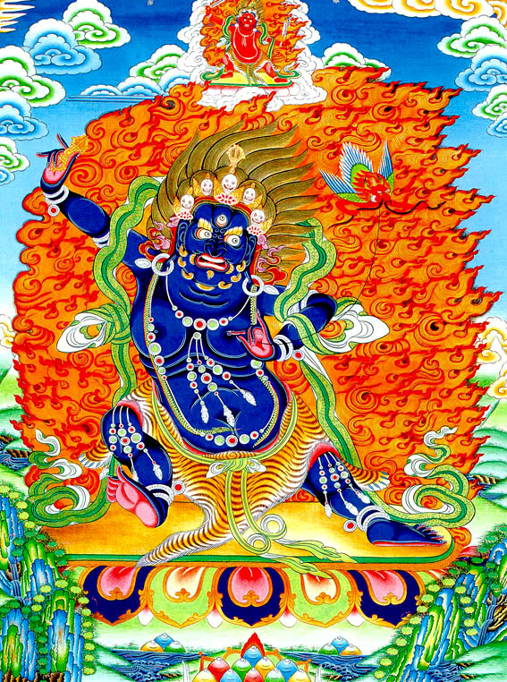

Below: Mahakala is draped in a white elephant skin. This is “the elephant of ego,” or, more precisely, of egotism – what Norman Mailer calls “the elephantiastical hubris” of delusions of grandeur. Note the body beneath the feet.

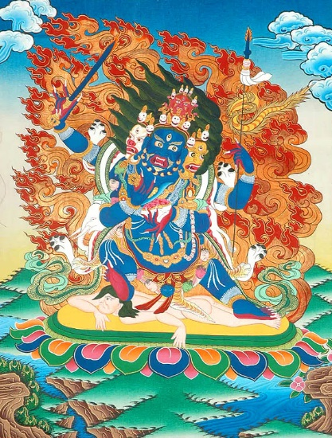

Mahakala Kurukula Kundalini

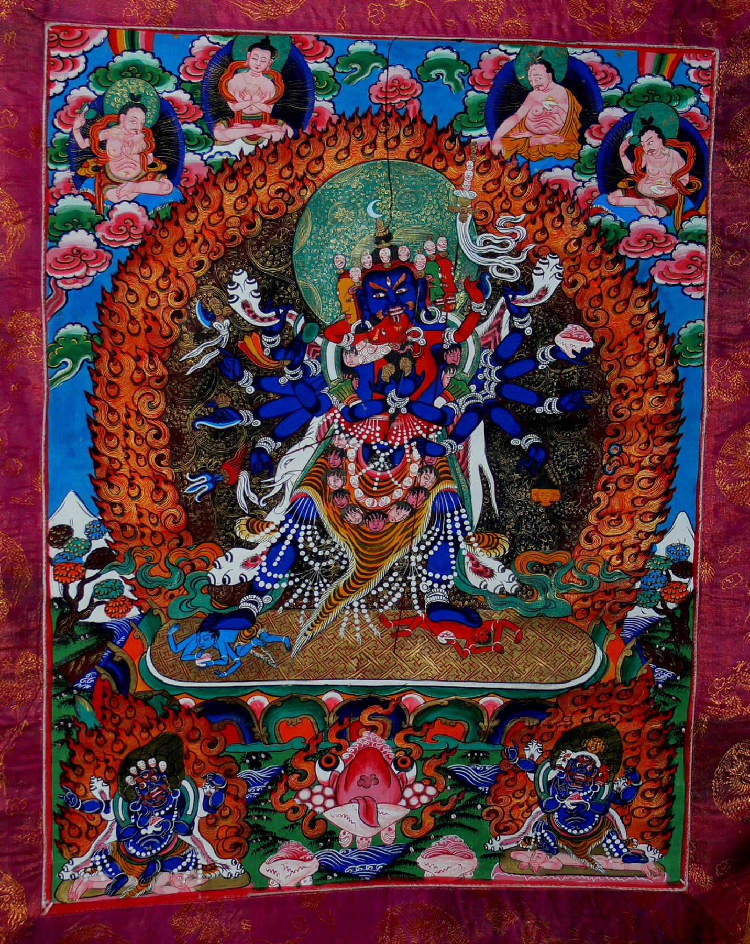

***PARAMA–SUKA CHAKRA-SAMVARA* – Supreme Bliss of Charka Synthesis**

**V KUNDALINI**

Kundalini communion in Buddhist iconography signifies the electrifying synthesis of yin-yang energies in the aspirant on the path of knowledge. C. G. Jung calls this the reconciling union of “anima and animus” in the alchemy of “individuation.”

 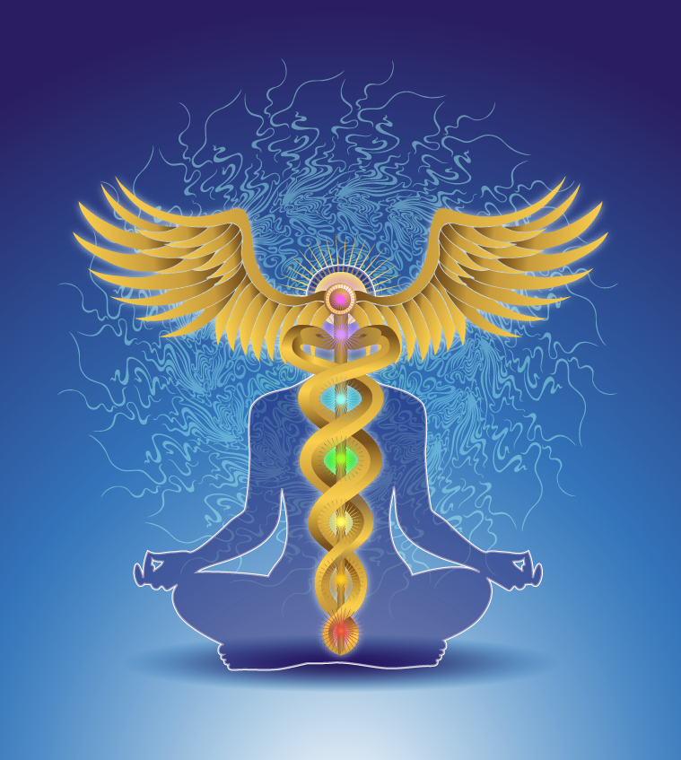

In Indian and Tibetan tantra, kundalini energy rises from the fire-serpent coiled in the muladhara chakra at the base of the spine.

The dragon energy uncoils, ascending through genital, emotional, heart, throat and third-eye chakras, climaxing in the fire-blossoming of the crown chakra at the top of the head.

In rarified ritual, sexual intercourse may occur, as a way of catalyzing kundalini communion; but physical orgasm is failure and profanation.

The transformation of erotic libido into rainbow-body is key to the meaning of caduceus (shown above).

Below: Alchemy of lotus power …

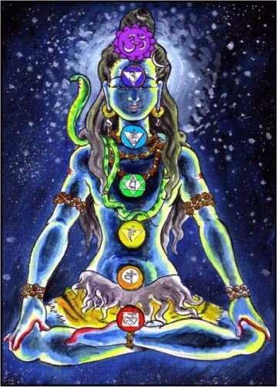



***Shiva-Shakti***



***Parama-sukha Chakra-samvara***

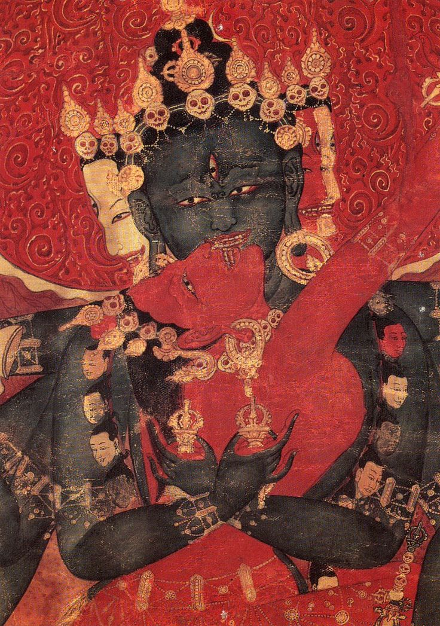

***Parama-sukha*** is “great bliss.”

***Chakra-samvara*** is “optimal functioning” of the chakras.

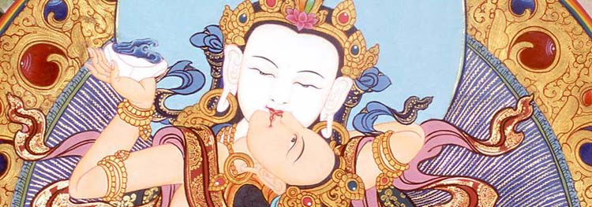

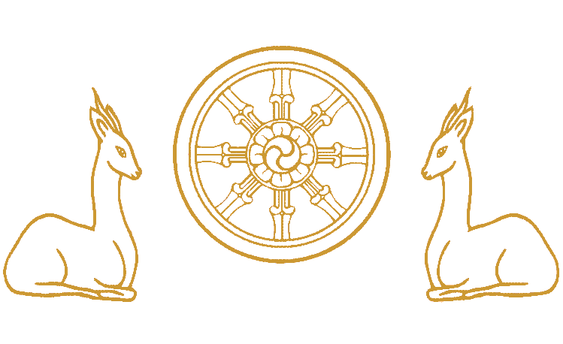

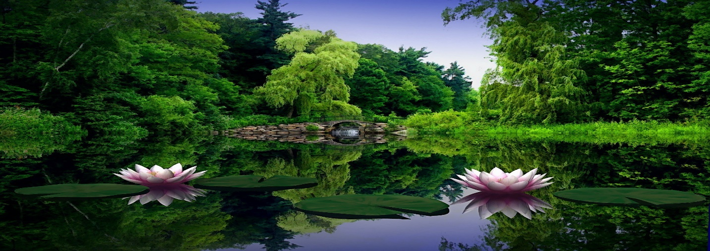

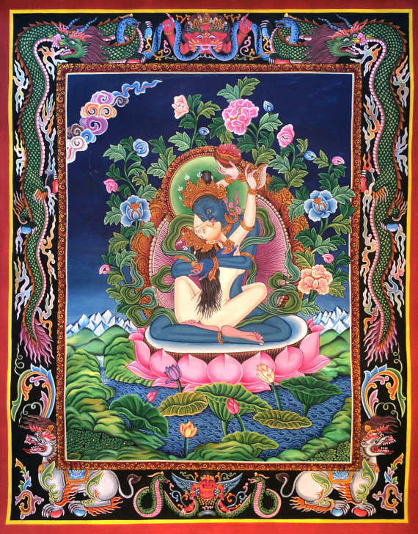

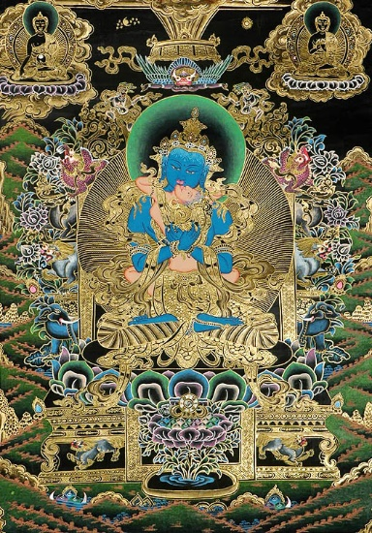

**VI COMPASSION**

Let’s revisit ***Manjushri***. He’s a fiery force in the lotus family.

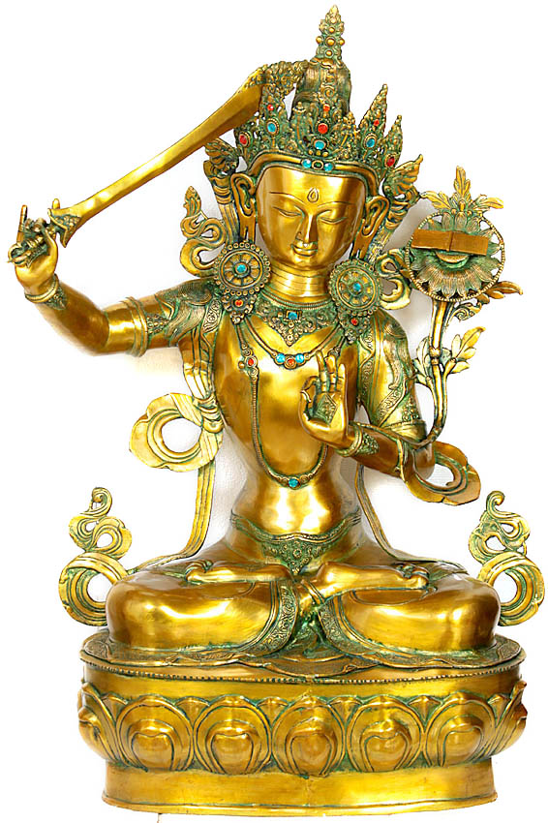

***Manjushri*** is **Bodhisattva of Wisdom**. He’s **Soul-Brother** to **Lokeshvara, Bodhisattva of Compassion**. Manjushri often rides a snowlion. He carries a Flaming Sword called ***Chanda Hasa*, “Dreadful Laugh.”** The sword angles upward in his right hand. Chanda Hasa cuts through illusion and illumines. Manjushri’s left hand forms varada mudra, holding the stem of a lotus. Upon the lotus in full bloom is Mahayana Buddhism’s most sacred scripture, the ***Maha-prajna-paramita*: Bliss-Wisdom of Virtue-Perfection**.

**Manjushri**

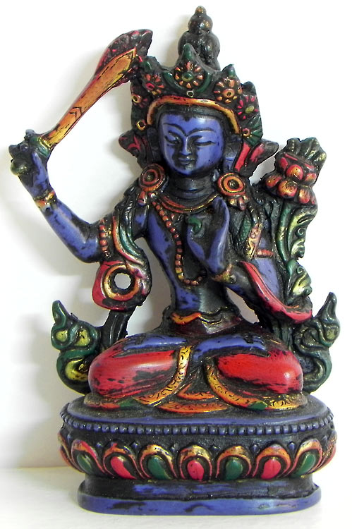

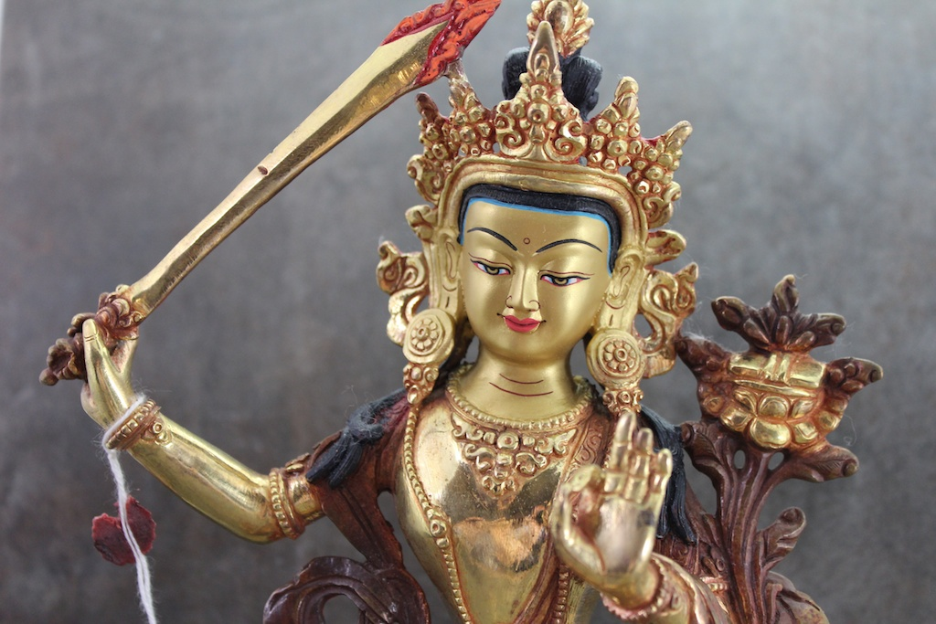



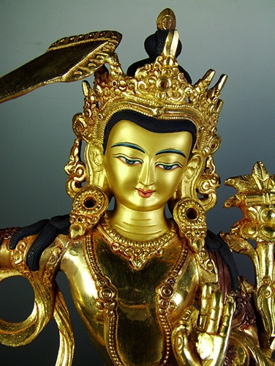

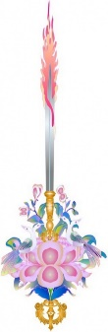  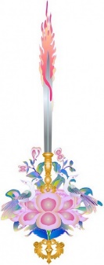

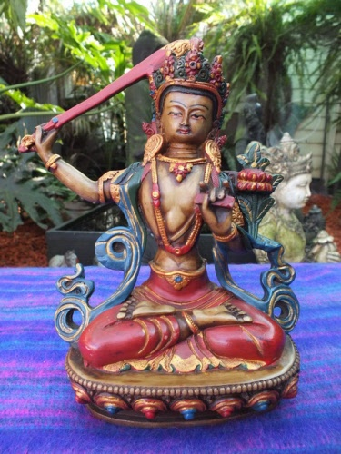

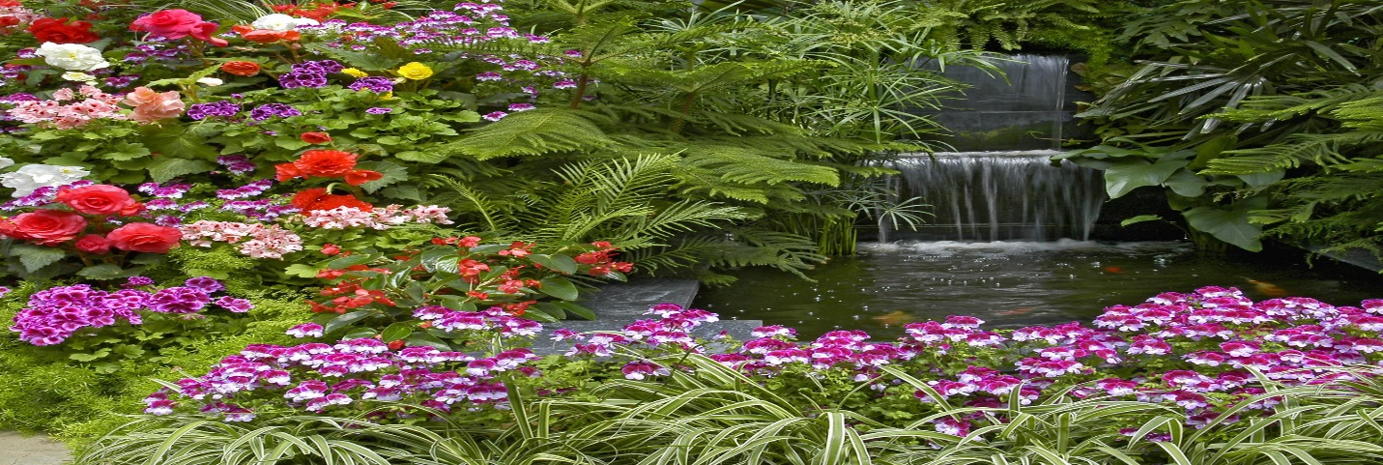

In Buddhist legend, Siddhartha Gautama felt compassion for the Chinese, because he had decided to incarnate in India rather than China. So he made a special gesture, portrayed in a poem I wrote (below). Gautama knew full well that Buddhism would travel across Asia.

**BUTTERFLY OF ENLIGHTENMENT**

 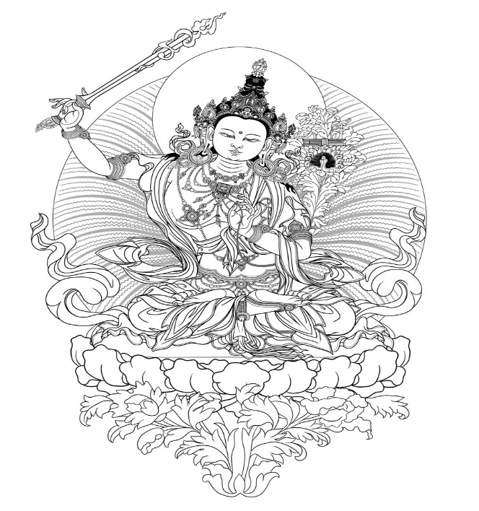 

From Buddha’s third eye streaked

a beam of light toward China penetrating

one of the five mountains rising

from the valley of Wu Tai Shan.

On cliff-face sprang

Manjushri;

wisdom bodhisattva’s

sword Chanda Hasa –

Dreadful Laugh –

cracking

the chrysalis.

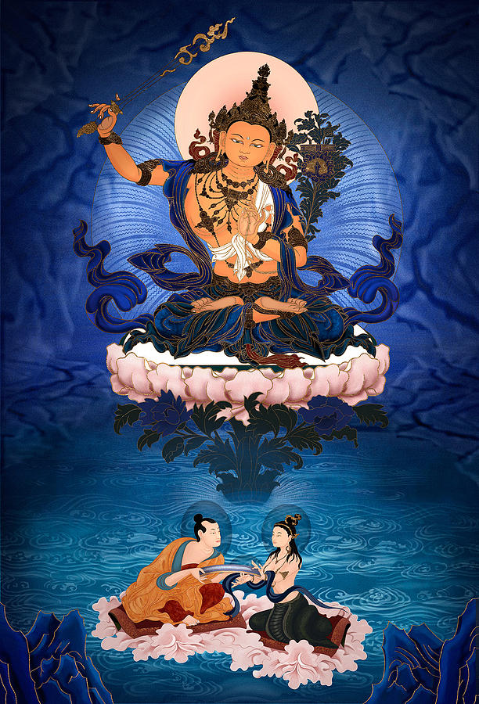

**In blue lagoon, a Naga-Mermaid Serpent-Queen passes a “treasure text” to Nagarjuna. Manjushri blesses the moment, having long ago set it in motion. His left hand vitarka-mudra holds the stem of a lotus that bends and buds toward the moon. Manjushri is, in a way: A Lotus-Riding Sword-&-Sutra Lokeshvara-Tara. Archetype of The Perfect Knight.**

Manjushri’s flashing *Chanda Hasa* – lightning-bolt source of *vajra* – is the *Sword of Wisdom*. Wisdom blooms from compassion because *prajna* and *karuna* are two names for the same. To be wise is to be loving; to be loving is to be wise.

**The Tao of Wisdom and Compassion.**

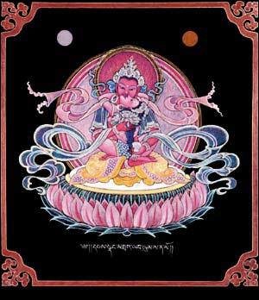

Now, it sometimes happens that Gautama Buddha appears between Manjushri and Lokeshvara, where wisdom and compassion meet. But why, you might ask, does Lokeshvara have eleven heads? The ten additional heads represent stages of a Bodhisattva on the way to Buddhahood. Ten steps on the ladder to enlightenment; sinking deeper into silence … portal to the cellular symphony.

A bodhisattva embodies ***bodhichitta***: the loving, generous, cheerful and awake mind of compassion. The measure of enlightenment is service. The reward for service is increased opportunity to serve.

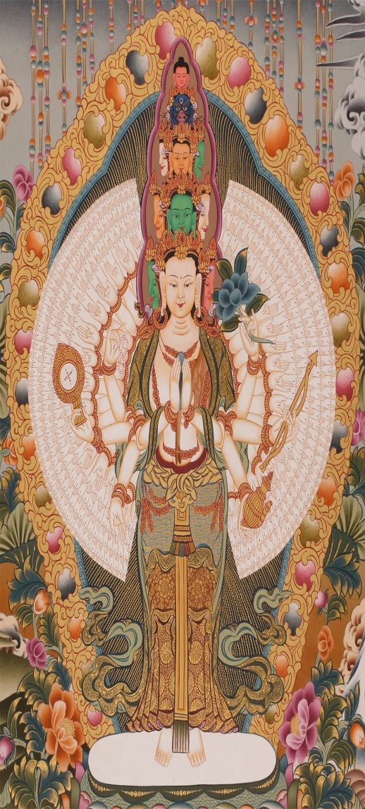

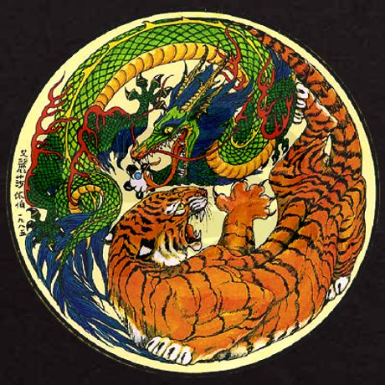

**Buddha’s Reply**



***We are nirvana in samsara***

***because samsara is in nirvana.***

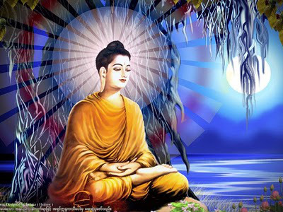

Asked if he was a god, Buddha said no.

Asked if he was merely human, Buddha said no.

Asked what he was, Buddha replied: “Awake.”

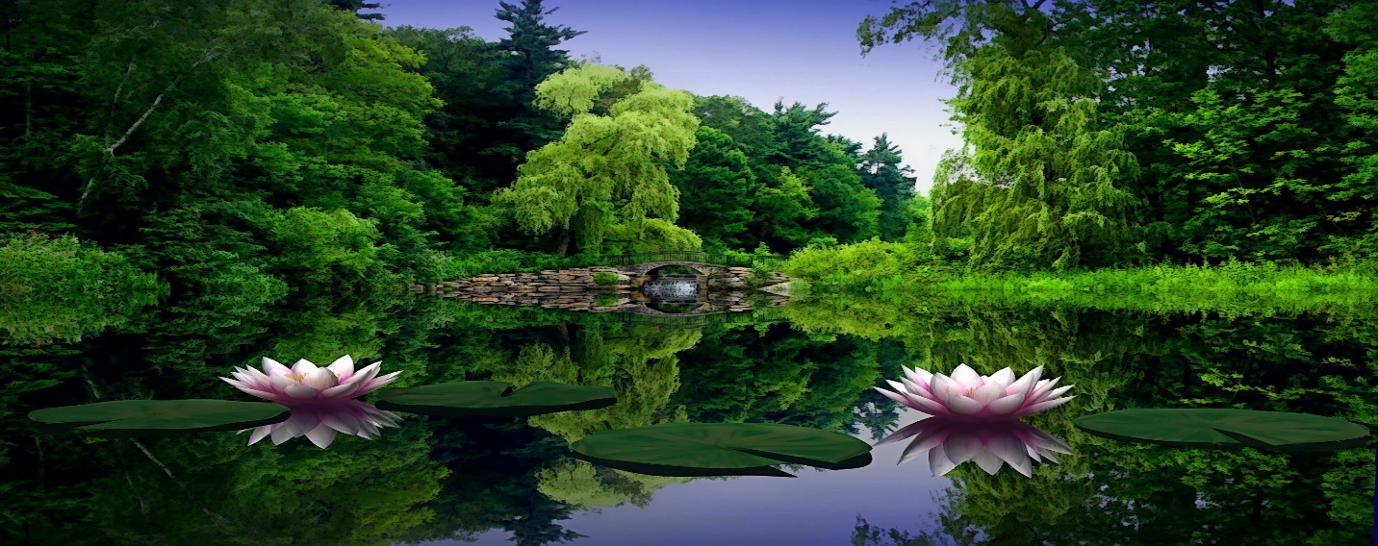

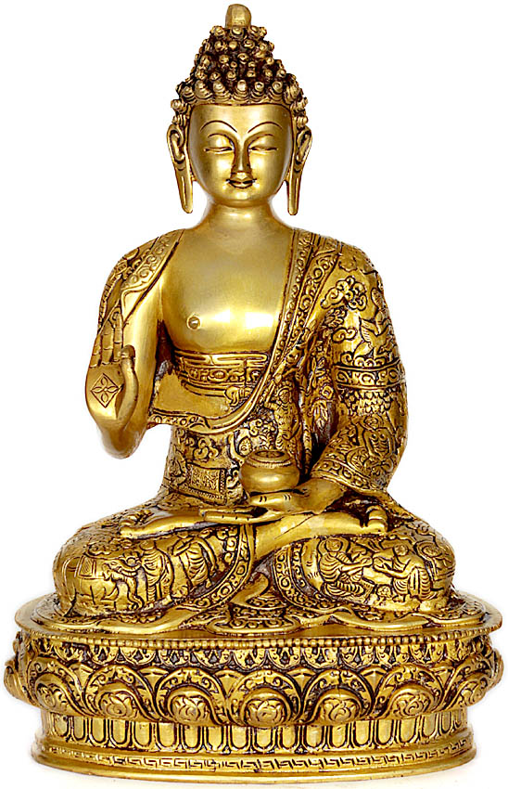

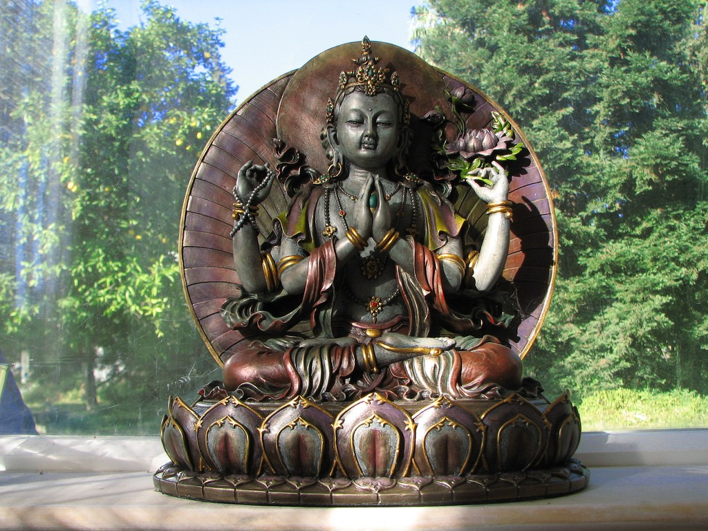

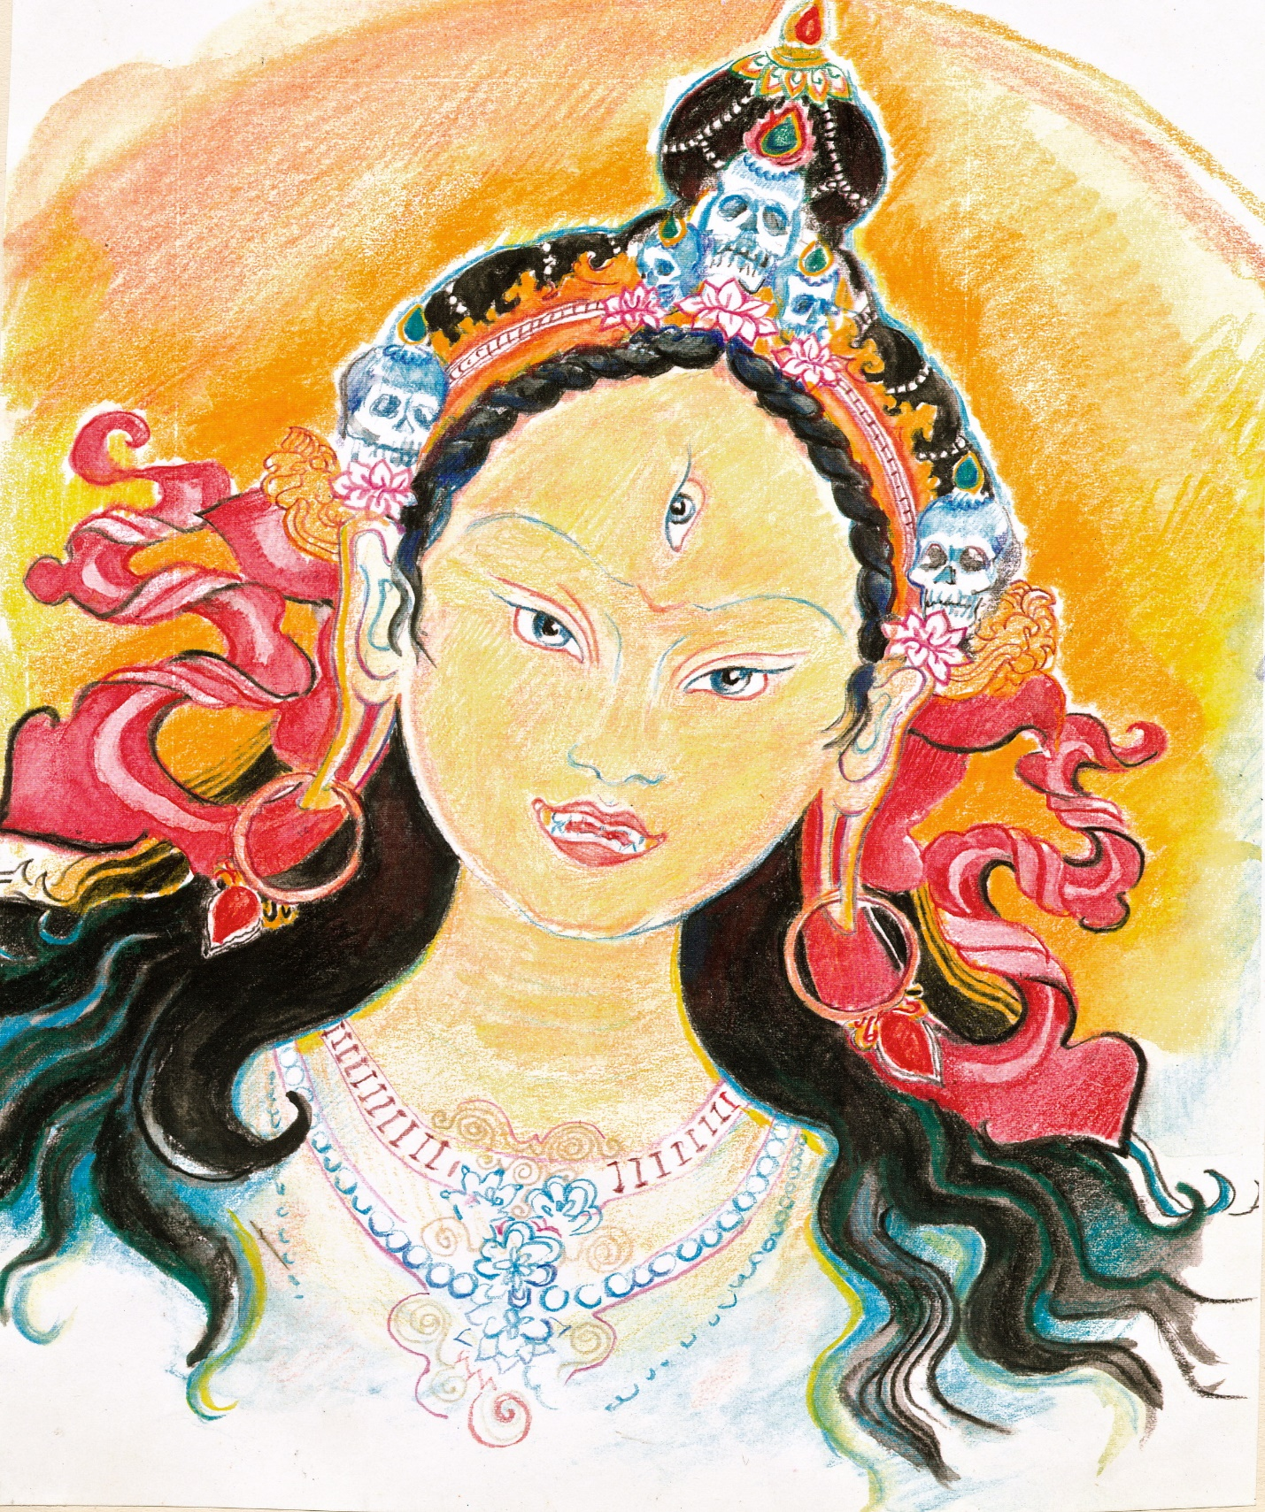

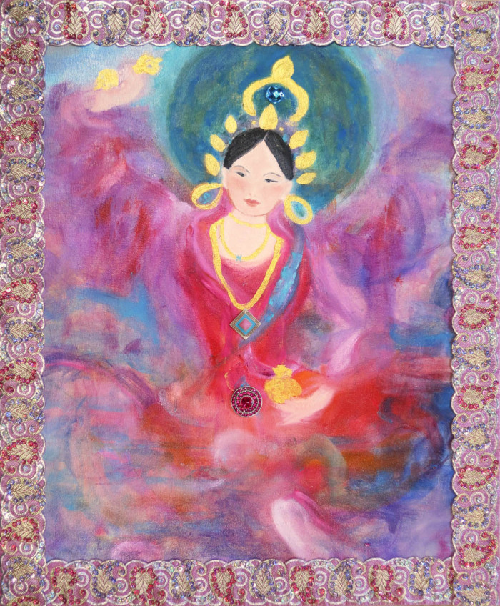

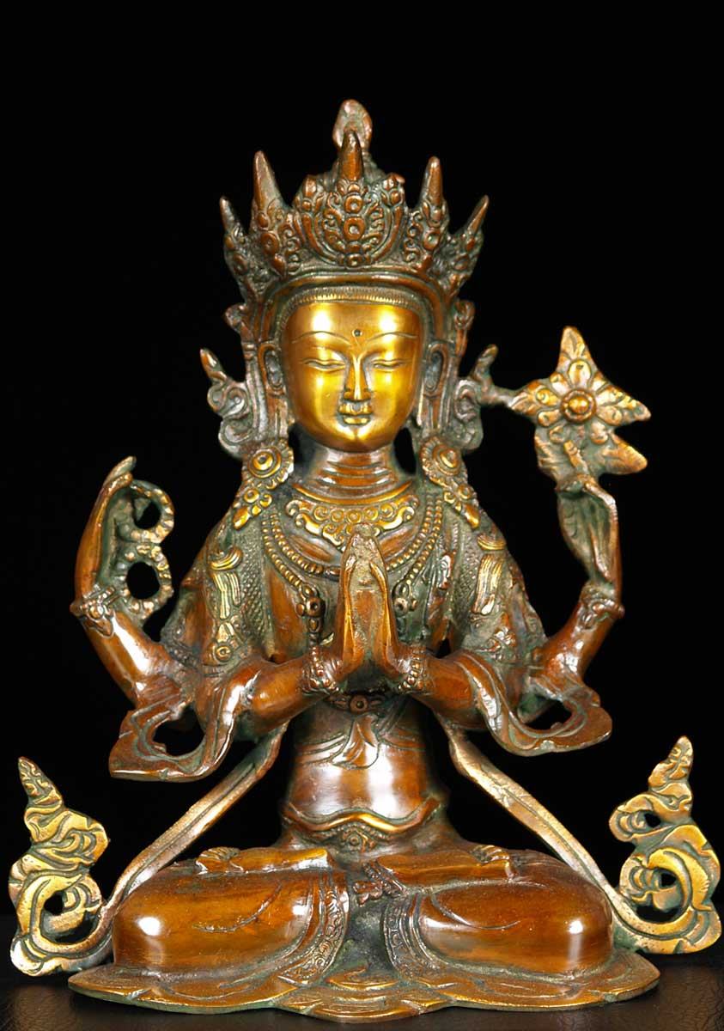

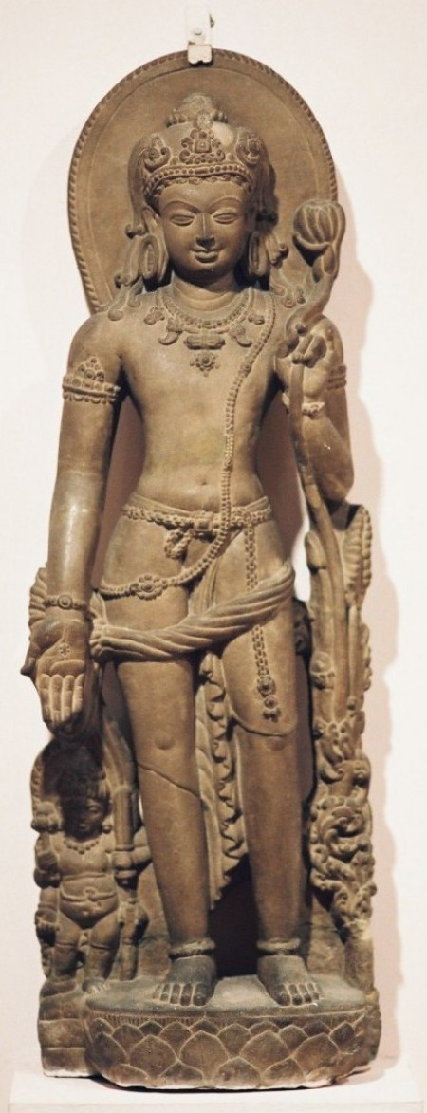

**VII THE MAGUS**

From his tongue (or, in some versions of the legend, from his heart chakra), Amitabha emanates a rainbow imbued light-beam that splashes into a lake in Bhutan, giving birth on a lotus to *Padmasambhava* – *The Lotus Born*.

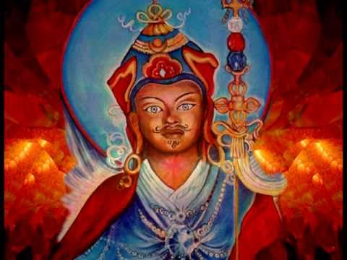

Padmasambhava and Lokeshvara are Soul Brothers, each emanating from Amitabha, and each a fully evolved Buddha-Bodhisattva.

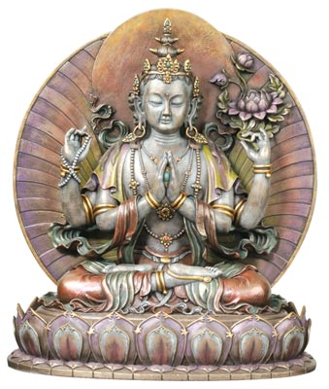



***Padmasambhava*, The Lotus-Born**

***Guru Rinpoche***





**Padma Guru – *Birth and Invocation***

**From the Lotus-field of Great Felicity,**

**Devoid of place or bearings, nowhere found,**

**A globe of light, the vajra body, speech and mind**

**Of Amitabha free from birth and death,**

**Came down upon a lotus cup, uncaused, unwrought,**

**Floating on an ocean vast, unbounded.**

**Thence am I …**

**Wondrous … enlightened … the Lotus-Born.**

  

**Hung.**

**In Orgyen’s land, upon its northwest rim,**

**On lotus, pistil-cup, and stem,**

**Wondrous, supreme mastery you found**

**And as the Lotus-Born you are renowned.**

**A ring of many dakinis encircles you,**

**And in your footsteps practicing we follow you.**

**To grant your blessings, come, we pray.**

**Guru Padma Siddhi Hung.**

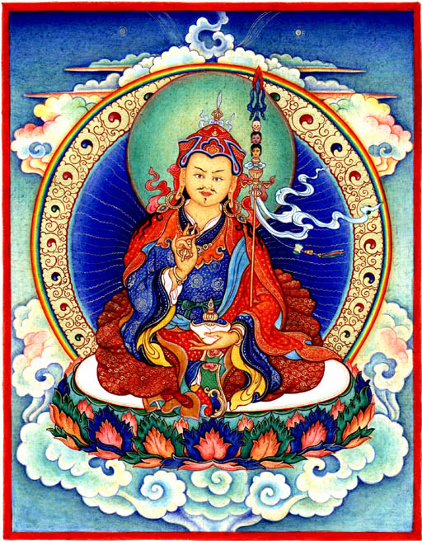 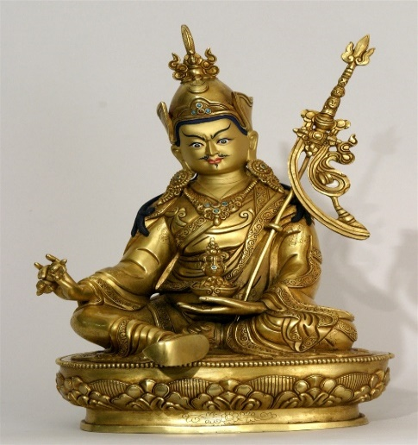 

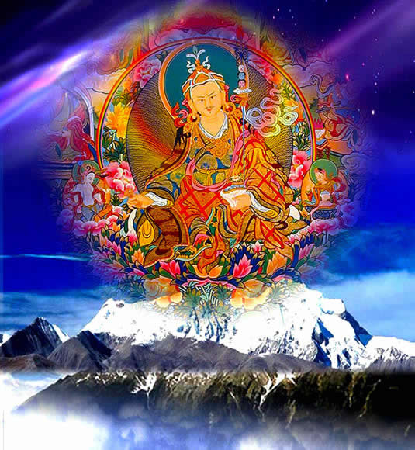

Looking closely at the picture above, we see that Rinpoche, also called ***Padmakara***, is flanked (at the level of his hands) by his two consorts: the Indian princess ***Mandarava***, and the Tibetan princess ***Yeshe Tsogyal***.

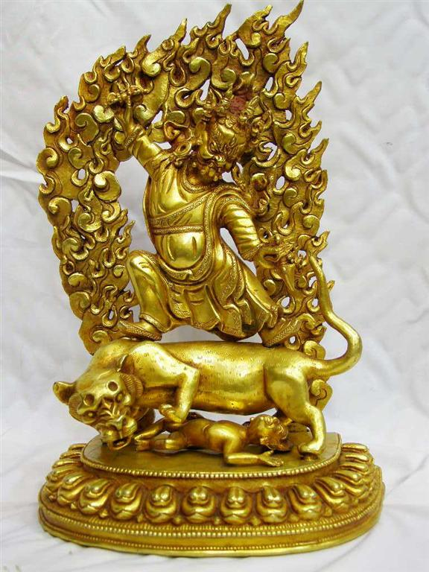

Padmasambhava is the author of the Tibetan classic, *The Book of Liberation*, mistranslated as *The Tibetan Book of the Dead*. Its fuller title is: *Liberation in the Between*.

Padmasambhava hid *The Book of Liberation in the Between* in a temple pillar, to be discovered seven centuries later by the reincarnation of one of his 25 major disciples. A sage who hides such a text is called a *terton*. The text itself is called a *terma* (“treasure text”).

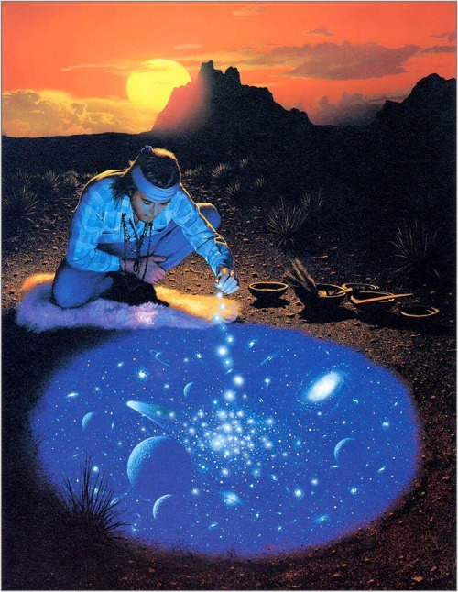

The “between” state has a double reference. It is a guide for souls who journey through the *bardo*: the after-life realm, between incarnations. It is also a wisdom-guide for people living, as it were, now: in life’s embodied journey between birth and death.

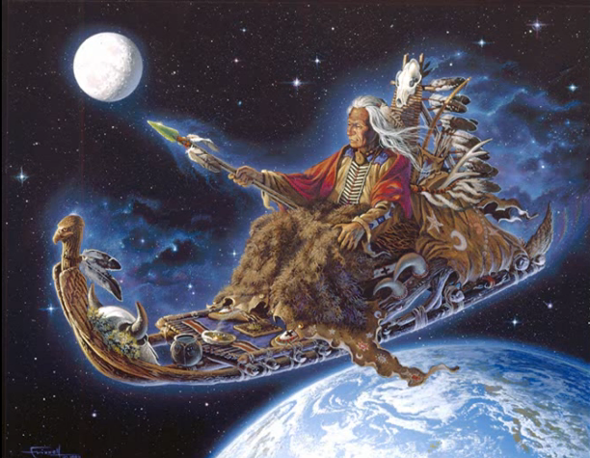



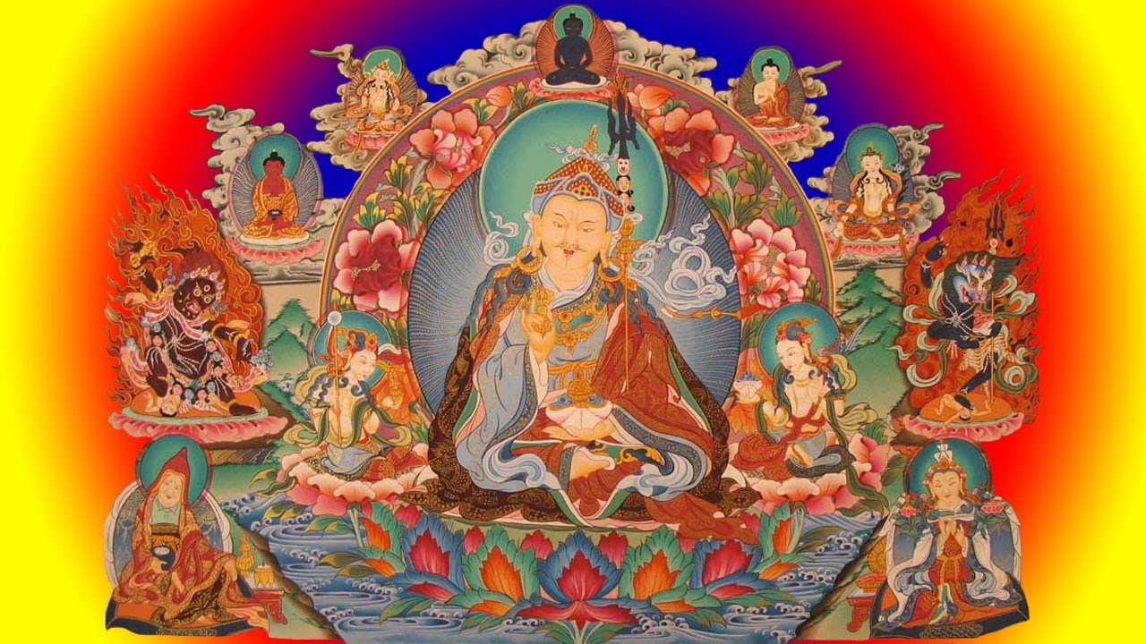

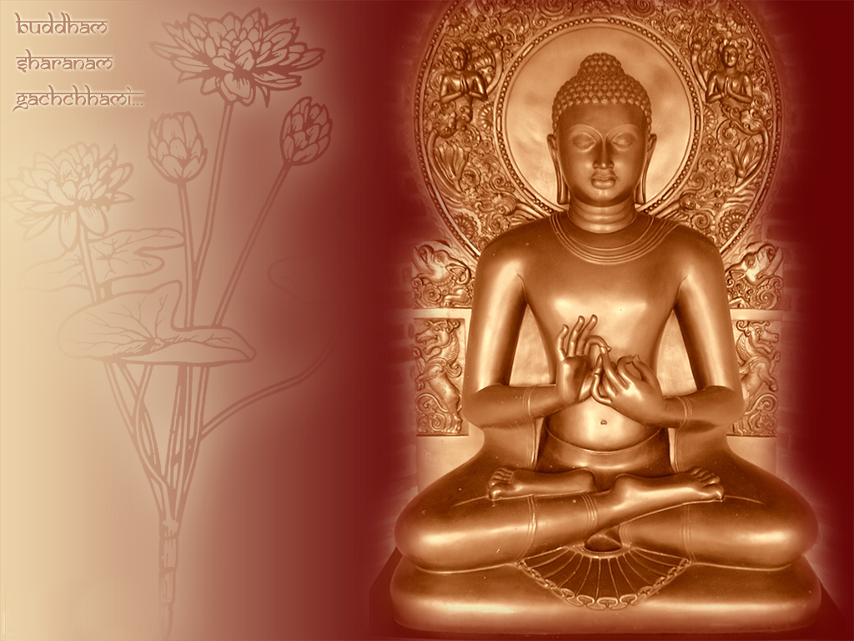

Ratnasambhava – Buddha of The Jewel Family

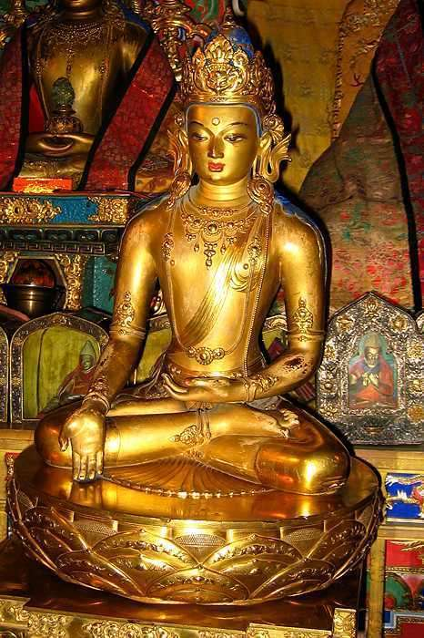

Siddhartha and Tsongkhapa

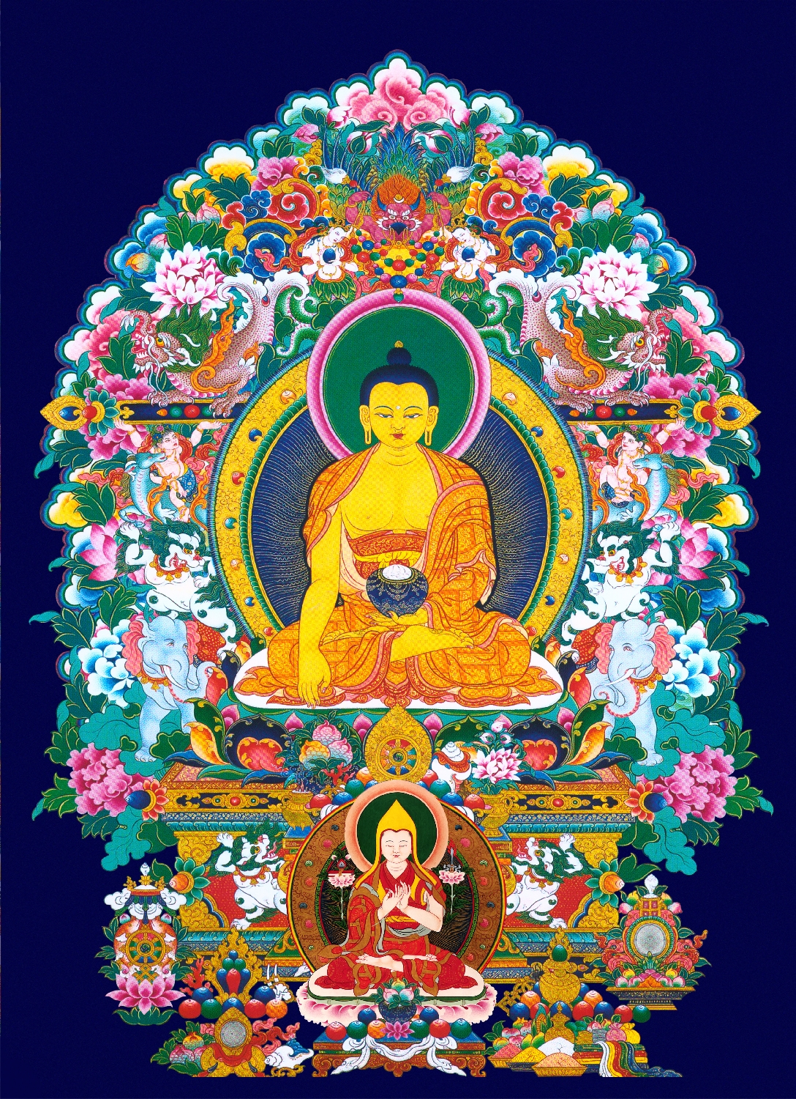

Amitayus

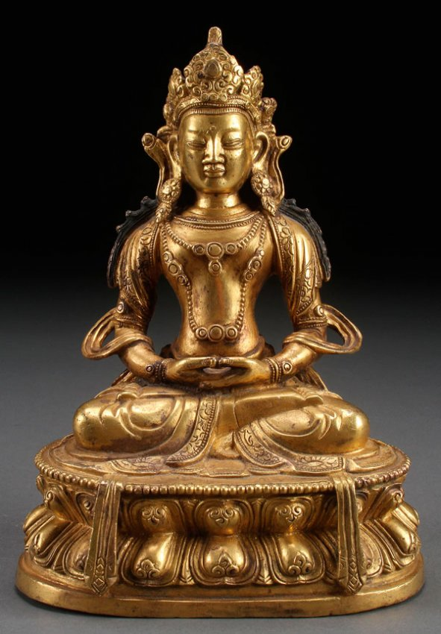

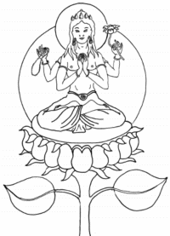





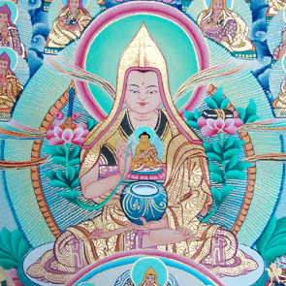



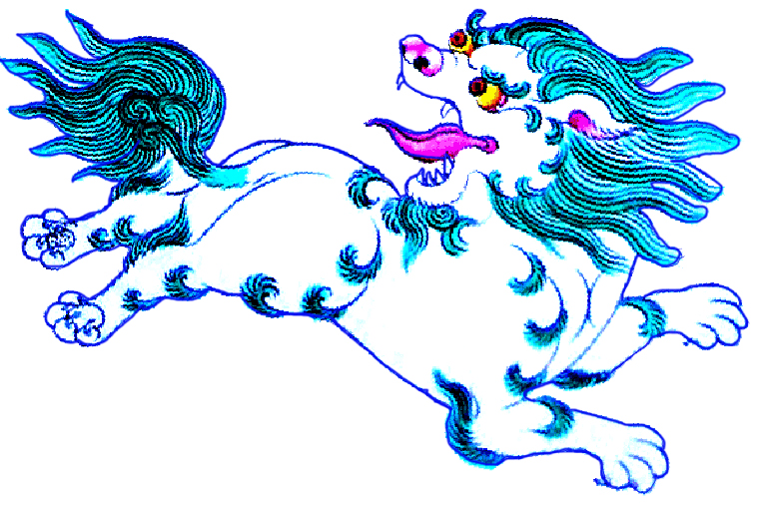

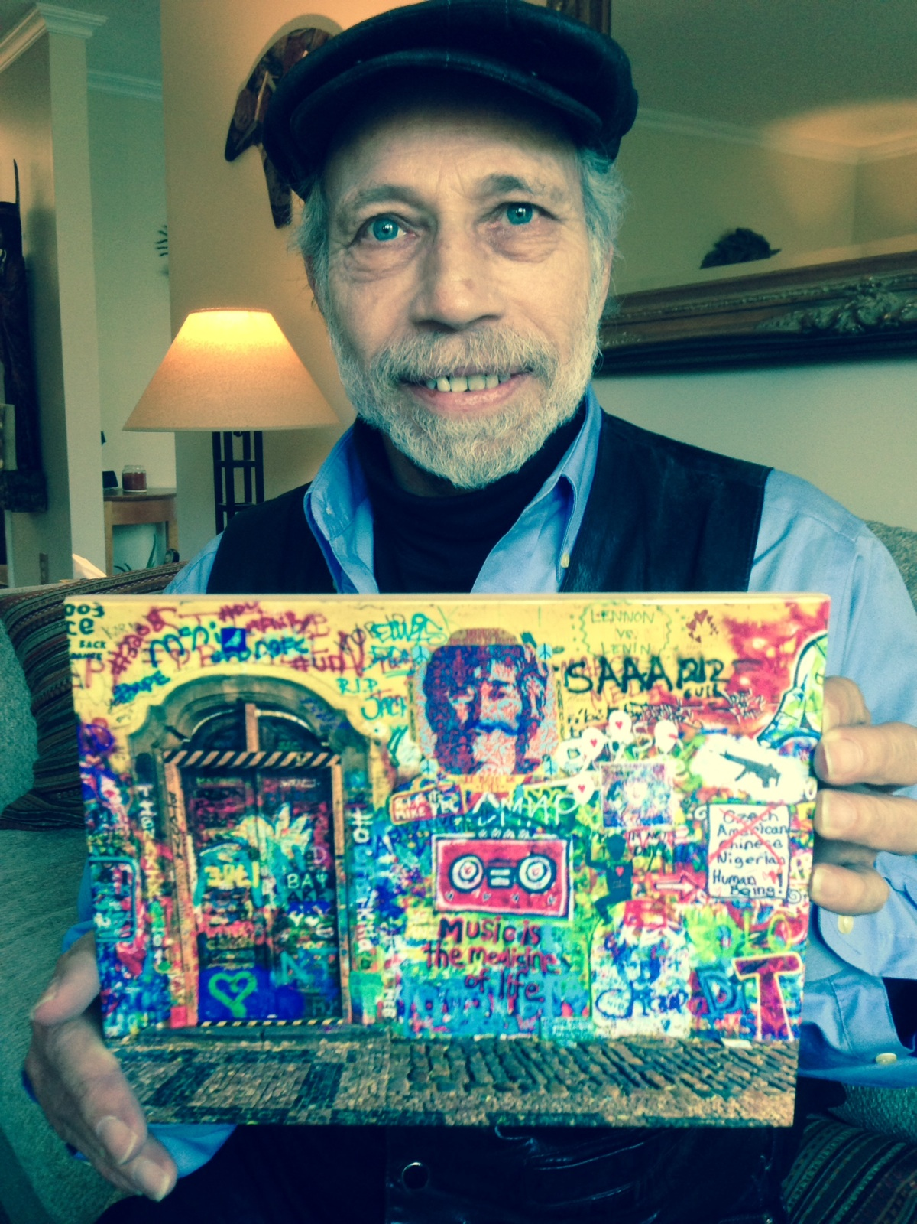

[**stefanschindler@comcast.net**](mailto:stefanschindler@comcast.net)